DRAFT PRESS RELEASE | FuggGlow launch release
DATE | 19 September 2023
VERSION | Draft (2)
IMAGE | To be sources

Glow crazy! The Entertainer announces the arrival of brand new glow-in-the-dark Fugglers
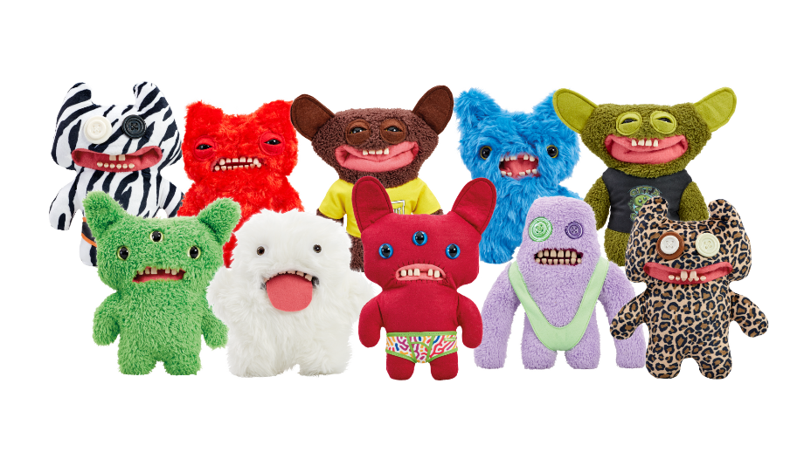
Leading independent toy retailer, The Entertainer, has revealed that an all-new variation of Fuggler, FuggGlows, will hit the shelves next month.
Exclusively launching at The Entertainer on Thursday 5th October, the latest Fuggler variation range, FuggGlows, offers a glow-tastic take on the quirky monsters that are best-loved for their contagious mischief, funny-ugly looks and unique personalities.
The launch, which introduces new characters such as Screech, Stinkface and Reek-O among other characters fans know and loathe, includes ten badly behaved monsters that boast unique glow in the dark features such as glowing eyes, mouth or clothing. To discover where they glow, simply wait for the sun to set and the FuggGlow to awaken as the glowing fiends sleep all day and cause chaos all night.
Priced at £16 per monster, FuggGlows are nocturnal nuisances that are not for the faint of heart! They’re lurking in the shadows, waiting to fire phlegm at unsuspecting victims. But fear not, the funny-ugly monsters are not as elusive as they seem – owners should simply keep a vigilant eye out for their glowing eyes, luminous mouths, or radiant attire, and they will be one step ahead of the midnight menaces.
With an excellent sense of adventure and humour, alongside heaps of mischief, FuggGlows are the perfect companions for those seeking a touch of whimsical mayhem. Whether you're a seasoned Fuggler collector or new to the scene, get ready for a glow-rious treat!
Alongside their glow-in-the-dark features, each monster proudly flaunts the Fuggler’s™ signature BUTT-on hole, human-like teeth, vacant eyes, and a disturbing demeanour. They are not for the faint-hearted as they’re definitely up to no good so be sure to choose wisely and pick the Fuggler that repulses you the least… or most.
Andrew Turner, head of marketing at The Entertainer, commented: “We are excited to announce that the latest Fuggler variant, FuggGlows, will be available to shop at The Entertainer very soon!
“Whether you’re a long-time Fuggler fan or you’re yet to discover the mischief of the funny ugly monsters, we’re confident that the FuggGlow range will be hugely popular with our customers.”
The complete FuggGlow range is available to pre-order online now and will be available to purchase in-store at The Entertainer and online at www.thetoyshop.com from Thursday 5th October 2023 at £16 per toy.
ENDS

For all The Entertainer press enquiries, please contact Rewired PR on TheEntertainer@rewiredpr.com, or:
Grace Coniry Grace@rewiredpr.com 07544 866384
Marie Larner Marie@rewiredpr.com 07544 859826
Ella Browning Ella@rewiredpr.com 07544 866377
Notes to editors:
About The Entertainer:
The Entertainer, along with the Early Learning Centre, stock thousands of toys and games at 171 stores across the UK and online at TheToyShop.com or elc.co.uk.
The Entertainer was founded by husband and wife team Gary and Catherine Grant in 1981 and The Entertainer has the same family values today. With the mission to be the best-loved toyshop - one child, one community at a time.
About Fugglers™:
Fugglers™ were founded in 2010 by a British woman known as Mrs. McGettrick, who created the concept of Fugglers after encountering individual denture teeth and envisioning them as looking funny on teddy bears.
Following the rights to the brand being bought by Spin Master in 2018, toy manufacturer Addo Play is now the official licensee of the Fuggler™ brand and has manufactured and marketed Fugglers™ with the endorsement of Spin Master since 2021.

