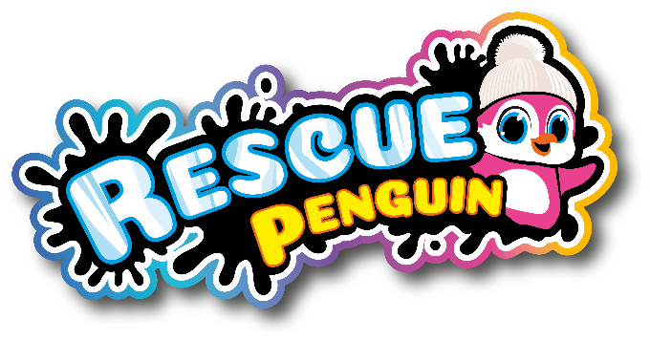

RESCUE AND TAKE CARE OF YOUR VERY OWN PENGUIN

Rescue Penguin (RRP £29.99) is an adorable interactive penguin with a unique unboxing experience.

When you’re ready to rescue your penguin, the box has three surprise tabs, each including things to help you take care of your endangered penguin. When you first rescue your penguin, they are cold, shivering, and dirty, in need of your love.
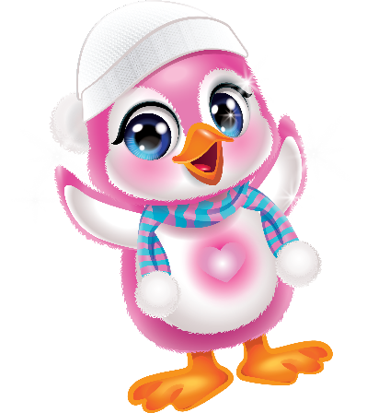
Open each tab on the box to reveal items that will help make your Penguin happy again. Open tab one to reveal an expandable cloth; simply add the cloth tablet to water and watch as it magically expands. Use the cloth to help clean the Penguin. Tab two includes an adorable hat and scarf to help keep Penguin warm. Tab three features a fish that you can use to feed your Penguin and make sure he doesn’t go hungry!

Penguin’s mood is communicated by the coloured flowing heart that changes colour depending on their emotions. Shifting from red to purple indicates he feels sad; yellow to orange is a sign of hungry to full and blue to indigo tells you he is going from feeling cold to warm! Nurture your penguin and take care of them to unlock more sounds and movements, showing their love for you as it grows. This extremely loveable penguin will enjoy being kept warm and safe, how will you take care of yours?

-Ends-

Notes to editor:
The Rescue Penguin is suitable for children aged 5 and over, and will be available from July from all good toy retailers and online.

