For immediate release

JoJo Maman Bébé launch their ‘Helping Hands’ Community Grants initiative with donations of up to £10,000 per winner pledged

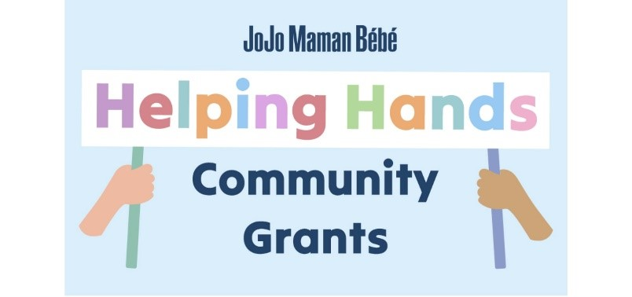

JoJo Maman Bébé, the UK’s well known B Corp brand for Baby, Kid’s and Maternity launch their ‘Helping Hands’ Community Grants initiative for the second year. Supporting local community projects across the UK and Ireland, the company will be donating up to £10,000 each to six winners chosen by the public.

Applications from registered charities, not-for-profit organisations and local community projects are welcomed, from today 18th July, until 15th August 2023. Entries will be shortlisted by the JoJo Maman Bébé Board of Directors, the final round to select the lucky winners will be decided by a public vote hosted on the official JoJo Maman Bébé Facebook brand page. The winning community projects to receive the grants will be announced in September.

The purpose of the ‘Helping Hands’ Community Grants is to support causes that are in need of financial assistance and ensure the brand continues to remain at the heart of the communities in which they are based. The initiative is a reflection of the founding ethos of the community-based brand. By September 2023, JoJo will have donated nearly £150,000 to a number of very worthy causes. The brand is delighted to make a positive impact at a local level to causes that matter to our customers.

Gwynn Milligan, JoJo’s CEO states, “Connection with our communities has always been at the heart of JoJo – for 30 years our friendly staff have welcomed parents, families and grandparents into our stores, whether for advice or a simple chat or to pause to breastfeed and change nappies. Our ‘Helping Hands’ Community Grants initiative goes that step further. Chosen by our customers, these will provide much-needed funds to key local initiatives and not-for-profits to help deliver or improve a project that supports the community we are a part of. After a successful launch in 2022, we’re delighted to run this scheme for a second year and look forward to being able to extend our reach through six more initiatives.”

One of the charity winners in 2022, It Takes a Village commented, “We are just about to launch our community antenatal support programme, The Pregnancy Project, which would not have been possible without the funding from JoJo Maman Bébé. This funding has allowed us to create, manage and cover our costs for this innovative pilot as well as hire our dream team of practitioners.”

They added, “We are so pleased that, thanks to the ‘Helping Hands’ grant, we have been able to offer several fully funded places on the course for expectant parents from low-income families and those with (or at risk from) perinatal mental health issues. We have also been able to provide subsidised tickets for all parents in our local community who are looking for a new kind of pre & postnatal programme that helps to foster lasting friendships and provides support that continues well after birth.”

Entries can be submitted via the dedicated page jojomamanbebe.co.uk/communitygrants

- ENDS -

Notes for Editors
Founded in 1993, JoJo Maman Bébé has grown to become the UK’s leading parent and baby boutique brand. The company has grown organically with a portfolio of 78 high street stores across the UK, as well as a successful website and strong social media presence. The new partnership with Next PLC will enable JoJo Maman Bébé to accelerate growth plans in the UK, IRE, and international territories. With a focus on good values, great design, fantastic customer service, environmental sustainability and loyalty to all involved, the company is proud to be a Certified B Corporation.

Contacts:
For interviews or further company information please contact the PR team: pr@jojomamanbebe.co.uk
020 7622 6543

JoJo Maman Bébé Press Office:
Garden House,
Cloisters Business Centre,
8 Battersea Park Road,
London SW8 4BG
jojomamanbebe.co.uk

