YOTO REDUCES SCREEN-TIME FOR KIDS WITH NEW INTERACTIVE AUDIO PLAYER

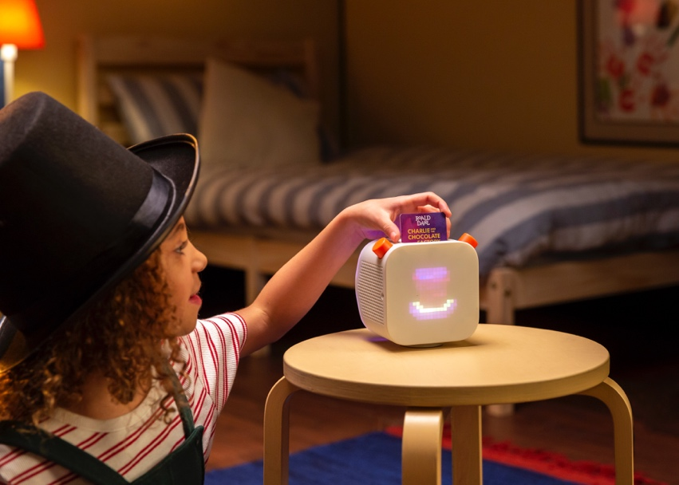

Yoto, the screen-free audio platform for children, is set to launch its new and improved Yoto Player this month.

Yoto Player is a connected speaker designed to safely give children full control over their listening, by entertaining and educating them while reducing screen-time. Yoto Player is controlled using physical cards that are inserted into the Player which play audio content.

Having secured licenses with Penguin Random House, HarperCollins, Hachette, Macmillan and more, the extensive and ever-expanding content library is packed with some of the world’s greatest children’s authors, including Roald Dahl, Judith Kerr and Julia Donaldson. The Yoto library also features music, activities, podcasts, radio and sound effects.

The second-generation Yoto Player features innovative design and enhanced functionality:
- Integrated battery for use around the home
- Improved, stereo sound
- Pixel display to assist with bringing content to life and to aid learning
- Bluetooth connectivity enabling parents to also use it as a regular speaker
- Create Your Own functionality, enabling users to create their own bedtime stories or link to their favourite radio stations or podcasts
- Night light, alarm clock and sleep aid
- Free content delivered straight to the Player: ‘Yoto Daily’ a short daily audio clip featuring different content each day, including fun facts, poems, jokes and more. Plus, Yoto’s very own radio station – ‘Yoto Kids Radio’
- Camera and microphone free

As a fully connected device, parents have access to the Yoto smartphone app allowing full control of settings and content management. Being a connected device, further post-purchase features and remote updates will be added regularly by Yoto for free.

The screen-free speaker helps to reduce excessive screen-time, giving young children access to entertaining content without removing the joy of using technology for fun learning and imaginative play.

Ben Drury, CEO and co-founder of Yoto, says “Our mission is to help inspire the next generation of creative, independent minds. Yoto Player introduces children to a world of curated audio content with them firmly in control. Research shows that audio can help to inspire creativity and imagination in children, whereas screen-time has the opposite effect.

“Children can listen to amazing audio without a smartphone screen, freeing their hands and minds for imaginative play whilst parents know that they are safe.”

Yoto Player is available to buy from www.yotoplay.com with an RRP starting from £79.99. For more information please visit www.yotoplay.com.

The smartphone Yoto parents app is available to download for free on iOS or Android.

-ENDS-

Notes to editors

Media contact
For more information please contact the team at W Communications at yoto@wcommunications.co.uk.

About Yoto

In 2015 inspired by Montessori principles, as well as the cassette players of their youth, Ben Drury and Filip Denker thought up the idea of a connected, screen-free audio device that children could be fully in control of using physical smartcards.

With no experience in hardware, electronics or industrial design, but liking the idea of a challenge, they got to work prototyping a basic device and started testing with their own families and friends.

An award-winning industrial designer joined the team in 2016 and helped develop their hacked-together prototype into a product for market release. With a more stable concept in hand, they launched a Kickstarter campaign for the Yoto Player in November 2017 and achieved full backing in a few days.

With help from their Sheffield based manufacturing partner, 2018 was spent producing and fulfilling the first-generation Yoto Player which sold out in August 2019. Raising investment off the success of this model, the new Yoto Player has been created with globally renowned design partner Pentagram. Yoto Player is the brand’s first product release of 2020, building on its already successful audio ecosystem.

