TRADE PRESS: PRINCE CHARLES AWARDS MERCI MAMAN WITH QUEEN’S AWARD
BRAND PRESS: Kitchen table idea turned into £7m-turnover business awarded the Queen’s Award for its achievements in International Trade
Personalised jewellery brand Merci Maman, has been awarded the Queen’s Award for Enterprise in the International Trade category, for a second time.
Béatrice de Montille, founder of Merci Maman, visited Windsor Castle on Wednesday 10th November in a reception hosted by Prince Charles & Princess Anne to collect the prestigious award.

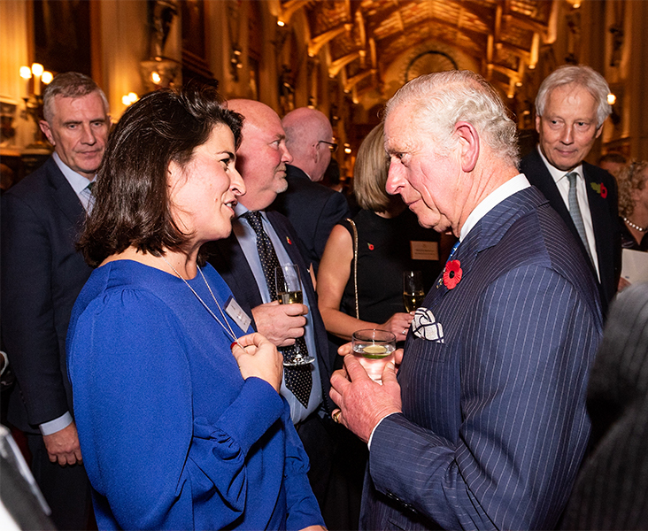
Béatrice meeting Prince Charles
Montille said:
“We are thrilled to receive this award and to be recognised by The Queen for our International Trade strategy. It was an honour to accept this award from Prince Charles and a truly inspirational evening I will never forget.

I expressed my immense gratitude to Prince Charles how grateful I am to this country that made me become an entrepreneur. From starting Merci Maman on my kitchen table, to now an international business with four European offices, I feel very proud today of what we have all collectively achieved so far. Merci Maman is a shared success story.”
The company which was founded in Fulham in 2007 by Béatrice & Arnaud de Montille, now employ a team of 55 with 3 offices in London, Paris & Berlin, delivering beautiful hand-engraved pieces all over the world.
This is the third royal seal of approval the company has received, with the Duchess of Cambridge wearing a Merci Maman necklace in 2014, and receiving the Queen’s Award for a first time in 2017.

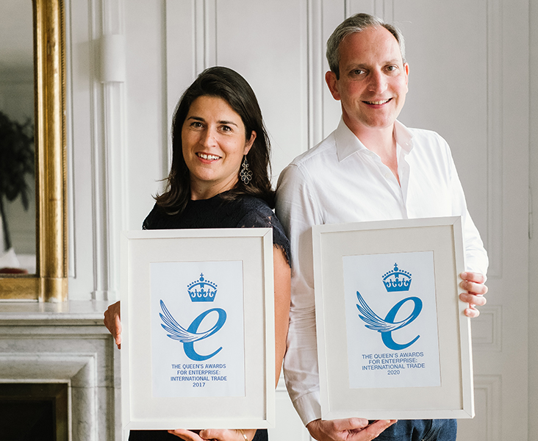
Béatrice & Arnaud with both Queen’s Awards
The Queen’s Awards for Enterprise are given to British-based businesses and organisations that excel at international trade, innovation and sustainable development. They are the highest official UK awards for British businesses and have been presented by the Queen since 1965.
The Merci Maman team celebrated the triumph with a royal themed party in the Merci Maman offices, followed by a dinner out.

