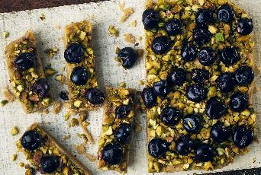

Opies exceptionally edible Christmas gift recipes

- Is there anything more thoughtful than gifting something handmade – especially at Christmas? And, spending a little time out of our busy schedule to make presents for family and friends can’t be a bad thing to reduce festive stress levels can it?
- Using their flavour pantry of mouthwatering and passionately preserved fruits and vegetables, the clever folk at Opies have beavered away to make a medley of marvellous Christmas gift recipes.
- There’s a plethora of present ideas to make at home: sensational sweet treats, bountiful, beautiful bakes and tremendous twists on traditional family favourites.
- There’s also an idea to swap the traditional box of chocs for something homemade as well as flavour-filled, fool-proof plant-based presents.
- Don’t forget the finishing touches – pretty boxes lined with paper or cello bags trimmed with ribbon make all the difference.
- Recipe credit: www.opiesfoods.com / @opiesfoods
- High-res images here: to be included here
______________________________________________________

Get your bake on to make a gift the whole family can enjoy …

Cherry & Pistachio Christmas Tree – expect plenty of ‘oohs & aahs’ when you gift this fantastic festive bake
Black Cherry Yule Log – Remember to include an indoor sparkler in the gift box for extra pazazz!
Ginger Streusel Mince Pies – a pretty box crammed with streusel-spiced topped pies is perfect for friends & neighbours

Don’t cop out with shop-bought chocs - make these easy handmade sweet treats instead

Chocolate Coated Cherries – make sure there are plenty of extras (these choccy cherries are so moreish we guarantee you’ll be eating as many as are giving away!)
Cherry Florentines – chewy, nutty, decadent - and utterly irresistible!

Plant based presents that are far from boring

Halva with Pistachio & Black Cherry – a Middle Eastern confection speckled with beautiful black cherry jewels and glistening green pistachio nuts
Vegan Gingerbread Biscuits – so good, you won’t believe that they’re vegan! Get the kids in the kitchen to help decorate!
