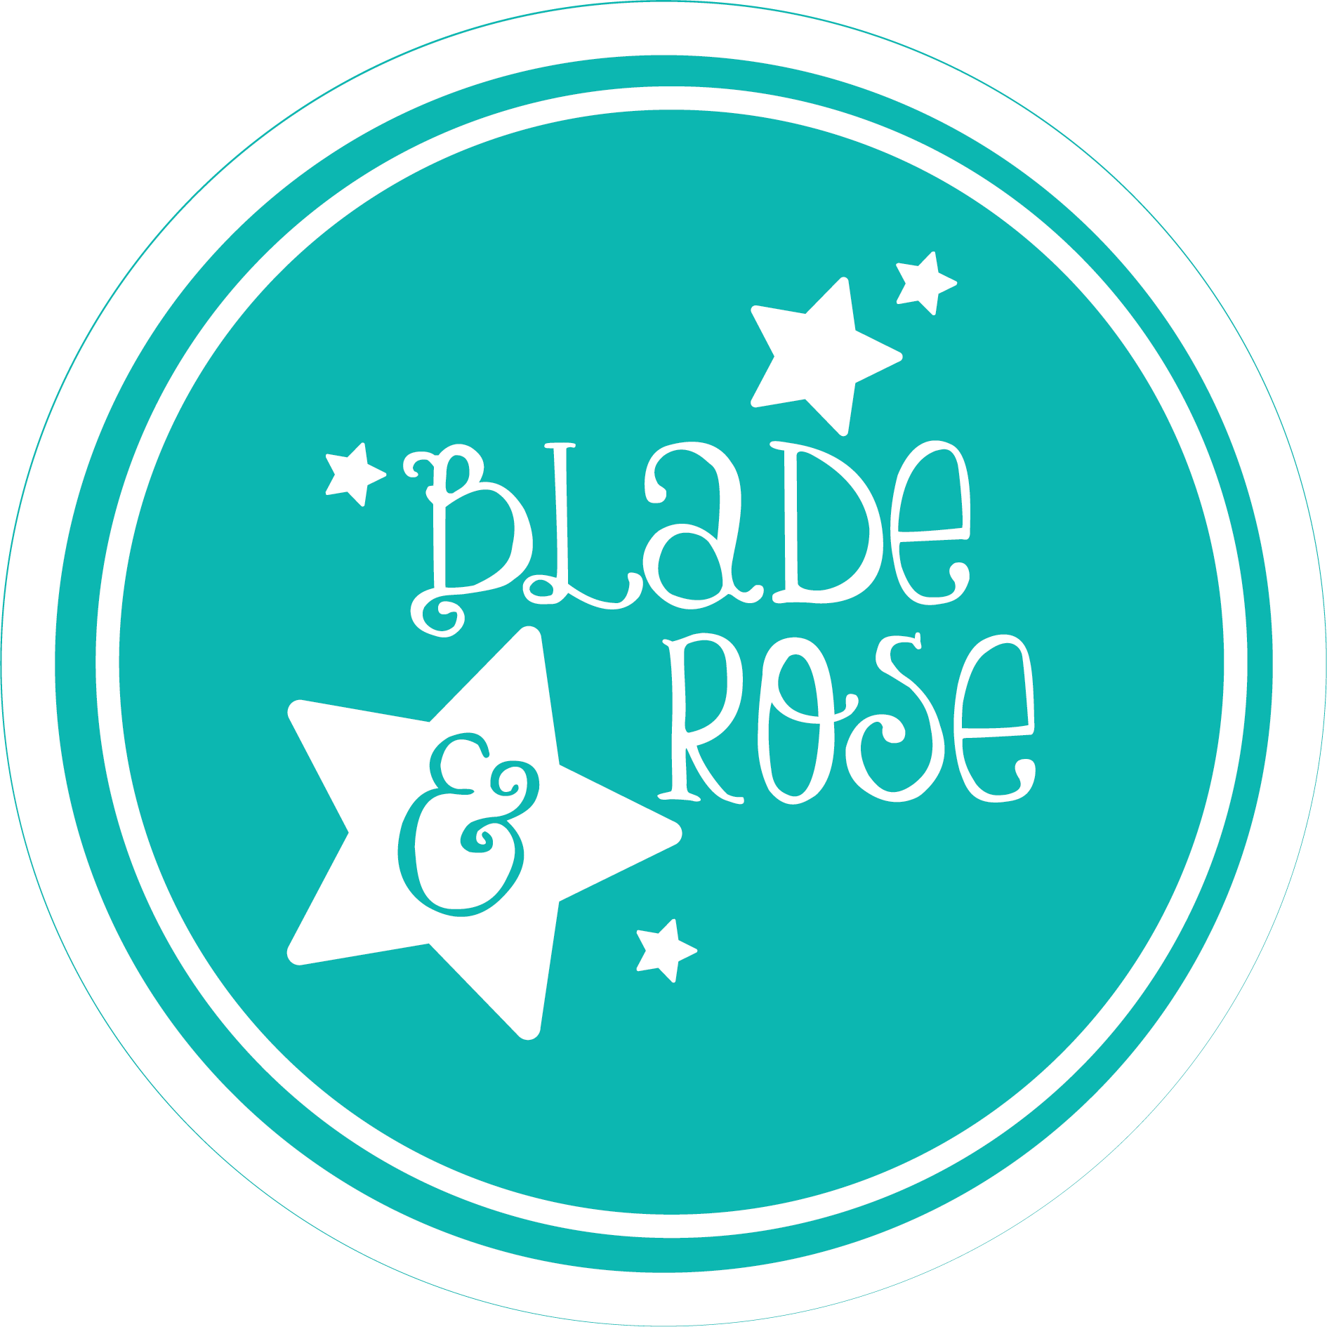

January 2026 RELEASE

Blade & Rose Launches Charming New Paddington™ Loves to Travel Collection
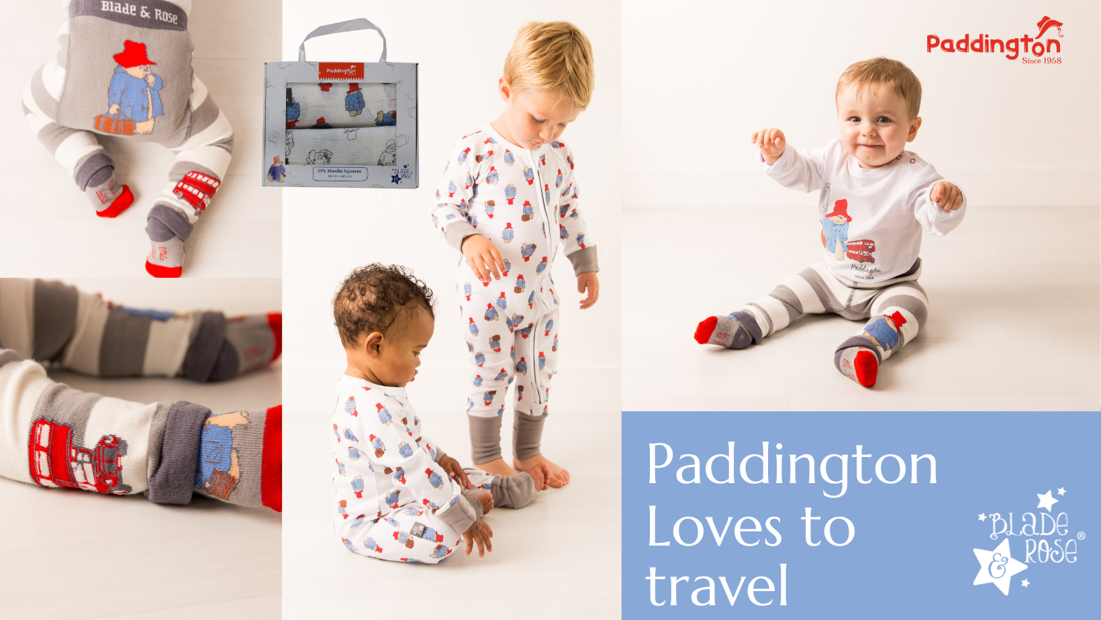
Award winning British children’s brand unveils its latest licensed range celebrating the nation’s favourite bear
Blade & Rose, the multi award winning British children’s clothing and gifting brand, is delighted to unveil its newest licensed character range: the beautifully designed Paddington™ Loves to Travel collection.
Loved by generations for his warmth, curiosity, and adventures from Peru to London, Paddington™ has been reimagined through Blade & Rose’s signature playful style bringing families a collection filled with charm, comfort, and gift-ready appeal.
The range features the brand’s iconic knitted character leggings, instantly recognisable for their fun and quirky designs on the bottom. This new launch showcases Paddington™ on the bottom and down the legs, complete with his famous red hat and blue duffle coat.
The collection also includes:
- A super soft matching top, featuring beautifully embroidered Paddington™ detailing on the front
- A crisp white romper with an all over Paddington™ london themed print
- A matching bib, perfect for everyday use or gifting
- A beautifully packaged muslin squares set, ideal for new arrivals and baby showers
Designed with comfort and durability in mind, all pieces are made from high quality, Oeko Tex certified fabrics ensuring they are gentle on delicate skin while standing up to the adventures of busy little explorers.

About Blade & Rose
Blade & Rose is a multi award winning British baby and children’s clothing brand, celebrated for its high quality, comfortable designs and its iconic signature leggings featuring playful characters on the bottom. Founded in 2010 by entrepreneur and mum Amanda Peffer, the brand has grown from a small family start-up to an internationally recognised favourite, stocked in gift shops, garden centres, boutiques, and leading retailers worldwide.
Notes to editors:
- https://bladeandrose.co.uk/
- Blade & Rose are winners of the following Awards : -*Drapers Kidswear Brand of the Year** Gift of the Year, best licensed product *, Best Preschool Apparel and Accessories Range in the Progressive Preschool Awards, Best Fashion Brand in the Baby Awards, Loved By Parents Best baby Fashion Brand and Best Toddler Brand, Best Children’s Fashion Brand in the Absolutely Mama Awards, Awards for Best Baby Fashion Brand and Best Heritage Children’s Fashion Brand in the Junior Design Awards
- Blade & Rose is Britain’s leading children’s gifting and clothing brand specialising in trendsetting leggings featuring stylish and quirky designs on the bottom and accessories. The company founded in 2010 by entrepreneurial mother of two Amanda Peffer during her maternity leave naming the company after each child’s middle name ‘Blade’ and ‘Rose’. Inspired by her then 3-month old daughter, who always had the bottom of her leggings on show, Amanda found herself constantly pulling down her daughter’s dresses until she decided to embrace the beautiful bottom sticking out and design a fun range of leggings around this concept. A major component of the development was to ensure that the quality of the fabric was durable, functional, would wash well and most importantly, that was soft and kind to children’s delicate skin.
- For details, hi-res imagery and feature opportunities, please contact Amanda amanda@bladeandrose.co.uk

Press Contact
Blade & Rose
amanda@bladeandrose.co.uk

Links to Images

About Paddington
For almost 70 years, British-born writer Michael Bond has delighted readers all over the world with his stories about Paddington, the bear from Peru, famous for his love of marmalade. The kindness and humour in the stories appeal to children and adults alike, ensuring Paddington's enduring popularity from one generation to the next.
Since then, Paddington’s adventures have been adapted several times for television and at the end of 2014 Paddington made his debut onto the big screen, a further film Paddington 2 followed in 2017. The third instalment Paddington in Peru was released in the UK on 8th November 2024 and internationally throughout 2025 grossing over $220 million at the box office. The movies are produced by STUDIOCANAL, Europe’s leader in production, distribution and international sales of feature films and series, part of CANAL+ Group, major player in the creation and distribution of content worldwide. In 2020, a brand-new Paddington TV series designed for a pre-school audience, The Adventures of Paddington launched on Nickelodeon, winning two Daytime Emmys.
You can catch-up with Paddington’s many adventures on:
Instagram & TikTok @paddingtonbear | Facebook.com/PaddingtonBear | dailymotion.com/Paddington | YouTube.com/PaddingtonBearOficial
Shop all collections at: https://store.paddington.com/
©P&Co. Ltd/ SC 2026
About STUDIOCANAL (a CANAL+ Company)
STUDIOCANAL, CANAL+’s in-house studio, is Europe’s leading film and television studio, with worldwide production and distribution capabilities. It operates directly in nine major European markets including Austria, Benelux, Denmark, France, Germany, Ireland, Poland, Spain and the United Kingdom, as well as in Australia and New Zealand, and offices in the United States and China. STUDIOCANAL finances, produces, and distributes 200 films per year. It owns one of the most prestigious catalogues in the world and the largest catalogue of European titles, boasting more than 9 400 titles from 60 countries. With a catalogue spanning 100 years of film history, STUDIOCANAL has invested close to 25 million euros into the 4K restoration of nearly 1 000 classic feature films over the past 7 years.
STUDIOCANAL also produces over 15 series each year, including local creations and premium international co-productions, and distributes its scripted productions and CANAL+ Originals
globally (2,000 hours of current and library content in distribution). Projects are produced in-house by STUDIOCANAL or through its worldwide network of production companies, including 2e Bureau, Flab, Kissman, Pernel, Upside and Grands Ducs Films
in France; Birdie Pictures, Urban Myth Films, Strong Film & Television, Sunny March TV and Brock Media in the UK; Bambú Producciones and Te Espero en Marte in Spain; Lailaps Films and STUDIOCANAL Series in Germany; Opus TV in Poland; Sam Productions in Denmark; Dingie in Belgium; and The Picture Company in the United States.
canalplusgroup.com/en/group/content-production-distribution-and-other
STUDIOCANAL Kids & Family Ltd, proudly owns the Paddington brand.
--

