
BOO! ON A BUDGET: HOW TO HOST A CHILLINGLY GOOD HALLOWEEN PARTY
It’s officially spooky season; autumn leaves are falling, and pumpkins are aglow – it’s the perfect time to get together with friends and family for a Halloween party.
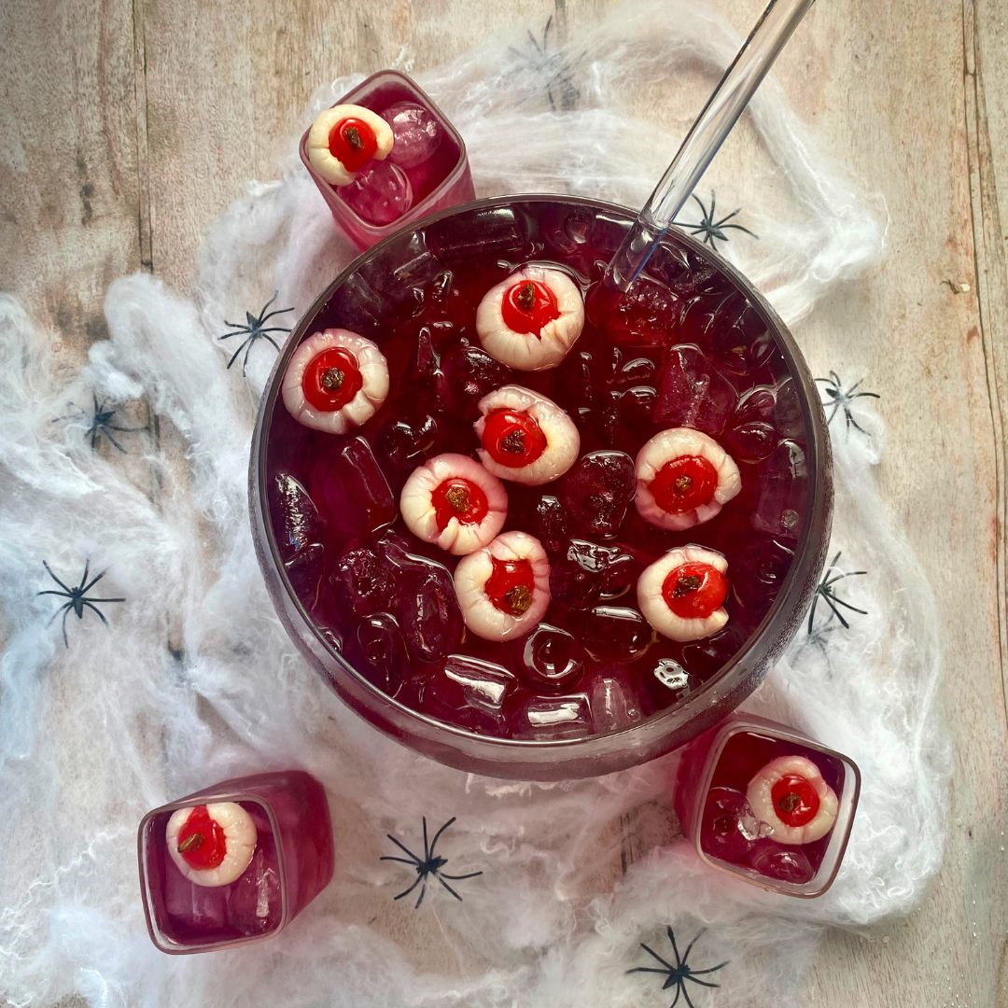
As Halloween creeps upon us, drinks expert and leading ice manufacturer, The Ice Co is here to bring you hacks and recipes to create a spooky and budget-friendly Halloween celebration that's as cool as ice.
As part of its Break the Dev(Ice) campaign – which championed catching up with close ones in-person over a refreshing drink, rather than via instant messaging – The Ice Co found that more than three-quarters (76%) of Brits believe we’ve lost the art of conversation. What’s more, one in five (22%) of us admitted that we haven’t called a friend in over three months!
With these creative ideas and budget-saving tips, you can enjoy a fang-tastic Halloween without the fear of overspending.
- Spooktacular food
Get creative and make your own delicious Halloween treats. For an interactive element and to get all the guests involved, set up a ‘Make Your Own’ pizza station, with pumpkin or ghost-shaped bases and whatever toppings you fancy. For another spooky savoury, cut strips of puff pastry and wrap around hotdogs – bake for 20 minutes in the oven and use a dab of honey to add edible eyes… now you’re left with scarily delicious mummies.
- Household item decorations
Finished a roll of kitchen paper? Save the tube, cut out spooky eye shapes and add a glowstick inside. Hide around your home and garden to give guests a fright when they enter. Another simple Halloween décor idea is to use binbags to make huge spiderwebs to stick on the doors.
- Get creative with edible garnishes
Use whatever you have on-hand to make your drinks look extra spooky. Whether it’s traditional red food colouring to make blood-inspired drinks or gummy eyeball sweets dropped into the bottom of a glass, the possibilities are endless. Our favourite is melting marshmallows and draping across the rim of a glass to look like cobwebs – finish off with some spiders and you’ve got yourself a very ghoul cocktail or mocktail!
Eyeball Lychee Martini
Ingredients:
x1 can lychees
x1 jar cocktail/glace cherries
x1 small box raisins
x1L blueberry juice
x1L cranberry juice
x1L sparkling water
x1 bag Party Ice

Method:

- Drain the lychees and reserve the juice in a jug. Push a raisin into one end of a cocktail cherry then push the cherry into a lychee to make an “eyeball”. Repeat until you run out of lychees.

- Fill a jug or fishbowl with party ice then add the blueberry and cranberry juice along with the reserved lychee juice, then top up with sparkling water.

- Finally add your eyeballs and your lychee punch is ready to serve!

Zombie

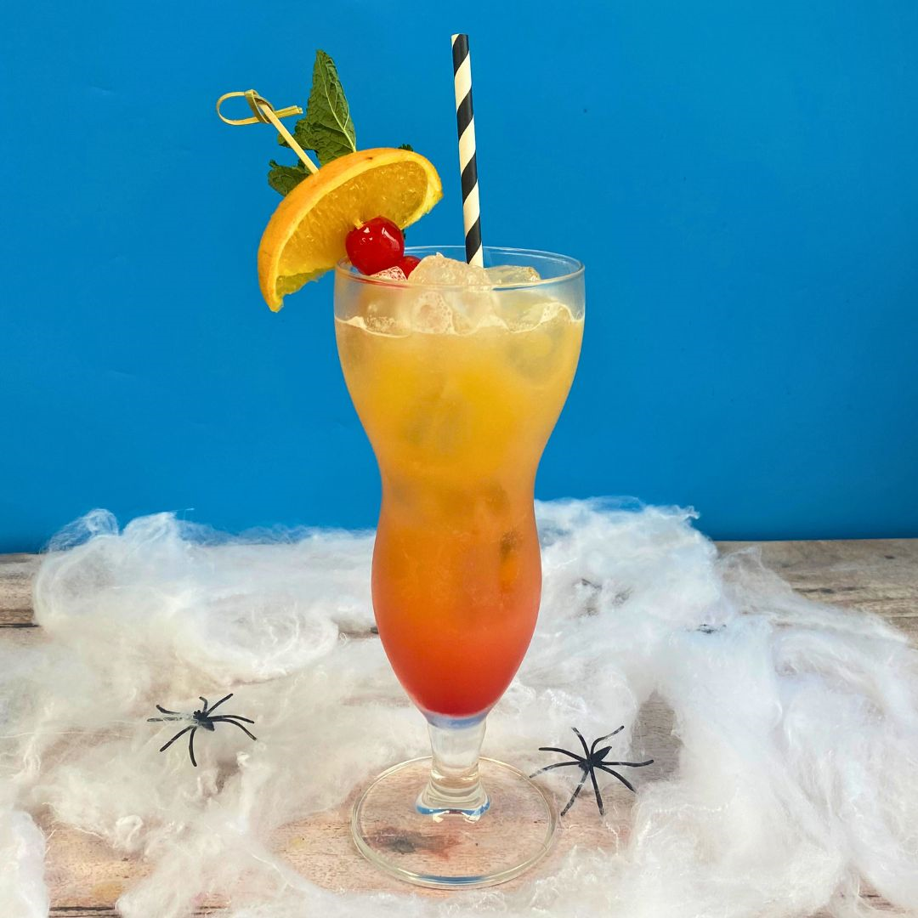

Ingredients:

x25ml dark rum
x25ml white rum
x150ml pineapple juice
x3 handfuls Party Ice
x1tsp Grenadine
Juice of 1 lime
Garnish: orange wedge, maraschino cherry and a mint sprig

Method:

1. Fill a cocktail shaker with party ice and add both rums, the pineapple juice and lime juice. Shake well to combine.

2. Fill a hurricane glass with party ice and strain the cocktail into the glass. Slowly pour in the grenadine.

3. To serve, skewer the cherries and orange wedge together and add to the glass, then garnish with a sprig of mint. Enjoy your Zombie cocktail!

Watch the full TikTok on Halloween hosting hacks here, or visit the website for more entertaining ideas and recipes: http://www.theiceco.co.uk/.

ENDS

Notes to Editors
For all media enquires please contact The Ice Co. press team on theiceco@hatch.group or 0113 361 3600.
About The Ice Co
Established in 1860, The Ice Co is Europe’s leading ice manufacturer. The business produces its own ice from its UK factories and supplies retail, wholesale, foodservice, events, and food manufacturing, both in the UK and abroad. It has also won a string of awards, such as The Grocer’s SME of The Year Award 2020 and has held the title Frozen Food Manufacturer of the Year for two years running.
The Ice Co’s key product lines include Party Ice, Crushed Ice, Polar Cubes, and Super Cubes - the super-sized slow melting ice cubes, made from spring water. For more information, please visit www.theiceco.co.uk.

