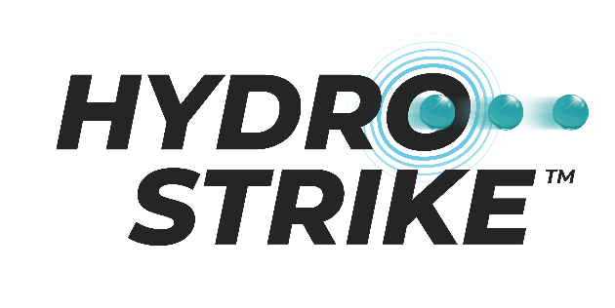

Level up your blaster game with the Hydrostrike Nova Pro Gel Blaster!

Take your game to the max with this mess-free and eco-friendly gel blaster.

The Hydrostrike Nova Pro Gel Blaster (RRP £59.99) will create hours of fun and epic competitive action. Packed with dehydrated Gel-Tek beads, simply fill the Hydrostrike hydration pouch with the beads, add water and leave for 4 hours to expand. Once your beads have expanded, load your gel blaster with ammo and get ready for battle!
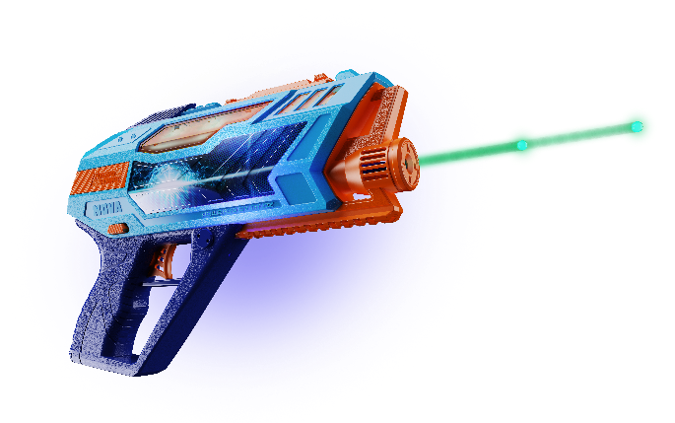
The gel blaster holds 500 beads at a time and is fully motorised, releasing up to 7 beads per second, allowing you to blast as quickly as possible, so you’ll never sacrifice speed. The beads burst on impact for blaster action without the clean-up, making it the perfect mess-free game that can be enjoyed in or outdoors.

Complete with a range of accessories to maximise your blasting potential, the Hydrostrike Nova Pro Gel Blaster includes eye protection glasses, normal and glow in the dark Gel-Tek beads plus a useful pouch to keep your beads packed away and ready for action!

This will be sure to keep players on the field for hours of action!

-Ends-

Notes to editor:
Hydrostrike Nova Pro Gel Blaster will be available this Summer from all good toy retailers and online.

