STIHL LAUNCHES NEW RANGE OF BATTERY-POWERED LAWN MOWERS FOR 2024

STIHL has made a major update to its comprehensive range of lawn mowers, offering homeowners a wider choice of battery-powered models than ever before.

The new 4 Series range includes the RMA 448 RV, the first ever battery rear roller mower from STIHL, meaning gardeners can achieve a classic striped lawn while still enjoying all the benefits that battery power brings.
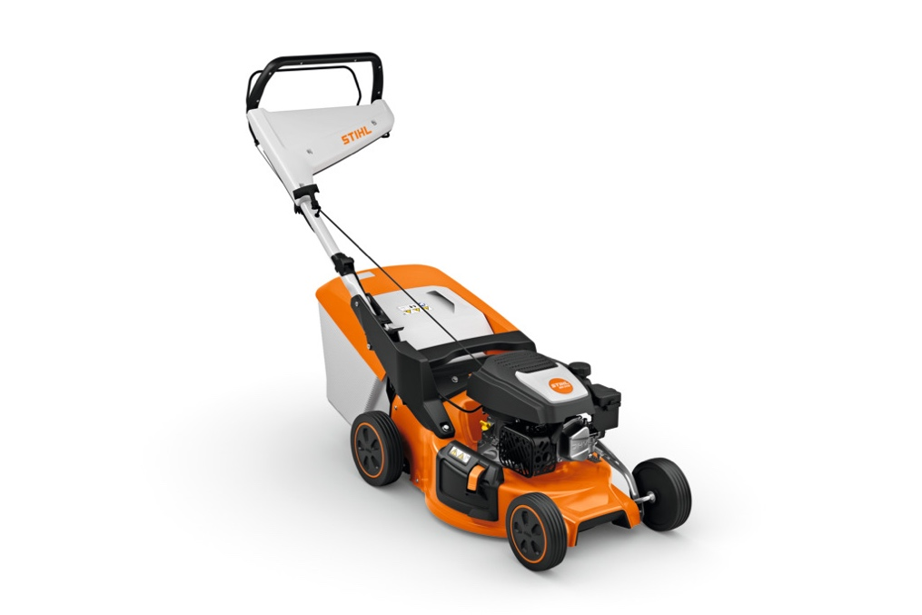
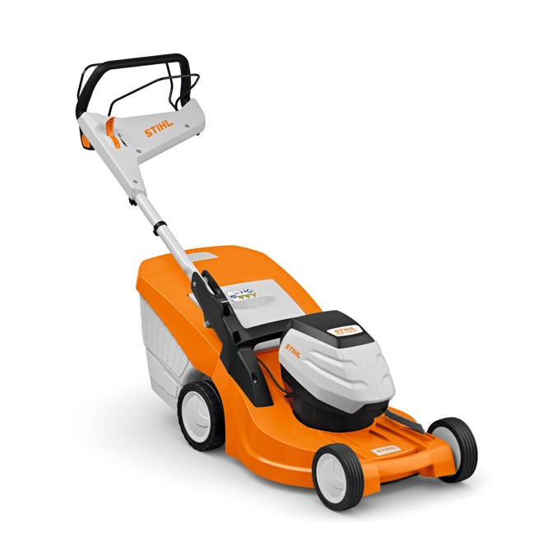
Figure 2 RMA 248.3
Figure 1 RMA 448 RV

The new models form part of the STIHL AK System, a wide range of tools that includes hedge trimmers, grass trimmers, chainsaws, blowers, mowers and much more. 2 Series mowers are ideally suited for use in small to medium gardens, while the new 4 Series models include additional features and are perfect for medium sized lawns.

Both 2 and 4 series lawn mowers are available in a variety of cutting widths to best suit the user, as well as different drive options ranging from variable speed (V), single speed (T) or just push along.

With a comfort mono-handlebar standard on all new models, removing the grass box has never been easier. The handlebars are height adjustable to suit the user for more comfortable mowing, and foldable for quick and compact storage too.

Offering four-in-one mowing, the user can choose to cut and collect, cut and drop, side discharge via the integrated opening, or mulch the grass instead. 2 Series models include a mulch plug as standard, whereas 4 series models feature a handy mulch switch for even easier operation.

Boasting single point height adjustment on all models, adjusting the cutting height from between 20-100mm can be done by the press of a button.

The ergonomic, well-balanced, and easy opening grass boxes open fully for speedy emptying, and the downward facing air outlets ensure low dust and excellent air flow. The position of the deflector handle has been improved too, meaning access to the grass box is as effortless as possible.

The new 2 Series mowers offer good stability and rigidity with their impact resistant high grade polymer components and durable steel decks. 4 Series models feature a lightweight, double skinned polymer deck for additional stability, as well as a UV and petrol resistant polymer front handle. What’s more, the 4 Series models also feature ECO Mode, which reduces rotations per minute where possible to conserve battery life.

The new for 2024 2 Series lawn mower range from STIHL includes;
- RMA 243.3, AK interchangeable battery system. RRP tool only £369, RRP set with AK 20 battery & AL 101 charger £489. Max. lawn area 230m²
- RMA 248.3, AK interchangeable battery system. RRP tool only £399, RRP set with AK 20 battery & AL 101 charger £529. Max. lawn area 220m²
- RMA 248.3 T, AK interchangeable battery system. RRP tool only £469, RRP set with AK 30S battery and AL 101 charger £619. Max. lawn area 340m²
- RMA 253.3, AK interchangeable battery system. RRP tool only £459, RRP set with AK 30S battery and AL 101 charger £619. Max. lawn area 275m²
- RMA 253.3 T, AK interchangeable battery system. RRP tool only £529. Max. lawn area 275m²

The new for 2024 4 Series lawn mower range from STIHL includes;

- RMA 443.3, AK interchangeable battery system. RRP tool only £489, RRP set with AK 20 battery & AL 101 charger £609. Max. lawn area 300m²
- RMA 443.3 V, AK interchangeable battery system. RRP tool only £549, RRP set with AK 30 S battery & AL 101 charger £709.00. Max. lawn area 350m²
- RMA 448.3 V, AK interchangeable battery system. RRP tool only £599, RRP set with AK 30 S battery & AL 101 charger £749. Max. lawn area 340m²
- RMA 448.3 RV, AK interchangeable battery system. RRP tool only £749, Max. lawn area 340m²

The new STIHL lawn mowers will be available to buy from STIHL Approved Dealers nationwide from this spring. For more information on STIHL’s extensive range of high-quality garden tools, please visit www.stihl.co.uk.

-ENDS-

About STIHL

It all started with a chainsaw, and to this day, it's still the product for which the STIHL brand is best known worldwide.

Ever since Andreas Stihl invented the first portable chainsaw, the STIHL name has stood for revolutionary technology, driven by significant investments in research and development and a single-minded passion for making people's lives easier when working in nature. It's because of this that STIHL has been the world's best-selling petrol chainsaw brand since 1971.

But the STIHL name is now synonymous with many other industries too, as well as with home gardeners looking for premium quality tools. The extensive STIHL range includes hedge and grass trimmers, multi-tools, pressure washers, construction tools, lawn mowers, lawn tractors, robotic mowers and of course, chainsaws.

A family-owned business based in Germany; STIHL employs more than 20,000 people worldwide and sells products in more than 160 countries globally.

STIHL GB is a wholly-owned subsidiary of the global STIHL Group. In Great Britain, STIHL products are available from more than 700 specialist Approved Dealers who offer expert advice and after sales support. Selected tools are also available from quality garden centres and from STIHL's own online store https://shop.stihl.co.uk/

Whatever STIHL tool you choose and however it's powered - battery, petrol or electric - each features countless innovations, exceptional performance and lasting quality.

Issued on behalf of STIHL GB by HROC Ltd. For further information please contact:

HROC Limited
Tel: 0121 454 9707
E: prstihl@hroc.co.uk

