REDUCE FOOD WASTE WITH THE
FRESH & SAVE VACUUM FOOD STORAGE SOLUTION FROM ZWILLING

ZWILLING has a long history of championing perfect food preparation and culinary innovation, almost 300 years in fact, and with food waste at an all-time global high, this German company has taken the lead by launching its new Fresh & Save vacuum food storage solution. Not only will this new collection of kitchen products help to reduce food waste by keeping food fresh for up to five times longer, but it will also preserve food’s flavours, nutrients and vitamins, locking the goodness in.

Food waste not only wastes valuable produce and money, but it has a devastating effect on the planet and our environment, too. According to British charity WRAP (Waste & Resources Action Programme) the UK alone throws away 6.6 million tonnes of household food waste every year and almost three quarters of that (70%) is food that could have been eaten. When food waste is disposed of in landfill, it rots and becomes a massive source of methane, a potent greenhouse gas with 21 times the global warming potential of carbon dioxide. Even growing and transporting the food which goes to waste emits harmful carbon pollution, so it’s easy to see the problem. ZWILLING has the perfect solution to that problem with its new Fresh & Save vacuum storage boxes and bags. Using the collection keeps food fresh for up to five times longer and it’s also perfect for leftovers, seasonal produce, packed lunches and batch cooking.

SIX OF THE BEST WAYS TO REDUCE FOOD WASTE FROM ZWILLING

1 Plan Meals Ahead
Most people have a rough idea of some of the dishes they will be cooking during the week or at the weekend but sitting down and properly planning mealtimes is a simple way to cut back on food waste. Do this before a big food shop and as well as cutting back on food that is not needed and gets thrown away, it will save money, too. Try to vary the meals and where possible, double up on some of the ingredients. For instance, minced beef or vegetarian Quorn can easily make spaghetti bolognaise, cottage pie and chilli, so that’s three meals already. Get a good balance of meat, fish, dairy, fresh vegetables and a selection of herbs and spices that can easily liven up mealtimes. Reducing food waste starts with careful planning so simply by only purchasing the goods needed to prepare meals on the list, it instantly reduces the possibility of having food hanging around that goes past its ‘best before’ date and ends up being thrown away. Plan ahead, shop with a list, reduce waste.

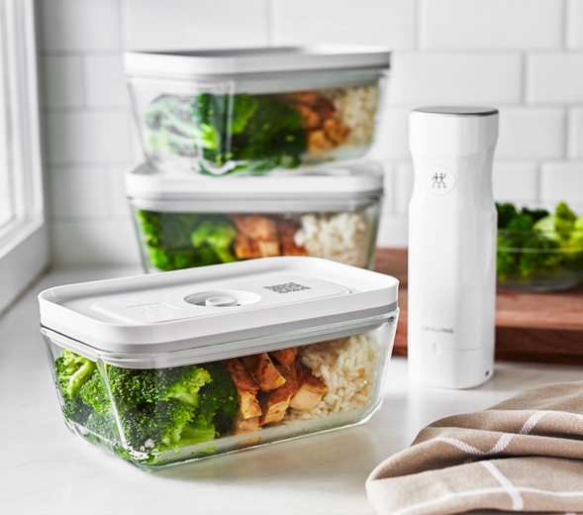

ZWILLING Fresh & Save Vacuum Food Pump, £69.95 and Glass Vacuum Boxes, from £9.95

2 Start Vacuum Sealing
This is where ZWILLING’s new Fresh & Save vacuum food storage solution can really help. The Vacuum Pump, Vacuum Boxes, Vacuum Bags and Vacuum Wine Sealer are all designed to help reduce food waste by vacuum sealing produce, meals and leftovers to preserve flavours and vitamins while keeping food fresh for up to five times longer. The vacuum sealed boxes and bags can be stored in the fridge, freezer or cupboard depending on their contents, and help make life easier and more convenient while reducing waste at the same time. Pre-prepared dishes can be re-heated and even placed straight into the oven up to 180°C {with lid removed} if using one of the glass Vacuum Boxes; lunches can be made the day before and kept overnight in the Vacuum Lunchbox with its separate compartments for sweet and savoury snacks and leftovers can be kept fresh with the shallow and easily stackable Fridge Box. Using the collection also helps reduce food packaging too, as loose items and ingredients can be purchased and stored in the Vacuum Boxes and Bags. Food stays fresh, it’s sustainable, saves time and money and reduces food waste. It’s a win: win all round.
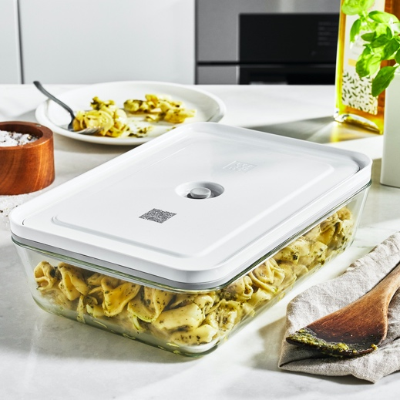

ZWILLING Fresh & Save Glass Vacuum Fridge Box, £24.95

3 Batch Cooking
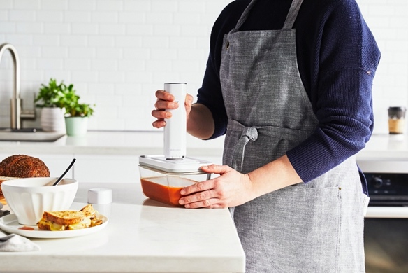
The next time cooking involves something like a soup, stew, pie, casserole, pasta dish or anything big and bulky, make more than is needed and save the rest for another day. By getting into the habit of batch cooking, it’s easy to make up days’ worth of meals in one go, which can then be vacuum sealed and stored in the fridge or freezer ready for re-heating another day. As well as savoury meals, batch baking can also be used for puddings, desserts and even biscuits, cakes and traybakes. To keep it all fresh, use the ZWILLING Fresh & Save wireless Vacuum Pump, which works by placing it on the valve of the Vacuum Box or Bag filled with batch cooked food then sucking out the air inside. It can be recharged using the included USB and it starts at the touch of a button; automatically stopping once the correct vacuum is achieved. It’s so simple to use, ultra-quiet and compact too. Perfect for keeping contents fresh ready for another day.

ZWILLING Fresh & Save Vacuum Food Pump, £69.95 and Medium Glass Vacuum Box, £14.95

4 Love Leftovers
Sometimes we cook too much and when it comes to dishing up meals, there’s a decent sized portion or two left over. Whatever you do, don’t throw it away. Pop the leftovers into a FRESH & SAVE Vacuum Box or Bag, suck the air out using the Vacuum Pump and hey presto, you have a delicious meal or snack that can be stored in the fridge or freezer for another day. Vacuum sealing not only keeps food fresh for up to five times longer, but it will also help to preserve food’s flavour, vitamins and nutrients. Perfect for pasta, soups and salads.

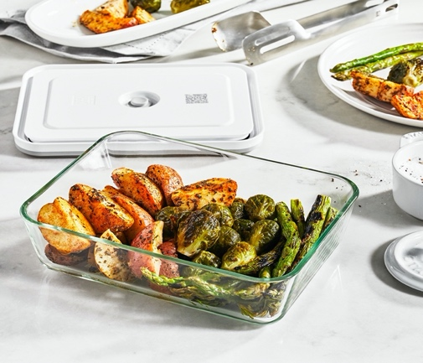

ZWILLING Fresh & Save Glass Vacuum Fridge Box, £29.95
5 Use an App
Now that we live in a world where pretty much everything is available via an app, use this technology to your advantage and download apps that can help reduce food waste. ZWILLING has developed its Culinary World app, which can be downloaded from the App Store and Google Play that is just the thing. Every FRESH & SAVE Vacuum Box and Bag features a QR code that scan be scanned with the Culinary World app. Once activated and with a few simple details keyed in, the app will remind cooks of the food’s extended shelf life date when the time comes, reducing food waste even further. The app also comes with additional features including shopping lists, recipes and more, so there are plenty of ways to be more conscious of what we are buying and throwing away.
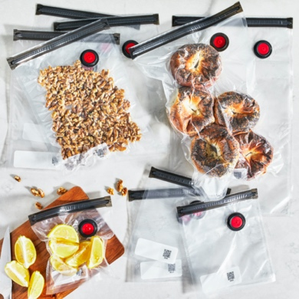

ZWILLING Fresh & Save Vacuum Bags, from £5.95 for 3 Large Bags

6 Get Organised
It may sound obvious but one of the main reasons we waste food is because we double up on buying items we already have at home. Take a weekend or a rainy afternoon and dedicate it to sorting out and organising the kitchen cupboards, fridge and freezer. Take all the contents out, check the ‘use by’ dates and place anything near it’s ‘best before’ date near the front so you can use it ahead of anything else. Make a list of everything you currently have and then stick it to the fridge or the inside of the cabinet door so that next time you’re making a shopping list, you know if you’ve run out of anything. By keeping ahead of store cupboard essentials as well as chilled and frozen items, you can start to rotate things that need using up and avoid buying things you don’t need.
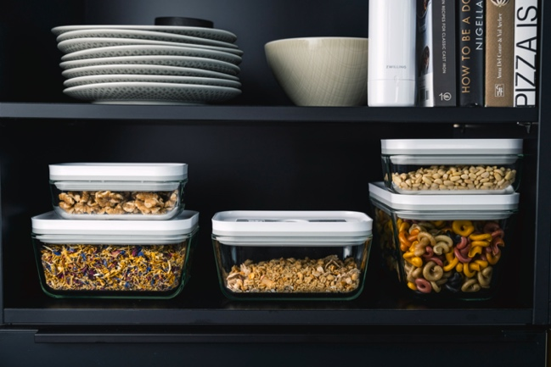

ZWILLING Fresh & Save Glass Vacuum Boxes, from £9.95
ENDS

ZWILLING FRESH & SAVE is available from https://uk.zwilling-shop.com #freshnessextended!

For more information, high res imagery or product loans for testing and photoshoots, please contact francesca@sellerspr.com | katherine@sellerspr.com or call 01962 977950

