KEEP FOOD FRESH FOR UP TO FIVE TIMES LONGER
WITH THE NEW FRESH & SAVE VACUUM FOOD STORAGE SOLUTION FROM ZWILLING

ZWILLING has a long history of championing perfect food preparation and culinary innovation, almost 300 years in fact, and with food waste at an all-time global high, this German company has taken the lead by launching a new FRESH & SAVE vacuum sealing system. Not only will this new collection of kitchen products help to reduce food waste by keeping food fresh for up to five times longer, but it will also preserve food’s flavours, nutrients and vitamins, locking the goodness in. What’s more, the FRESH & SAVE solution makes life simpler, as it is aimed at helping us to organise better, using up leftovers and re-heating pre-prepared meals, perfect for busy lifestyles and meals on the go. FRESH & SAVE keeps food fresh, saves time and money and tackles sustainability and wasteful packaging. It is so multifunctional that it’s set to become the ultimate food preservation solution for everyday meals and special occasions.

The new FRESH & SAVE collection comprises four food preservation products that are designed specifically to keep ingredients and meals fresh for longer, reduce food waste and make life simpler at the same time. All products feature a QR code for use with the ZWILLING Culinary World app {available to download from the App Store and Google Play}, which reminds the user of the food’s extended shelf life date. The compact Vacuum Pump along with Vacuum Boxes, Vacuum Bags and Vacuum Wine Sealer are all created by ZWILLING to offer the perfect solution to food waste and sustainability. Each product offers functional, timeless design with ZWILLING’s Double Sealing Technology and a 24-month guarantee. Customers can choose to buy products individually or in a set such as the Glass Starter Set, £89.95 which includes the Vacuum Pump, a large and medium Glass Container and four Vacuum Bags {two small and two medium}.
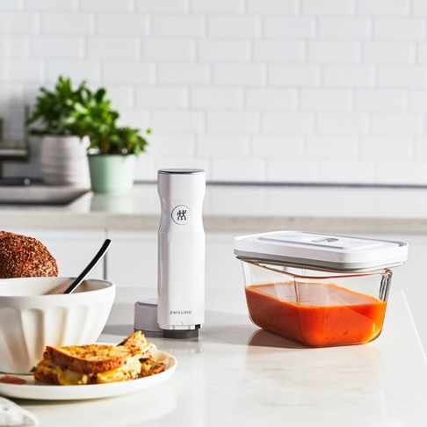

ZWILLING FRESH & SAVE Vacuum Food Pump, £69.95 and Medium Vacuum Box in Glass, £14.95
The sleek and wireless FRESH & SAVE Vacuum Pump is always ready to go as it doesn’t require complicated setting up and simply starts at the touch of a button then automatically stops once the correct vacuum is achieved. It only takes a few seconds to complete the vacuum process and it can be recharged using the USB cable included. It’s whisper-quiet, easy to use and ultra-convenient - perfect for everything from keeping ingredients and meals fresh to extending the life of fresh herbs.
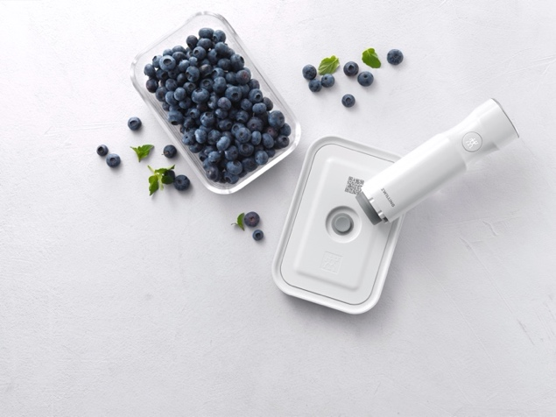

ZWILLING FRESH & SAVE Vacuum Food Pump, £69.95 and Small Vacuum Box in Glass, £9.95

ZWILLING’s FRESH & SAVE Vacuum Boxes are available in glass and plastic to suit your culinary needs. The cold and heat-resistant glass boxes come in small, medium and large sizes as well as a gratin dish and a flatter box ideal for cold meats and deli items. The glass vacuum boxes come with a BPA-free plastic lid with vacuum function, which keeps food fresh for up to five times longer, preserving food’s flavours, vitamins and nutrients. Use for leftovers and pre-prepared meals or to freeze raw produce without the risk of freezer burn. Suitable for use in ovens up to 180°C {with lid removed}, microwaves {with vacuum seal released} and dishwashers, the glass boxes can be stacked inside one another to save space after use.
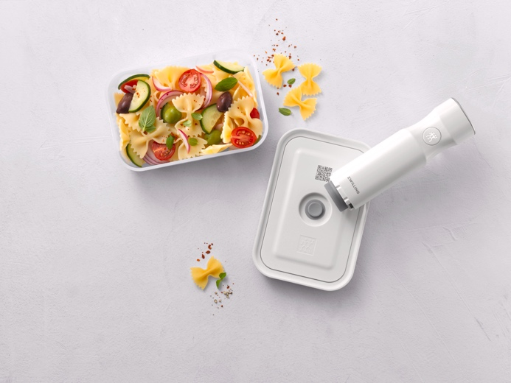

ZWILLING FRESH & SAVE Vacuum Food Pump, £69.95 and Large Vacuum Box in Plastic, £19.95
The ZWILLING FRESH & SAVE Vacuum Boxes also come in plastic, which are sturdy, lightweight and BPA-free. Just like the glass versions, the lids include a vacuum valve made of silicone and are available in small, medium and large sizes as well as a handy lunchbox. The plastic designs can also be stored in the fridge or freezer and are microwave {with vacuum seal released} and dishwasher-proof. As with the glass boxes, the plastic Vacuum Boxes feature a QR code on the lid for the ZWILLING Culinary World app. Once activated, the app reminds users of the food’s best before date.
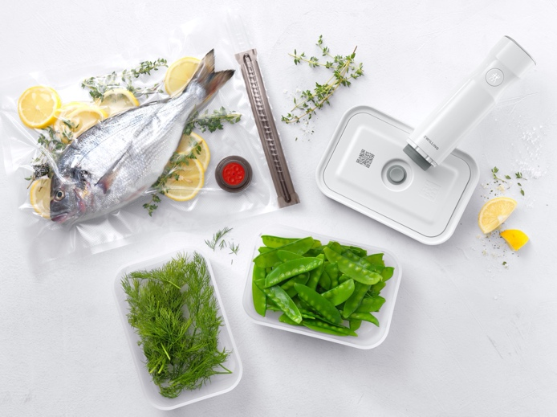

ZWILLING FRESH & SAVE Vacuum Box in Plastic, from £9.95

There are also BPA-free, reusable Vacuum Bags in the FRESH & SAVE range, which can be sealed securely and simply using the included zipper. Perfect for also marinating meat or fish as well as sous-vide cooking, there’s even a marinating aid that stops liquid from entering the pump. The Vacuum Bags are temperature resistant (-18˚C to +100˚C) and suitable for heating food in the microwave. The bags also feature the QR code for use with the ZWILLING Culinary World app, which reminds the user of the food’s best before date.
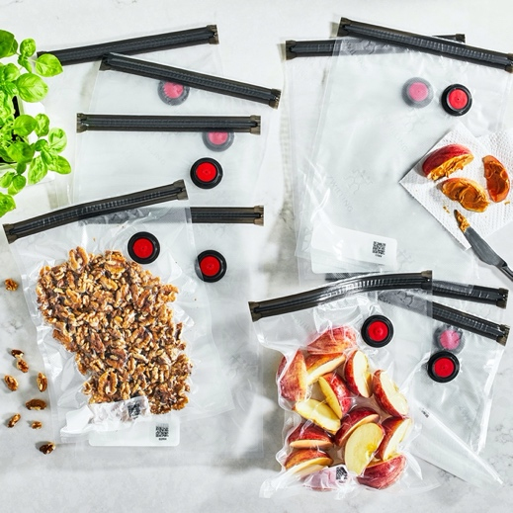

ZWILLING FRESH & SAVE Vacuum Bags, from £5.95 for X3 Large Bags
Last but by no means least, the new ZWILLING FRESH & SAVE collection also includes a dishwasher-proof Vacuum Wine Sealer. Use to keep wine and juices fresh and flavoursome for longer as well as locking the aroma in. You can also use it for oils and vinegars for cooking, too. Just take care not to use it for fizzy drinks; so if you happen to open that Champagne or Prosecco, you’re just going to have to drink it all!
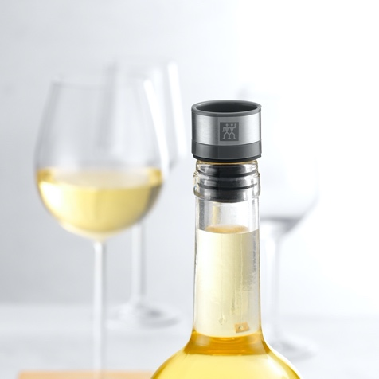

ZWILLING FRESH & SAVE Vacuum Wine Sealer, £4.95

Helping to reduce food waste even further, ZWILLING has also developed a useful Culinary World app, which gives users of its FRESH & SAVE products the ability to have a really good overview of their food storage with best before dates clearly visible. Simply scan the QR code on the Vacuum Bag or Vacuum Box lid with your smartphone or tablet and type in the contents of said bag or box. Select whether it’s going to be stored in the cupboard, fridge or freezer and the app will calculate the extended shelf life, reminding the user before the prepared meal or food expires. The app also includes a host of additional practical food features such as shopping lists, recipes and more.
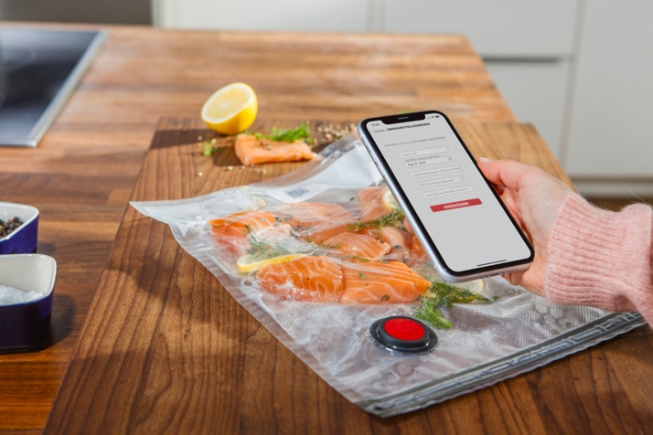

ENDS

ZWILLING FRESH & SAVE is available from https://uk.zwilling-shop.com #freshnessextended!

For more information, high res imagery or product loans for testing and photoshoots, please contact francesca@sellerspr.com | katherine@sellerspr.com or call 01962 977950

