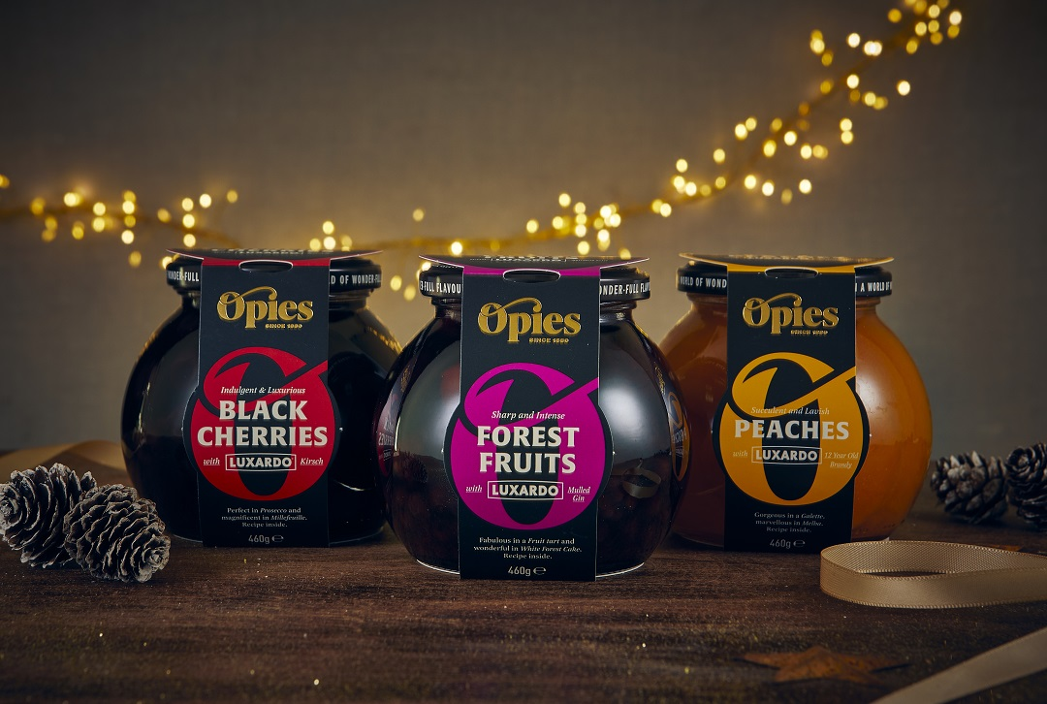

Opies Fruits with Alcohol: Chefs say they add a punch to simple puddings so could they become your festive food kitchen saviour that’ll cost less than a tenner?

- Opies Fruits with Alcohol are vital kitchen cupboard ingredients, which according to leading chefs, pack a punch in home styled puddings¹.
- NEW Opies Forest Fruits with Mulled Gin provides next-level flavour to meringues, roulades, sparkling cocktails and more. An abundance of forest fruits preserved in syrup flavoured with delicately spiced Mulled Gin.
- Inspirational on-pack recipes for flavour-filled puddings to make at home.
- The ideal Christmas gift solution: an attractive and affordable stocking filler gift, addition to a home-made hamper or a festive treat for hard-to-buy for family and friends who love food and love to cook.

Whether you’re a complete novice in the kitchen or your culinary efforts can rival those of a MasterChef champ, ingredients that easily transform home-styled dishes from zero to hero are surely an absolute must-have?

Opies collection of Fruits steeped in syrup infused with alcohol can single-handedly revolutionise your menu: changing the simple to the sublime and the mainstream to the moreish in minutes! Opies is working with internationally respected liqueur manufacturer and trader Luxardo®, whose legacy has been enjoyed by royalty and the world’s best bartenders. Their high-quality spirits have been impeccably paired to perfectly balance the soft, succulent fruits.

With a host of recipe ideas available on-line and on pack, these flavoursome treats can be used in recipes to replace canned or fresh fruits to significantly raise the flavour intensity of a favourite fruity dish. As they have incomparable quality, it’s easy to transform roulades, strudels, pavlovas – even cakes and tray bakes with a simple switch, or enjoy simply, with a good scoop of ice-cream or a generous glug of cream.

This precious Luxardo® syrup can be mixed with a little water to make boozy ice cubes for cocktails, warmed and combined with gelatine and champagne to create grown-up jellies or drizzled over meats to make an extraordinary glaze.

Not only is the collection ideal for an impromptu need to cater for unexpected guests they also offer the perfect gifting scenario and a welcome change from the more predictable bottle of wine or box of chocs. From teachers and neighbours to friends and family and even that last-minute overlooked gift.

Opies Fruits with Alcohol collection includes:
- Decadent whole Black Cherries steeped in syrup infused with Luxardo® Kirsch, ideal for the iconic Black Forest Gateau, but also surprisingly tasty accompaniment to goats’ cheese. Available from Sainsbury’s, Morrisons, Waitrose, Booths, Nisa, and high-quality independent retail stores. MRSP £7.50
- Succulent Peaches steeped in syrup infused with Luxardo® 12 Year Aged Brandy, ideal for Peach Melba or a lavish twist on a prawn salad. Available from Sainsbury’s, Morrisons, Waitrose, Booths, Nisa, and high-quality independent retail stores. MRSP £7.50
- New for 2023 Forest Fruits steeped in syrup infused with Luxardo® Mulled Gin. A fine mix of redcurrants, blackberries, blackcurrants and sour cherries. With a sharpness from the fruit balanced with the warming cinnamon, nutmeg, and notes of mulled gin, they are ideal in an Eton mess or to add intensity to fruit tart. Available from Sainsbury’s, Booths and high-quality independent retailers. MRSP £7.50
- Delightful Baby Pears steeped in syrup infused with Luxardo® Amaretto will add a twist to a traditional Tarte Tartin or dazzle in Chocolate Espresso Meringues. Available from Morrisons, Booths, Nisa and independent retail stores. MRSP £7.50
- Vibrant Pineapple steeped in syrup infused with Luxardo® Spiced Rum will boost Pineapple Upside Down cake and add a refreshing twist to Tiramisu. Available from independent retail stores. MRSP £7.50
- Rich and opulent Baby Figs steeped in syrup infused with Luxardo® 12-year aged brandy are fantastic in Figgy Pudding and tantalising in truffles. Available from independent retail stores. MRSP £7.50
The entire range can also be purchased online from www.bennettopie.com

ENDS
Notes:
¹ Article: Joy of Spring, Charlie Hibbert, Chef Director at Thyme Hotel – The Sunday Times 17.04.22
¹ Article: Nigella, Jamie & Mary cheat in the kitchen – you can too - The Times 13.10.22
Samples: available on request. Please get in touch.
High-Res Imagery (branded and unbranded options): https://www.dropbox.com/sh/c5awclv7wal0bdx/AADNo_-rirdpTlkMz3DkPrnTa?dl=0

