MEDIA INFORMATION
4th October 2019

THE TOWNIE PATH GO! 10D FROM ELECTRA
– For those looking to explore more, ride farther and climb hills faster –

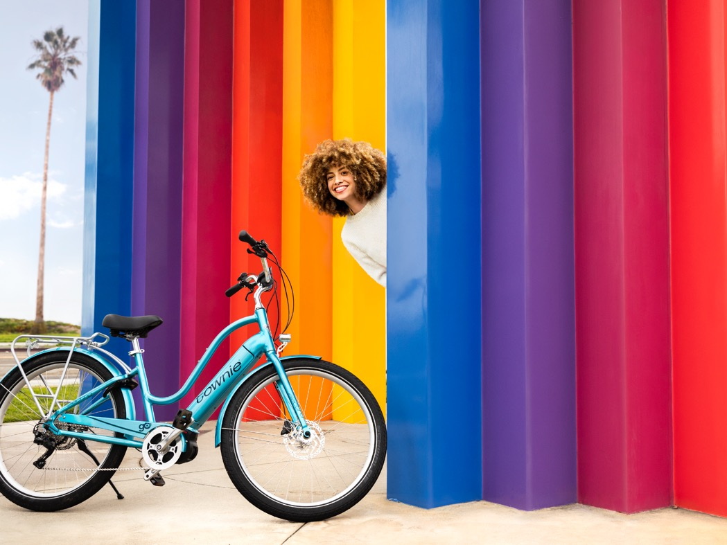

Leading lifestyle bicycle manufacturer Electra, launched a top-of-the-line ebike the Townie Path Go! 10D EQ, this ebike is geared up, dialled in and ready to explore. Boasting the latest Bosch systems technology and componentry The Townie Path Go! combines performance, advanced technology and Electra style for ultimate comfort and control.

The Townie Path Go! 10D EQ is designed for riders looking to explore more and have fun doing it. With its sleek design of an in-tube battery it’s the next evolution of premium ebike. While this is a more rugged bike, it's still a Townie making it comfortable and easy to ride. You want to find new roads and discover new paths. Roll wherever the road takes you with a 10-speed derailleur, powerful disc brakes and larger 27.5" tires, tackling terrain with better traction and control. The in-tube battery provides support when you need it with a range up to 65 miles. No doubt you'll be ready for any path you cross

Key features include a Bosch Performance Line motor, fully integrated PowerTube 500W battery and Bosch SmartphoneHub controller. A 10-speed derailleur provides a wide range of gears while Schwalbe Super Moto-X 27.5" puncture-resistant tires, powerful hydraulic disc brakes and a Townie comfort gel saddle guarantee a smooth ride on any terrain

- The Townie Path Go! 10D EQ features our patented Flat Foot Technology® and Bosch Performance Line motor for optimal comfort and control.
- Easily monitor detailed rider data in one place with the Bosch SmartphoneHub controller.
- Fully integrated battery on a step-thru frame.
- Equipped with front and rear lights, colour-matched fenders, ABUS frame lock and rear MIK compatible rack.
- Customize your ride by adding an Electra Ringer Bell or basket to carry your stuff.

Over the past 25 years the Electra brand and bikes have evolved, moving forward with technology and design. An exciting development for Electra is its line of ebikes – a movement that is here to stay. The ebike offers the perfect combination of technology and lifestyle, benefitting riders of all ages, genders and riding styles. Studies have shown that people who currently own ebikes are riding more often, meaning more time outside. People are riding three times farther than they would normally ride on their bikes and they safer on ebikes.
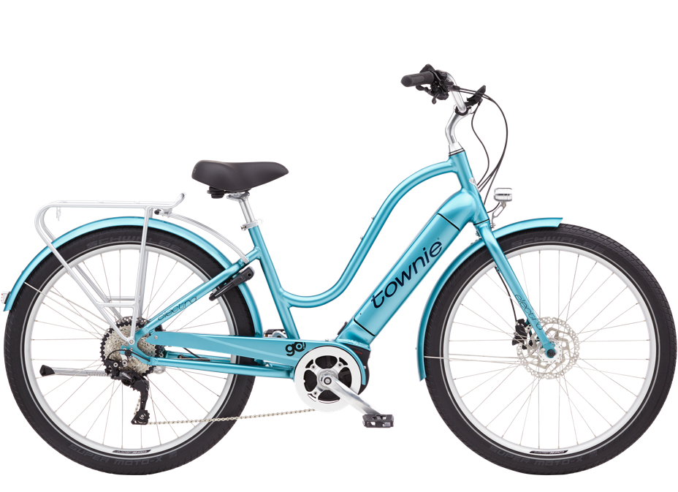

The Townie Path Go! retails for £2950.00 and comes in three sophisticated colours: Holographic, Aqua Metallic and Pearl White. For more information visit www.electrabike.com.

Way to roll…

Shop online https://www.trekbikes.com/gb/en_GB/bikes/electra-bikes/c/EB100/
Facebook: https://www.facebook.com/ElectraBicycleCompany
Instagram: https://instagram.com/electra_bicycle
Vimeo: https://vimeo.com/118342551

Ends
Editor’s Notes

Issued on behalf of Electra by In The Bag PR
For more information please see www.electrabike.com
For further information please contact; Sophie Kermani, Director – In The Bag PR
TEL: 07739554794 and EMAIL: sophie@inthebagpr.co.uk

Electra Bicycle Company is the leading lifestyle bicycle brand in the U.S. They make bikes to ride - not like 45 miles in tight shorts and clicky shoes ride - just ride. Everyone has a place to go and its way more fun on an Electra. The Southern California-based company boasts some of the most comfortable and beautiful bicycles on the market today, fuelling their growth throughout Europe, Asia Pacific and Latin America. Their accessories and signature bike collections – Loft™, Cruiser and Go! E-bikes - come in a variety of colour palettes and playful personalities for those ready to outrun boring. While Electra is serious about making bikes, they aren’t so serious about riding them, making them the official bike of nothing official.

Helen Guesford – UK
Marketing Manager UK
Trek | Electra | Bontrager
Trek Bicycle Corporation Ltd
TEL: +44 (0) 1908 360160
Helen_Guesford@trekbikes.com

