Eggsellent Easter Fun with Bluey

As seen on the hit show Bluey, fans can now buy the new Bluey Easter Basket, for some eggsellent Easter holiday fun – a perfect chocolate free Easter treat.
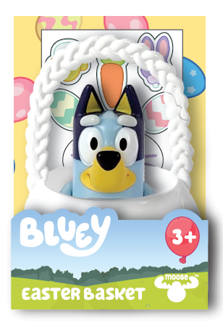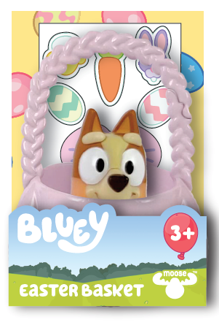

There are two baskets to choose from – one with a Bluey figure and one with her sister Bingo - so kiddos can recreate some of the happy holiday moments from Bluey, the hit global show loved by kids, parents, Hollywood stars and British celebrities.

The cute basket contains an adorable Easter themed sticker sheet, so kiddos can decorate their basket with colourful Easter bunnies, carrots, chicks and eggs.

For little kiddos on the go, the basket loop splits, so it can be easily attached to a backpack or bag so Bluey can come along too!

Price: Bluey Easter Basket £4.99
Age: 3-5yrs
Stockists: Smyths, Argos, The Entertainer and major supermarkets

Ends
For further information, please contact Playtime PR:
Chloe Bailey: chloe@playtimepr.com | 07970 649008
Chrissie Williams: chrissie@playtimepr.com | 07715 816363

About Bluey
Bluey follows a loveable, inexhaustible 6-year-old Blue Heeler pup, Bluey, who lives with her Mum, Dad and her 4-year-old little sister, Bingo. The series showcases the everyday events of family life – from going to a restaurant and visiting the hairdressers to catching the bus or having a playdate – and celebrates these moments, turning ordinary experiences into extraordinary imagination-packed adventures.

Bluey is produced by Ludo Studio for ABC KIDS (Australia) and co-commissioned by ABC Children’s and BBC Studios. Financed in association with Screen Australia, Bluey is proudly 100% created, written, animated, and post produced in Brisbane Queensland, Australia, with funding from the Queensland Government through Screen Queensland and the Australian Government.

About Moose Toys
Moose Toys exists to make children Superhappy, it’s at the heart of everything we do. The team has innovation in its DNA and is famous for the design, development and manufacture of award-winning toys that continue to disrupt the market! Moose Toys leads in categories including collectibles, craft, dolls, games and youth electronics and is consistently recognized as the most creative company in the industry. We are a family-run business, but that doesn't mean we are small-time. We shook up the toy industry in 2014 with the global phenomenon Shopkins, and through these pint-sized characters, we reinvigorated the way children play. Not satisfied to stop at toys, we have also stretched ourselves into creating content, entertainment and making worldwide licensing deals. Moose calls Australia home, but our 500-strong team is scattered globally, spreading the Superhappy.

