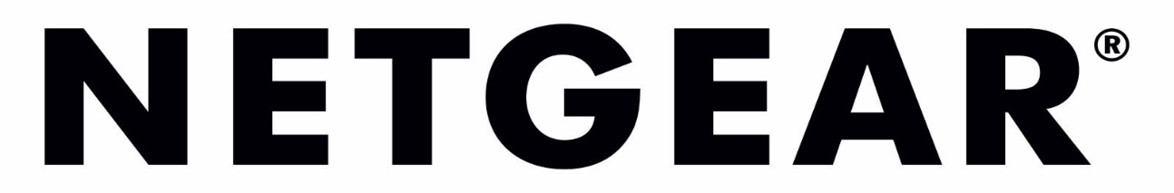
NETGEAR INTRODUCES WORLD’S FIRST WIFI 6E UNLOCKED 5G MOBILE HOTSPOT
New Nighthawk M6 Pro Mobile Hotspot Router Packs Maximum Speed, Capacity and Security into a Portable, Palm-sized Device

Bracknell, UK. - January 3rd, 2023 – NETGEAR®, Inc (NASDAQ: NTGR) the leading provider of award-winning connected products designed to simplify and improve people's lives, today raised the bar once again by supporting the new 6GHz band for client devices on its Nighthawk M6 mobile hotspot routers. The ultra-fast M6 Pro 5G WiFi 6E Hotspot Router (MR6450) supports 5G internet up to 4Gbps‡ and WiFi speeds up to 3.6Gbps∞.

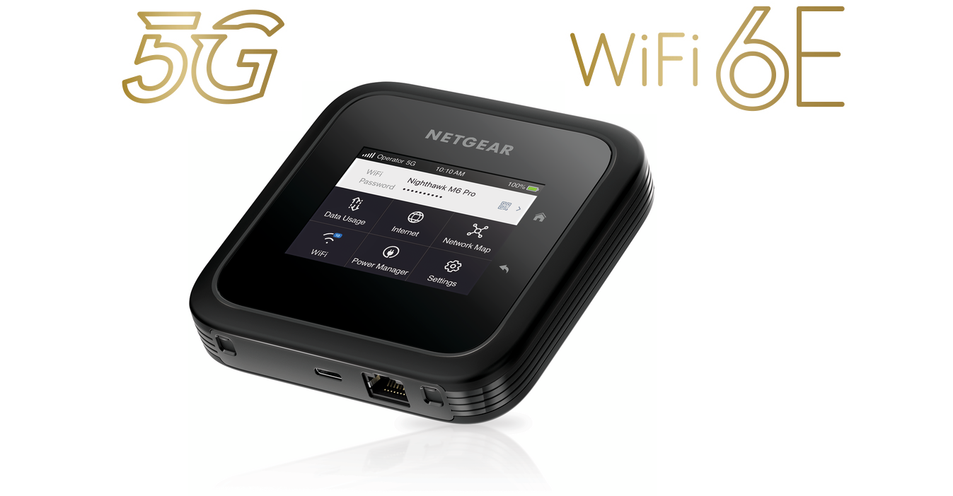
Evolving work and lifestyle changes have spurred the growing need for always-on, secure, high-speed internet connectivity for multiple connected devices anywhere and everywhere. On the road, traveling for business or pleasure, via commercial transport or in a car or RV, WiFi you can trust is imperative. Public WiFi, while convenient, is not secure and not worth risking a critical business transaction or personal bank transfer. The M6 Pro provides a portable, secure WiFi connection with a built-in firewall for up to 32 devices in any place that has cellular coverage. Travelers and/or mobile workforces can enjoy uninterrupted video streaming, Zoom calls, online games, social media updates and large file uploads/downloads, all at the same time without risk of intrusion. And worldwide roaming support¹ helps them stay connected no matter where they go.
Also ideal for home or vacation home use, the M6 Pro can boost WiFi coverage up to 1,000 square feet with In-Home Performance Mode, simply by removing the battery and using the power adapter. In larger homes, the hotspot can be used together with an existing WiFi router by plugging it into the 2.5 Gbps Ethernet port. For locations where cellular signal is not strong, external antennas (sold separately) can increase 5G reception when plugged into the M6 Pro’s antenna ports. The onboard USB-C port can be used to charge devices or as an ultra-fast wired connection, up to 5Gbps∞, to a computer or a laptop.
The Nighthawk M6 Pro combines the Qualcomm® Snapdragon™ SDX65 Mobile Platform with NETGEAR’s decades of networking technology expertise to deliver premium performance with groundbreaking speeds. It’s equipped with a long-lasting battery that powers up to 13 hours of work or play on a single charge*. The hotspot is unlocked and will work with major 5G/4G network operators’ SIM cards.
“No matter where you go, whether it’s for a quick business trip, extended holiday or a bit of both, the convenience and peace of mind of having a powerful, secure, personal network in your pocket can’t be overstated,” said David Henry, president & GM of Connected Home Products and Services at NETGEAR. “The M6 Pro combines the latest WiFi 6E and 5G technologies into a small, elegant form factor for ground-breaking, secure mobile WiFi and ultra-fast speeds. This is a complex feat of engineering only NETGEAR could achieve.”
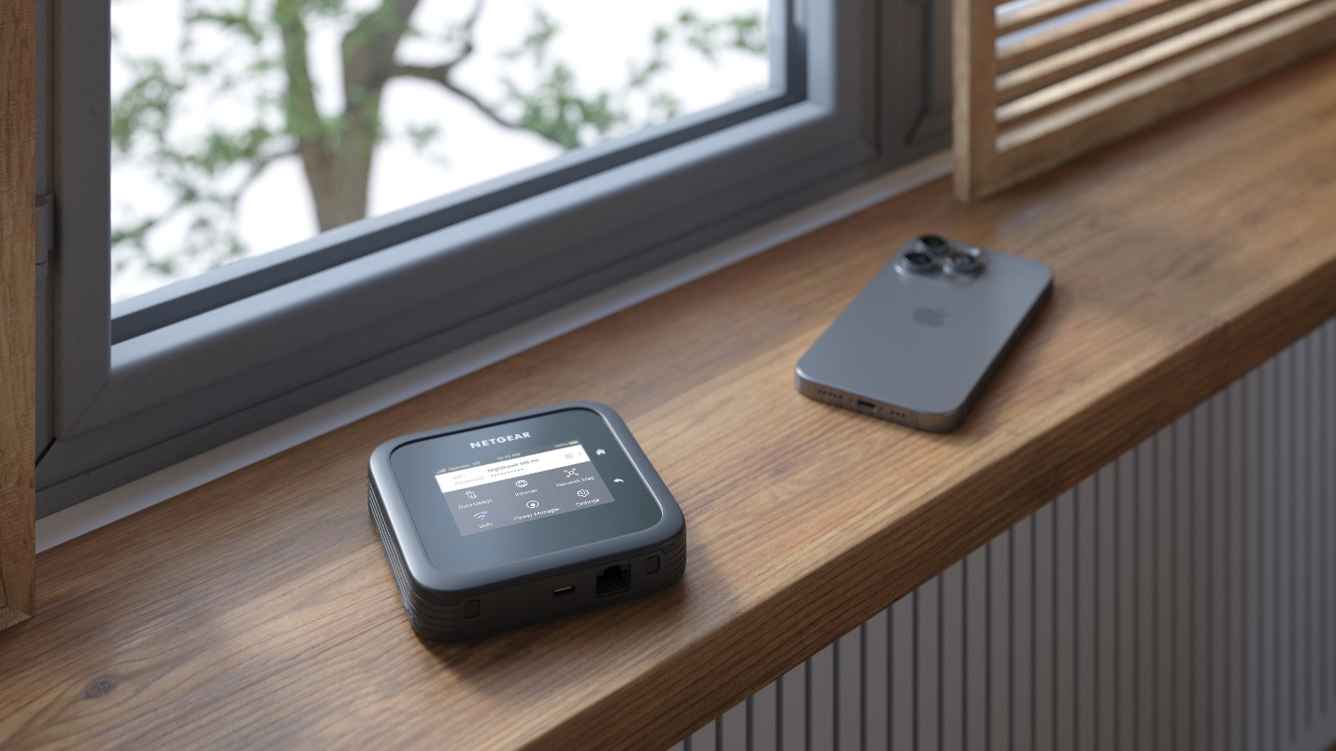
Technical Specifications:
- Next level 5G Performance: Strong, reliable, secure 5G internet with speeds up to 4Gbps. Perfect for work & play while travelling.
- Ultra-fast WiFi Speeds with WiFi 6E: WiFi speeds up to 3.6Gbps for up to 32 devices for fast downloads, gaming, & streaming.
- Powered by Qualcomm® Snapdragon® SDX65 Chipset: The advanced Qualcomm modem supports 5G’s Sub-6 band, delivering an arsenal of technologies and extreme power efficiency.
- Intuitive Touch Screen Interface: Set up, manage, share, & monitor WiFi easily on the 2.8" LCD touch screen.
- Secure and Reliable Network: Conserve mobile data and avoid dangers when connecting directly to public WiFi. The Nighthawk M6 provides a built-in firewall for a private WiFi connection with additional password security for the Web UI and LCD.
- Unlocked Potential: Accepts nano SIM cards from major 5G/4G network operators.
- In-Home Performance Mode: Boost WiFi coverage up to 1,000 sq. ft at home. Simply remove the battery & use the power adapter.
- USB-C port: Charge a device or access an ultra-fast wired connection up to 5Gbps.
- Mobile Accessories: Increase your 5G cell reception by connecting external 5G antennas (sold separately) to the available antenna ports.
- Powerful 5040mAh Battery: Stay connected longer. Battery lasts up to 13 hours on a single charge.
- HPUE Support: Enables better 5G range. Pick up a 5G signal at the outer edges of 5G coverage areas, even where other devices cannot.

The M6 Pro is easy to set up and use, and its compact design makes it easy to bring wherever a wireless connection is needed. It has an intuitive color touch screen to conveniently monitor data usage, view and change the WiFi name/password, check mobile signal strength, and manage network settings.
The M6 Pro Mobile Router (MR6450) is available now in UK from Netgear.com/uk.
MSRP: £899.99
About NETGEAR, Inc.
NETGEAR® (NASDAQ: NTGR) has pioneered advanced networking technologies for homes, businesses, and service providers around the world since 1996 and leads the industry with a broad range of award-winning products designed to simplify and improve people's lives. By enabling people to collaborate and connect to a world of information and entertainment, NETGEAR is dedicated to delivering innovative and advanced connected solutions ranging from mobile and cloud-based services for enhanced control and security, to smart networking products, video over Ethernet for Pro AV applications, easy-to-use WiFi solutions and performance gaming routers to enhance online game play. The company is headquartered out of San Jose, Calif. with offices located around the globe. More information is available from the NETGEAR Press Room or by calling (408) 907-8000. Connect with NETGEAR: Twitter, Facebook, Instagram and the NETGEAR blog at NETGEAR.com.

‡ This mobile router has a maximum 5G speed of up to 4Gbps. Actual speeds will depend on multiple factors including (but not limited to) your ISP supporting 5G Sub6 carrier aggregation, distance to your ISP’s 5G tower, network congestion, location of the mobile router at your premises, and any obstructions between the mobile router and your ISP’s 5G tower.
∞ Maximum wireless signal rate derived from IEEE 802.11 specifications. Actual data throughput and wireless coverage will vary and be lowered by network and environmental conditions, including network traffic volume, device limitations, and building construction. NETGEAR makes no representations or warranties about this product’s compatibility with future standards.
* Actual battery life will vary depending on network and environmental conditions, devices connected, content streamed, device settings, and aging of the battery.
† Battery must be removed and switched to “Best Performance and Range” profile.
1 Requires activated SIM with International roaming enabled.

Source: NETGEAR-G
UK Media Contact:
Zaboura Consultancy
Netgear@Zaboura.com
U.K. Sales Inquiries: UKsales@netgear.com

