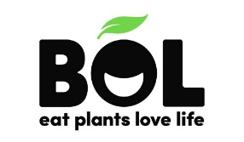
Chick’n Soup For the Soul…and Veganuary
BOL’s new plant-based soup uses Jackfruit, but tastes just like a traditional chicken soup
Taking part in Veganuary doesn’t have to mean that you miss out on your favourite comforting meals any more.
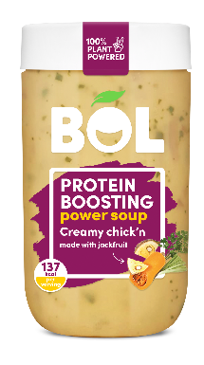
This January, BOL is introducing a world first plant-based creamy Chick’n Soup that still has all the warming flavours and comforting scents of the classic winter warmer, but with a sneaky plant-powered switch: we’ve swapped the chicken for tender, shredded jackfruit. But you won’t even notice because it tastes just like a traditional chicken soup.
More than just a winter warmer, this protein boosting Power Soup offers all the cosy flavours of your childhood favourite, but with 2 of your 5-a-day, and 13 grams of plant-powered protein. With our innovative addition of shredded jackfruit, alongside hearty potato, butternut squash, leeks, and cannellini beans, plus a classic mix of herbs, the creamy soup has all the hearty texture you’d expect, alongside fibre, magnesium, potassium and antioxidants aplenty.
After all, it wouldn’t be a power soup without some plant-power.
BOL also has a host of delicious new recipes to help you enjoy Veganuary, including Vanilla, Almond & Oats Power Shake: a nutritionally complete meal, bottled, and a Chickpea Masala Dinner Box which packs all the tastes of takeout but with 17 grams of protein, 17 grams of fibre and forkfuls of fresh, plant goodness.

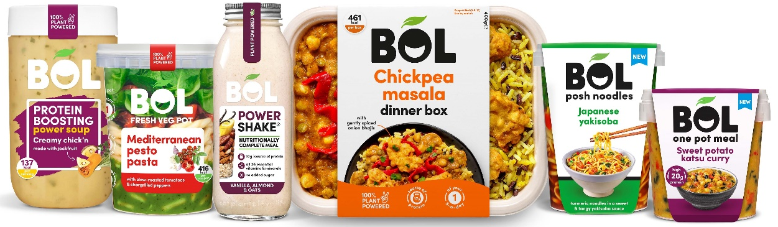
ENDS
For more info, a delivery of BOL to your doorstep, or any images, please get in touch with Clemmie at clemmie@anecdotepr.com
About BOL Foods BOL promises never to be boring, never to compromise on taste or quality and to always use business as a force for good. 100% plant based, our meals are completely natural, high in plant protein and contain up to 3 of your 5-a-day, as well as always being delicious and nutritious. BOL foods now has six product ranges: Veg Pots, Power Pots, Posh Noodles, Power Soups, Dinner Boxes, Centrepieces & sharing Bites and Salad Jars which are available nationwide. BOL has long focused on a triple-bottom line (people, planet, and profit) and as member of B-Corporation strongly believes in and practices business as a force for good.
www.bolfoods.com
Twitter: @BOLfoods
Instagram: @BOLfoods
Facebook: www.facebook.com/BOLfoods

