Clipper revitalises infusion range with NEW and improved functional flavours
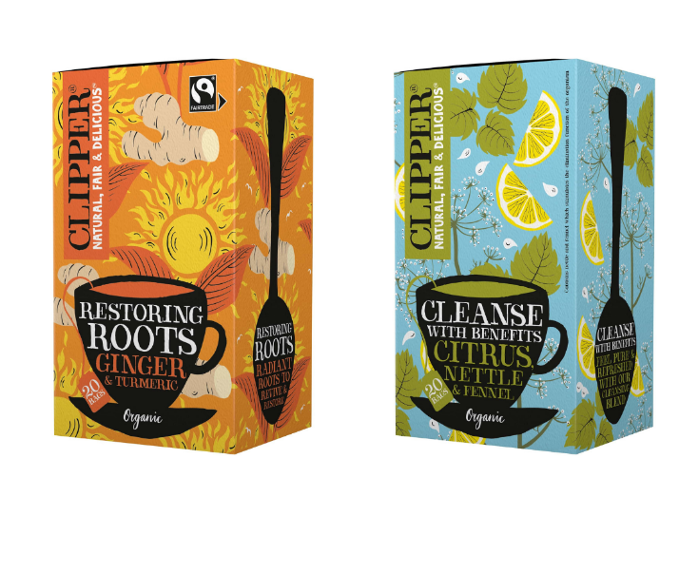
Clipper Teas, the natural, fair and delicious tea brand owned by Ecotone UK, has expanded its range of organic infusions with three exciting new flavour variants to support consumer lifestyle needs.
The new functional teas include:
- Organic Cleanse with Benefits – an infusion of fresh citrus with sweet anise-inspired fennel
- Organic & Fairtrade Restoring Roots – an infusion of spicy ginger and warm turmeric
The new flavours each offer a careful blend of natural ingredients designed to either revive, restore or cleanse. Carrying Clipper’s distinctive and joyful tone of voice, the pack designs feature vibrant, playful illustrations and bright colours to stand out to the growing audience of functional tea drinkers.
Coinciding with the new flavours, Clipper has also revamped its recipe and pack design for its popular infusions Organic Snore & Peace (chamomile, lemon balm & lavender infusion) and Organic After Dinner Mints (mint & fennel infusion) to bolster consumer appeal and visibility on shelf.
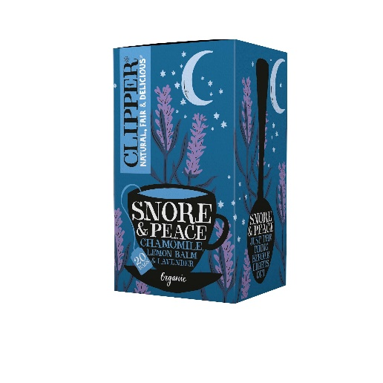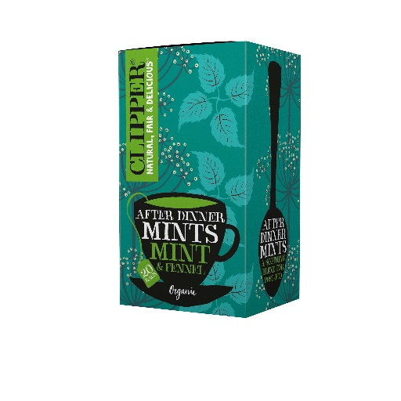
Clipper Organic Restoring Roots and revamped Clipper Organic After Dinner Mints, will bolster Clipper’s infusion offering at the key retailer. The full infusions range will be available via clipper-teas.com.
Aligned with the brand’s organic principles, each tea bag in the infusions range is unbleached, plant-based and non-GM – offering up a natural, fair and delicious cup of tea that ethical shoppers can feel good about.
Clipper Teas, along with its parent company Ecotone UK, is B Corp certified. Committed to supporting biodiversity, Clipper sources its tea from organic and Fairtrade farmers that use sustainable farming methods.

ENDS
For more information please contact:
Emily Baker: emily@highlightpr.co.uk.

About Clipper Teas
Clipper is a different kind of tea company and a pioneer in ethical, sustainable tea production since 1984.
B Corp certified, Clipper targets conscious consumers who care about what they put into their bodies and the impact this has on the world around them – a consumer tribe the brand refers to as Generation Tea.
In 1994, it became the UK’s first Fairtrade tea company. Today, it is the world’s largest Fairtrade tea brand, supporting 114,000 producers and their families around the world. In the last 25 years, Clipper has paid over £4m in Fairtrade premiums, ensuring its tea workers always get a fair deal and supporting them to use sustainable farming methods.
Part of the Ecotone UK family, Clipper’s tea factory in Beaminster produces over 1 billion tea bags a year, which are sold in over 50 countries worldwide. Committed to organic and ethical sourcing, Clipper only ever uses natural ingredients and processes to make the finest quality hot beverages.
In 2018, Clipper became the first tea company to make all its heat-sealed tea bags unbleached, non-GM and fully-biodegradable. Clipper’s factory is carbon neutral, uses renewable energy sources and 98% of factory waste is recycled.
Natural, fair and delicious. That’s the Clipper difference.
Twitter, Facebook and Instagram

About Ecotone UK

Ecotone UK (formerly Wessanen UK) is a natural and organic food company, with pioneering food brands in expanding market segments, including:
- The UK’s first Fairtrade tea company, Clipper Teas, which makes natural, fair and delicious hot beverages and created the world’s first fully biodegradable, non-GM and unbleached tea bag;
- Whole Earth, the UK’s no.1 peanut butter brand and manufacturer of natural and organic spreads, cereals and drinks, and
- Kallø makes market-leading, organic rice, corn and veggie cakes, as well as the UK’s fastest-growing range of stocks and gravies;
- Mrs Crimble’s, the gloriously gluten-free cake brand that makes delicious baked goods for all to enjoy.

Ecotone UK has been B Corp certified since 2018 and champions its mission, ‘Food for Biodiversity’, through a commitment to protecting the living planet for current and future generations. It is focused on providing food that is good for people and the planet and conducts its business in a sustainable way.
These principles are channelled through its involvement with its subsidiaries, and the brand is accredited by or a member of a range of industry bodies and associations including; B Corp, Fairtrade Foundation; Soil Association; UK Tea & Infusions Association, and the Organic Trade Board.

Twitter, Facebook and LinkedIn

