Tap To Tidy Like Stacey Solomon With Cricut
No trend is rising higher than home organisation – and now celebrities such as Stacey Solomon are regularly taking to Instagram to showcase their freshly organised, labelled, and personalised containers.

Stacey has become renowned for her Tap To Tidy features, which showcase a messy space becoming expertly organised, and something which many of us are now copying on our own grids.

Now, people can Tap To Tidy in their own homes with Cricut. Cricut are the leaders in smart cutting machines that can be used to re-create Stacey’s gorgeously organised home look.

Amongst a whole host of things, Cricut can be used to easily make quirky designs and labels to add to any household item and help you to get organised and Tap To Tidy!

Just look at how these examples from the Cricut crafting community, alongside Stacey’s own organising, show how the Cricut machines can easily recreate this popular trend!

Labelling with the Cricut Joy

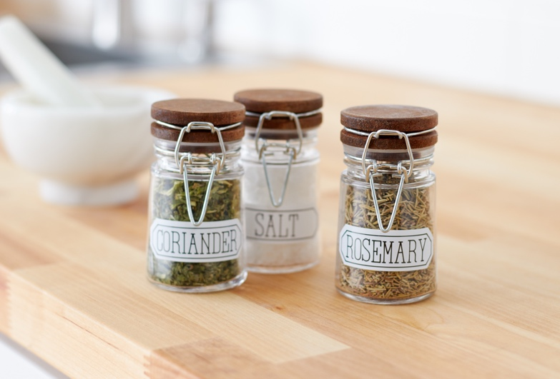
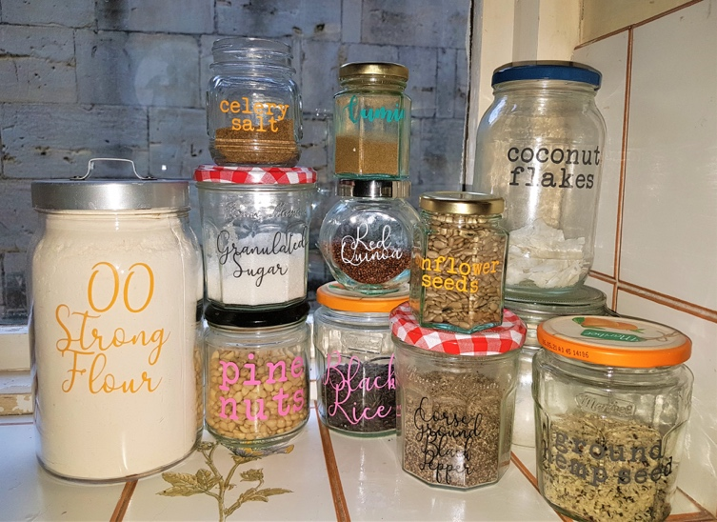

Stacey Solomon’s home labelling
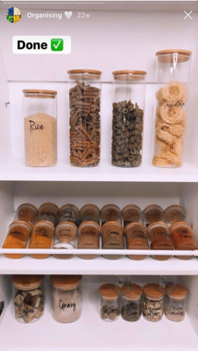
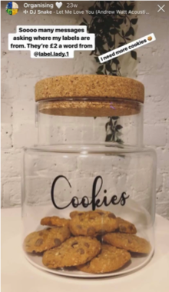
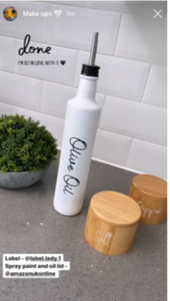

Cricut has recently launched its new Cricut Joy – its most portable machine to date, perfect for customising the home in the ways seen above. Cricut Joy is available from Hobbycraft, Amazon, John Lewis, Littlewoods, Very and independent retailers and has an RRP of £179.

Meet The Whole Range;
- Cricut Joy™ – RRP £179.99 – Cricut’s newest and most portable cutting machine to date, making it faster and easier to get started with your personalisation, customisation and organisation
- Cricut Explore Air™ 2 - £259.99 – Big value, big results. Cricut’s Explore Air 2 is perfect for the hobbyist crafter looking to experiment with more complex designs
- Cricut Maker™ - £379.99 – The ultimate smart cutting machine. The Cricut Maker can quickly and accurately cut 300+ materials and offers the widest range of tools

As well as some of the latest creations and designs from the craft world, and exceptional imagery, Cricut can share a host of assets with you including;

- Trends, comment and inspiration
- Projects your readers can try at home
- Case studies from our amazing, varied and inspiring Cricut community

- Ends -

Cricut make smart cutting craft machines, and help people lead creative lives by providing tools to make their do-it-yourself projects beautiful, fun, and easy.

For further information or Cricut review enquiries, please contact khodson@cricut.com

Cricut Website - https://www.cricut.com/
Cricut Facebook - https://www.facebook.com/OfficialCricut
Cricut Instagram - https://www.instagram.com/officialcricut_uk/?hl=en

