SCAN THIS QR CODE FOR VIDEOS ON HOW TO PLAY

Got2Glow Fairy Finder, £39.99rrp
Catch the magic glow! Kids will love finding over 100 fairy friends with the Got2Glow Fairy Finder!

Fairies can be found anywhere and everywhere... it's just a matter of where you look! Kids can find fairies in their bedrooms, in the dark, outdoors, and even upside down - there will always be a fairy around! Bond with your virtual fairies by saying hello, playing a game, giving them hugs and feeding them.

The magic of catching fairies has never been so attainable, simply open the heart shaped lid on your Fairy Finder and watch in awe as a fairy light show is activated and a virtual fairy finds its home inside. Close the lid and they'll be your Fairy Friend Forever!

There are over 30 unique fairies to find with each jar. Share fairies with your friends to collect over 100 fairies in all, including ultra-rare fairies and upside-down fairies.

Which fairies will fly into your jar? With so many fairies to discover, your days will fly by trying to catch them all! Increase your chances of collecting ultra-rare fairies by playing games and bringing your jar to new locations! The more you play, the more fairies you’ll catch!

You can also share fairies with friends! The Got2Glow Fairy Finder is equipped with a light sensor, microphone, speaker, LCD screen, plus a handle so you can catch the magic glow wherever you go!

- Discover your fairies’ unique appearance in the Find My Fairy app
- Look after your fairies as you feed and play with them, the more you play the more fairies you'll catch

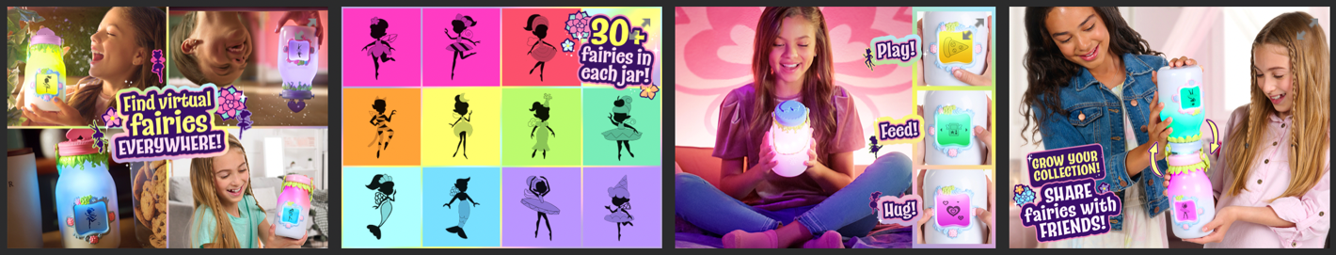

Website and social media:
Brand site: https://wowwee.com/got2glow-fairy-finder
Brand Instagram: @got2glowfairies
Brand TikTok: @got2glowfairies
Hashtags: #got2glow #got2glowfairies

Retailers: @ entertainer_toys (available now) – from 2nd March: @smythstoys and all other toy retailers

