RUSSELL HOBBS’ BRAND-NEW ATTENTIV RANGE PUTS YOU IN FULL CONTROL
The stylish new range boasts a variable temperature kettle, coffee maker and 2-slice Colour Sense Technology toaster
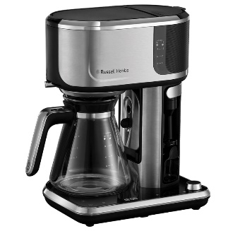
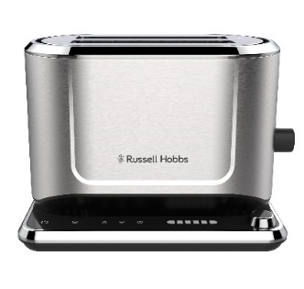
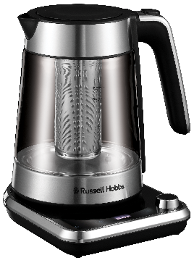

Russell Hobbs, a leading name in UK household brands, has unveiled its brand-new Attentiv collection for 2022. The range, available in major retailers across the UK, includes a high-tech 2-slice toaster, a 1.7L kettle and a coffee maker – all available in a sleek stainless-steel design to fit seamlessly into any kitchen.
The Attentiv Kettle’s variable temperature feature allows you to set your kettle at various increments between 40°C and 100°C. As well as boiling to your desired temperature, this handy detail also means you can enjoy a speciality tea without ruining its delicate flavours. Even better, the Attentiv Kettle has a removable tea infuser basket, perfect for loose leaf teas, and ideal if you do not have a teapot to hand.
The kettle’s touch screen interface is equally user-friendly. In a few taps, you can set the Attentiv Kettle to make your perfect hot drink, and it does not stop there. This innovative new kettle can save and memorise your last temperature setting so your perfect brew can be made at the tap of a button!
In addition, the Attentiv Kettle has been designed with a ‘Keep Warm’ timer for your busier days. Even if the phone rings just as the kettle has boiled, your water will still be ready and waiting for you afterwards, staying warm for up to 30 minutes. With rising costs and the current energy crisis this kettle can come in handy in a pinch saving up to, 63% energy* due to its generous 1.7L capacity.
The Attentiv range also boasts a 2-slice toaster, which features colour sense technology to automatically adapt the toasting time to your bread type, stopping the toasting cycle when the correct shade has been achieved. All you need to do is choose your preferred browning level and let burnt toast become a thing of the past.
Plus, the Attentiv Toaster remembers the settings used last, even after it has been unplugged. So, whether you love sourdough, bagels, or day-old white bread, this toaster will get the shade of golden perfection just the way you like it. The Attentiv toaster also features longer and wider slots to fit a whole range of different breads and sizes, putting an end to half toasted slices!
With a touch screen interface and frozen, reheat and cancel functions, this user-friendly toaster offers complete control for all your toasting needs.
The Attentiv Coffee Maker is the ultimate multi-talented addition to your kitchen collection. Not only can it create barista styled lattes and cappuccinos, the Attentiv Coffee Maker has a cold brew function, perfect for iced coffee lovers, and those partial to an espresso martini or two. This barista-style appliance features an array of settings to give you the power to personalise each drink your way with handy strength and cup size settings – whether you’re just fancying a quick cup of coffee, or want to fill a thermos, it will make just the right amount for you.
The Attentiv Coffee Maker features a Milk Frother, helping you to achieve perfect milky coffees every time. Plus, with an easy to clean touch-screen control, you’re only a few taps away from making your perfect coffee, and it will remember your preferences for next time too.
Cira Jones, Assistant Brand Manager at Russell Hobbs, comments: “The new Attentiv range has been designed with personalisation in mind, to make breakfast time just right for everyone. Everyone has a personal preference on the perfect slice of toast along with the ultimate cuppa or coffee, and this range makes life that extra bit easier with its high-tech features. This is one of our most advanced kettle, coffee maker, and toaster sets ever produced and we’re confident customers will love it.”
The Attentiv range is available to buy from major UK retailers and uk.russellhobbs.com For further information, please visit uk.russellhobbs.com.
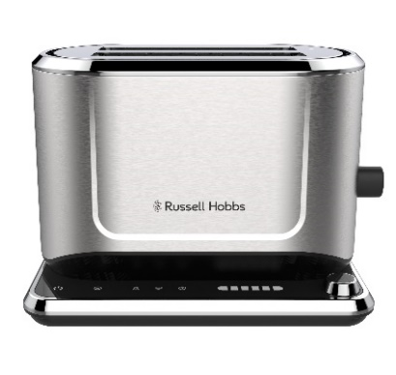

Russell Hobbs Attentiv Kettle, RRP: £69.99 Russell Hobbs Attentiv Toaster, RRP: £79.99
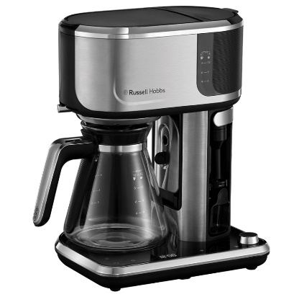

Russell Hobbs Attentiv Coffee Maker, RRP: £119.99

ENDS
Notes to Editors
For more information, please contact russellhobbs@hatchpr.co.uk
Claim Substantiation
*Boiling 1 cup (236ml) vs 1 litre.
Attentiv Kettle Product Features
- Variable temperature
- Removable Infuser basket
- Touch control
- Steep timer
- Favourites memorised
- Keep warm timer
- Push to open lid
- Anti-scale filter
- 360° base with cord storage – left or right-handed users
- Perfect pour (no drips)
- Boils one cup in under 46 seconds
- 1.7l capacity
- Save up to 63% energy*

Attentiv Toaster Product Features
- Touch control
- Colour Sense technology
- Traditional mode
- Favourites memorised
- High lift
- Long and wide slots
- Frozen, Reheat and Cancel functions
- Bun warmer
- Deep crumb tray

Attentiv Coffee Maker Product Features
- Strength and size personalised
- Milk frother
- Touch control
- Cold brew
- Favourites memorised
- Measured volumes
- Integrated coffee spoon
- Fold down stand for smaller cups
- Pause feature
- 24-hour timer
- Keep Warm function

About Russell Hobbs
Every ingenious Russell Hobbs creation is here to help you do you. That’s because we’re inspired by the things that matter to you.
Just-in-time brews. Tackling creases on your own terms. Giving new recipes a go. We get what’s important, especially when life’s hectic and, let’s face it, far from perfect. That’s why our ideas are beautifully British and ready for living.

