'Uplift 2.0' The New Progressive Design Tackling Mental Health and Waste Fishing Nets
Good for our minds, good for our planet

July 2020 - Award-winning British designer Tom Lawton launches Uplift 2.0 - a solar powered spiralling kinetic sculpture made from recycled fishing nets.

A mesmerising, spiralling sculpture, Uplift 2.0 is powered by the sun and gently revolves, creating a visually soothing motion designed to help you relax. The progressive new design uses 100% waste fishing nets from the Cornish Hake Fisheries to form the spiral’s structure, which in turn gives it it’s stunning translucent aquamarine colour.

“Uplift 2.0 sits on your window sill gently revolving. Its relaxing motion creates a never-ending spiral that's simply hypnotic to watch. It helps the mind unwind as it as it forever flows.” Lawton comments.
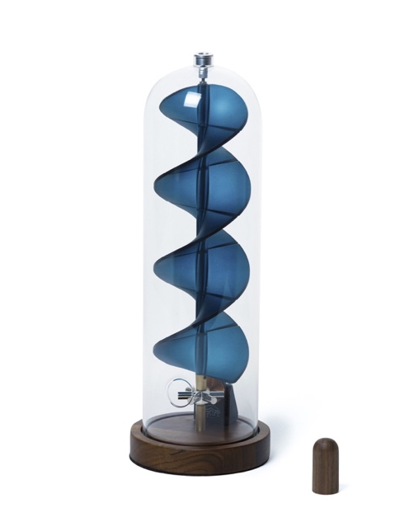
Working with Fishy Filaments, an award-winning waste processing start-up based in in Newlyn, Cornwall and a family-run artisan manufacturer, Plastic-IT in Shropshire, Lawton has been able to successfully manufacture the design using 100% recycled fishing nets. Following a series of industrial processes, the result is a highly refined design that looks and feels like glass.
"But it's not just good for your mind, it's good for the planet too.” Lawton continues. “I wanted to make Uplift 2.0 in a beautiful aquamarine colour, translucent like ocean waves, so I turned to the coast in search of inspiration. There I found the same problem we are all staring at, but rather than feel despair I saw incredible potential in the marine plastic that littered the beach."

One waste fishing net allows Lawton to make roughly 70 Uplift 2.0s. With 1,000 pre-orders already taken, Lawton is using 100kg of recycled material in his initial batch, the equivalent of fifteen fishing nets. This is a significant amount of waste fishing net being recycled off the Cornish coast and prevented from going to landfill, or worse still, left in the ocean.

For every Uplift 2.0 sold on beuplifted.co.uk, £10 will be donated to The Sea Sanctuary - a unique mental health and wellbeing charity rooted in the concept of ‘blue health’. Its programmes rely on the environment and use techniques thought to be the first of their kind in the world. They use a combination of sail training, marine activities and evidence-based therapies to help children and adults who are struggling with issues such as stress, anxiety, depression, and a whole range of mental and emotional health problems.

Uplift 2.0 is designed, manufactured and assembled by hand in England. It’s available for pre-order now from https://beuplifted.co.uk with delivery from September 2020. RRP: £185.
-ENDS-
Boiler Plate
Welcome to Uplifting Products. We’re new on the scene, inventing uplifting products designed to make you smile. With an award-winning British Inventor at the helm, we lift spirits and provide moments of calm in an otherwise chaotic world. Tom Lawton, co-founder of Uplifting Products is the epitome of the great British inventor and is possibly Britain's loveliest one too. Concerned about the environmental crisis and passionate about doing something positive about it, Tom looks for long-lasting solutions to some of life’s problems.
Press Office
LFPR
Lydia Ford | Lydia@lydiafordpr.com | 07801802014
More information and interviews are available on request. High resolution images, logo and video can be found http://bit.ly/UPLIFT2PRESSFOLDER
Social Media

Follow Tom’s journey for uplifting products on social media:
Instagram: https://www.instagram.com/tomlawton/
Twitter: https://twitter.com/tomlawton

Uplift Celebrity Testimonials

"Wowzer, Tom Has done it again. Uplift 2.0 captures the essence of the regenerative future; she runs on sunlight, turns waste material into timeless art, and calms the spirit as she spins. Just beautiful!" - Kate Raworth, Renegade Economist

"I love it. Such a beautiful thing" - Matt Haig, Author

"I love this. A happy, dreamy, solar sculpture" - Derren Brown, Mentalist

"Uplift is so hypnotic. I could watch it forever" - Jamie Oliver, Chef

"The infinite movement of the Fibonacci spiral in the beautiful and calming sculpture Uplift always connects me to my true potential and source. I'm so grateful for my Uplift and I enjoy it everyday!" - Gordana Biernat @mypowertalk

Notes to Editors

Tom Lawton - British Inventor
Tom Lawton is an award-winning British Designer based in Wiltshire. Tom was the winner of the Green Dot Award (2009) and Sustainable Design Award (2010). Tom was the star of C4 series 'Tom's Fantastic Floating Home' in 2013. His previous inventions include Million Mile Light, BubbleScope, Firewinder, WakeYoo and Honkies. Tom Lawton founded Uplifting products in 2019 as part of his mission to lift the spirits of a stressed out world. For Tom’s full bio, visit: www.tomlawton.com

Uplift 2.0 Technical Specifications
- Product Diameter: 11cm | Product Height: 30cm | Overall weight: 900g
- Power: 100% Solar Powered Engine
- Included in the box: Base, Spiral, Dome and Magnetic Wand
- Recyclable Materials: Walnut (base), Mild Steel (mechanism), Waste Fishing Net Nylon (spiral), Borosilicate Glass (dome)
- Each unit is shipped in recycled gift packaging

The Sea Sanctuary - Waterside Court, Falmouth Road, Penryn, Cornwall TR10 8AW
The Sea Sanctuary takes therapy out of the office and onto the water – it’s a recipe that has helped hundreds of people improve their mental and emotional wellbeing since the charity was launched in 2006.
https://seasanctuary.org.uk

Uplift 2.0 Kickstarter campaign
Uplift 2.0 raised £25,000 within 48 hours as part of a Kickstarter campaign which went live on 26th November 2019. The campaign ran until 31st December 2020 and has now raised £76,739.00.
https://www.kickstarter.com/projects/millionmilelight/uplift-20-unwinding-spiral-sculpture-to-soothe-the-soul
Uplift 1.0
Uplift 1.0 was designed and manufactured in 2018, selling 440 units as part of a limited design run. Lawton has made a few key improvements that take Uplift 1.0 from being an object d'art to becoming the classic design piece that is Uplift 2.0.

