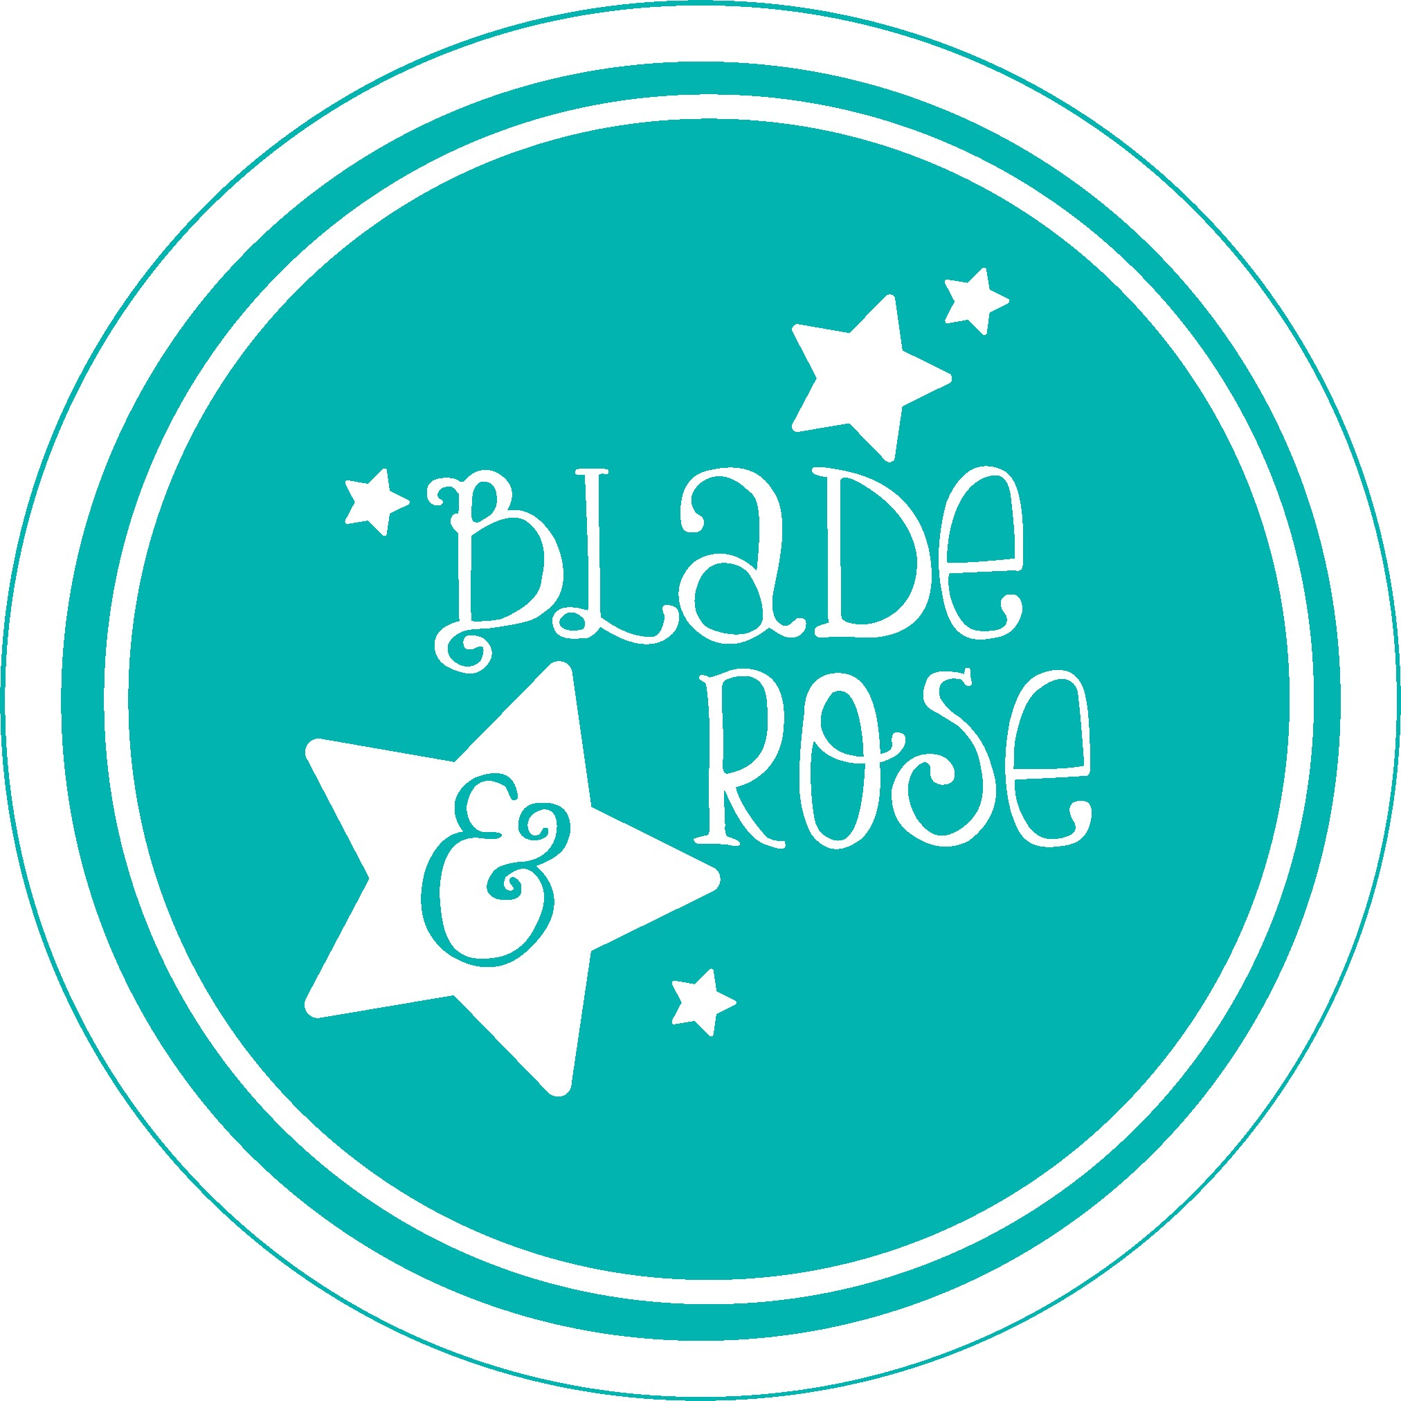

With an estimated 1.4 million UK households now keeping hens, Stella the Hen is sure to be a popular addition to the award-winning Blade and Rose Collection.
These cute leggings have a folksy look and feel with the dark blue background and white floral wallpaper pattern design. A cheerful bright sky blue beautifully highlights, Stella, our lovely dark blue and white striped hen with a glorious red tail and comb, this colour palette is repeated on the matching socks. The signature Blade and Rose branding appears on the waist band of the leggings and the cuff of the socks. The star of this collection is the bright red long-sleeved top, the attention to detail on not one, but two embroidered hens elevate this gorgeous gift. With embroidered flowers, leaves, beak, and feet, also with folksy undertones, this is one collection we know will be here for years to come. Available in sizes 0m – 4 yrs.
Blade and Rose are owned by husband and wife, Amanda, and Jon Peffer, they founded the company in 2010. Their design and distribution centre are based in their hometown of Kendal in the Lake District. At the heart of Blade and Rose are their eco and sustainable ethics. They ensure all their products comply with Oeko-Tex Standard 100, and all their suppliers are SGS or BSCI compliant which ensures that global cotton production is better for the people who produce it and better for the environment it grows in, ensuring the softest and safest fabrics for the consumer. Any plastic they use is recycled and recyclable.

For further information please contact helencottrill@bladeandrose.co.uk

