Men’s underwear brand JustWears ‘take care of where it all began’ this Father’s Day

Designed for comfort not clamminess

- Ideal for the eco-conscious dads: Co2 neutral and biodegradable
- Like a second skin - five times softer than cotton
- Available from as little as £12.48 per pair at just-wears.com

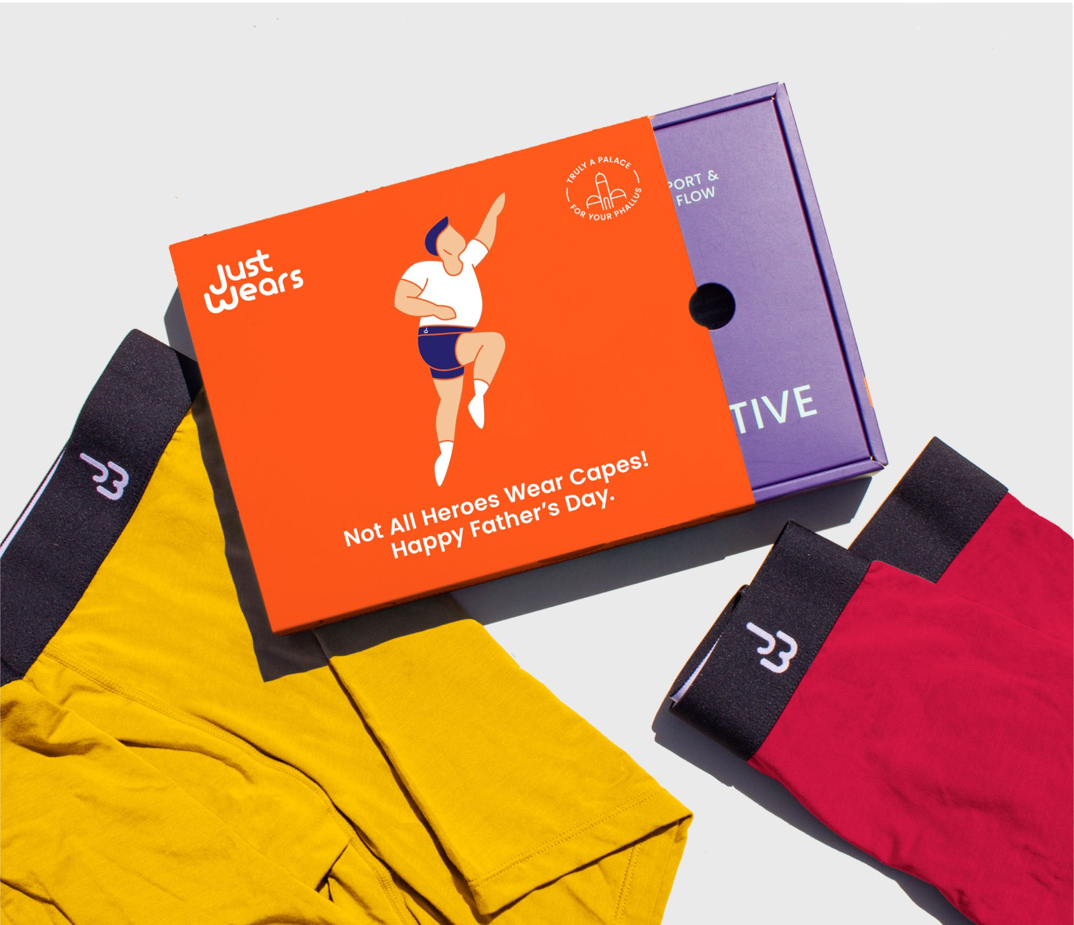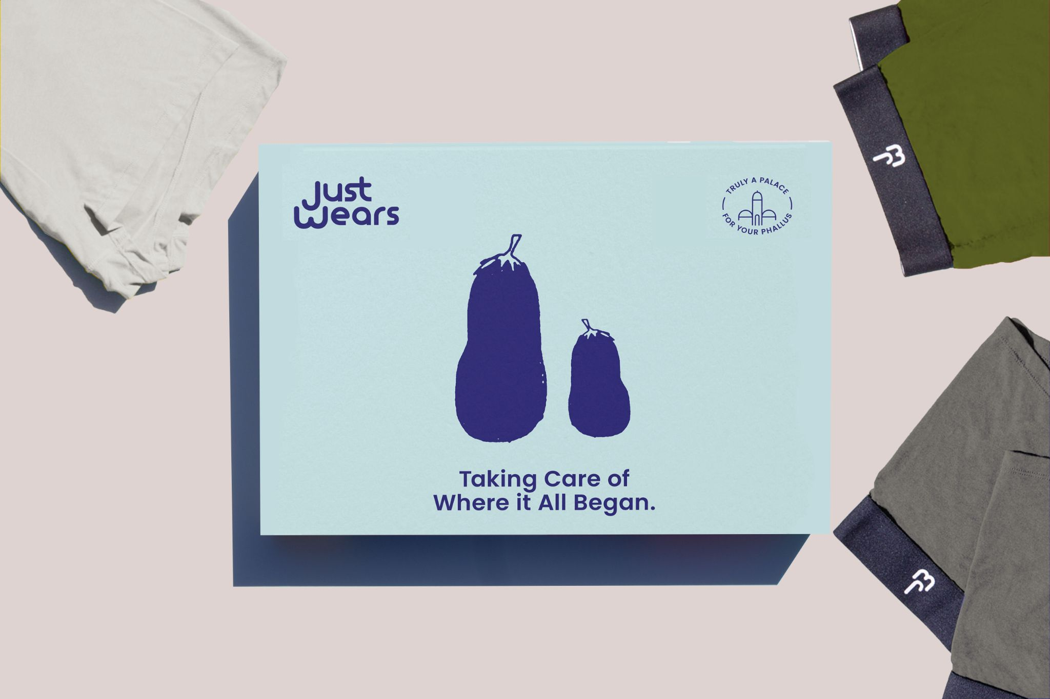

May 4th 2021: This Father’s Day, take care of where it all began with a gift that will ‘look after his sack.’ With their iconic tongue in cheek branding, JustWears will have your dad smiling as he opens this lighthearted gift on June 20th.

Having got used to dressing for comfort rather than show over the last year, most men now want all their items of clothing to meet loungewear standards of cosiness, and JustWears - a British, eco-friendly underwear brand at the forefront of comfortwear - will wick away any sweat ‘down there’, separate his meat from his two veg, and provide all day comfort as the weather hots up.

Dubbed ‘a palace for your phallus’ and retailing from just £12.48 a pair, they are the perfect gift when it comes to comfort and coolness - and the range of colours, from monochrome, to multicoloured will satisfy any sartorial tastes.

Goodbye to perspiration
Boasting JustWears’ unique, ergonomic pouch design, separating his meat from his two veg, these Boxer Briefs feature high-performance ventilated fabrics on the underside offering more space and airflow right where it’s needed most and wicking away unwanted perspiration. Made from MicroModal Air fabric - 50% more absorbent and breathable than cotton - your dad will be kept pleasantly cool whatever he’s up to - whether he’s working out, working hard, or lounging.

Softer than cotton and eco-friendly
JustWears’ Boxer Briefs don’t just solve sweat ‘down under’. Made from luxe-feeling fibres from sustainable Austrian Beech trees that are 40% cellulose and produced in a non-toxic and renewable process - not only are these boxers CO2 neutral and biodegradable, but they are also five times softer than cotton. What’s more, the remaining wood left over from the process of making them is recycled to supply energy back to the JustWears factory - making these the ideal gift for any modern-day, eco-conscious man looking for boxers so soft and comfortable, he won’t know they’re there!

Could improve sperm count and fight odour
Tested by more than 25,000 men who vouch that the breakthrough boxers are a game changer, the natural super fibres in these pants are also antibacterial, helping to prevent body odour - so he’ll be smelling sweet all day long! Last but not least, JustWears’ underwear could also improve sperm count - useful for any dad who still wants to add to his family.

Says JustWears’ Co-Founder, Yang Liu: "When it comes to Father’s Day, we know it can be hard to decide what gift to give. Without resorting to boring vouchers, this June you can give your dad a useful but humorous token of affection that’s sustainable to boot. As we say, ‘look after his sack like he looks after your back.’”

The Pandemic has accelerated our desire for casual and comfortwear - comfort is king and there should be no compromise when it comes to the crown jewels!”

JustWears’ Boxer Briefs come in two different designs: Active - with Pouch - the perfect athletic cut with JustWears’ signature pouch, and Pro - without Pouch - the ideal daily wear.

For more information on JustWears, their Boxer Briefs and full range of underwear, visit: www.just-wears.com

-ENDS-

For press enquiries, images and interviews:
E: yang@just-wears.com
T: 07535232697

About JustWears
Launched on Kickstarter in 2017, JustWears’ husband and wife team, Alex Walsh and Yang Liu, quickly became the most backed apparel project in the UK ever. Since then, the brand has sold more than 100,000 pairs to over 25,000 customers in 73 countries, and the duo have appeared on BBC Dragons’ Den (where they received two offers) and shows like ITV's This Morning. In just under two years, JustWears has grown to seven figures in revenue and happy customers say that these underpants are literally the only underwear their meat and two veg deserve.

Prices and options available online:£19.37 a pair (2 pairs), £16.65 a pair (3 pairs), £14.15 a pair (6 pairs) and £12.48 a pair (9 pairs)

