SmartyPlants: For Happier, Healthier, Hassle-Free Houseplants
Houseplants are more popular than ever, with an estimated 44.9 million people in the UK owning them*. But even experienced indoor gardeners can struggle to keep indoor greenery thriving.
That’s why SmartyPlants struck such a chord with plant lovers worldwide. The brand has raised more than £140,000 on Kickstarter from 1,500 backers, proving just how frustrating people can find indoor plant care.
But not for much longer, thanks to SmartyPlants! This smart sensor blends innovative technology with practical, personalised advice, helping users keep their houseplants happy all year round.
SmartyPlants Plant Sensor, £39.99
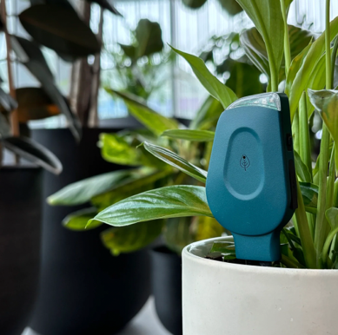
Available in green or grey now at https://www.smartyplants.uk
Placed directly into the soil, a SmartyPlants sensor monitors moisture, light, temperature, humidity and nutrients. It connects to a free app, which translates data into real-time care guidance, giving plant owners clear instructions to help their plants flourish.
With rechargeable batteries lasting over three months per charge and WiFi connectivity for remote check-ins, SmartyPlants is designed to make plant care straightforward, sustainable and successful.
How does it work?
- Stick it in the soil: The sensor measures light, temperature, humidity, soil moisture and soil nutrients.
- Connect to the app: Data is analysed and turned into tailored, actionable plant care guidance, delivered in real-time via the free SmartyPlants app.
- Let your plant do the talking: Plant parents receive clear, simple care instructions so their greenery can thrive, with no more second-guessing.
For larger plant collections, there’s also a Three Pack (£99.99), Five Pack (£154.99) or Ten Pack (£289.99).
-ends-
Media Contact: Holly James | holly@hollyjamespr.com | 07578 929 729
Press Imagery: Download high-resolution imagery (cut out and lifestyle) and logos at this link or on Press Loft.

*Source: Barratt Homes Survey August 2025
https://www.barratthomes.co.uk/advice-and-inspiration/a-beginners-guide-to-houseplants/
Survey revealed that 78% of adult Brits own houseplants. There are 57.5 million adults in the UK, so 78% equates to 44.9 million people.

