Our new Entwined Collection is here which is a new 6-piece capsule collection, honouring everlasting love and relationships. The new collection introduces intricate rope detailing on all pieces, and includes the new padlock charm, representing an everlasting love that never wavers and an unbreakable bond between you and the ones you love.

The delicate padlock, timeless in its design, can be hand-engraved with the initials, letters or numbers that are significant to you on the personalised necklace or bracelet. The on-trend pieces are perfect for the beach or bar, and with everything made in 18k gold plating, the Entwined collection is made to last.

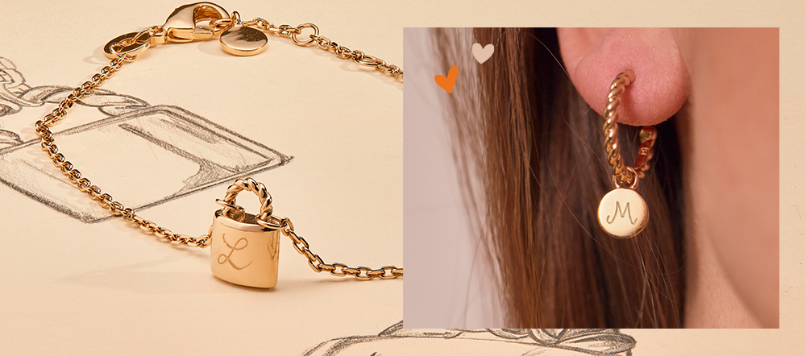
L-R: Padlock chain bracelet £59, and Entwined hoop earrings £79

Prices start from just £49. Even better, every order is shipped within 24 hours making the gift-giving or treat-yourself process super speedy! Fans include Rosie Wicks, Daisy May Cooper, and Stacey Solomon.

All links to hi-res imagery and pack shots available here – https://drive.google.com/drive/folders/1mmfpwgSLvPU7I6tAIjQ9BoweiG0aq2ko?usp=sharing

