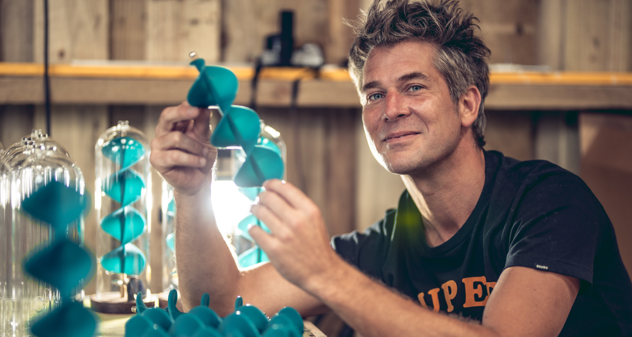
Hand Assembly Begins for Uplift 2.0 in Malmesbury
The New Progressive Design Tackling Mental Health, Made from 100% Recycled Fishing Nets

September 2020 - Malmesbury, Wiltshire. Award-winning British inventor, designer and TV personality, Tom Lawton starts production of Uplift 2.0 - a solar powered spiralling kinetic sculpture made from 100% recycled fishing nets.

Tom Lawton, co-founder of Uplifting Products, will hand assemble 1,000 Uplift 2.0s this month from his workshop in Malmesbury. Uplift 2.0 is Lawton’s latest creation - a mesmerising, solar powered sculpture for home. Designed to sit on your window-sill and revolve, it’s hypnotic motion creates a sense of calm to help you relax and unwind. The progressive design uses waste fishing nets sourced from Cornish Hake Fisheries to form the structure’s spiral. Lawton comments, "I wanted to make Uplift 2.0 in a beautiful aquamarine colour translucent like ocean waves, so I turned to the coast in search of inspiration. There I found the same problem we are all staring at, but rather than feel despair I saw incredible potential in the marine plastic that littered the beach.”

One plastic fishing net allows Lawton to make roughly 70 Uplift 2.0s. With sales reaching 600 to date and a total of 1,000 going into production this month, it’s a significant amount of fishing net being recycled off the Cornish coast and prevented from going to landfill or left in the ocean. Lawton continues, “As an inventor, I strive to bring uplifting products and long-lasting solutions to the world’s problems and for me Uplift 2.0 is such an achievement and so relevant for today - it’s good for the mind and for the planet.”

1,000 Uplift 2.0s are going into production in September and for each Uplift 2.0 sold on beuplifted.co.uk, £10 will be donated to The Sea Sanctuary - a unique mental health and wellbeing charity rooted in the concept of ‘blue health’. So far Lawton has raised over £1,000 for the charity whose programmes rely on the environment for marine activities and evidence-based therapies to help children and adults who struggle with issues such as stress, anxiety, depression.
Uplift 2.0 is designed and assembled by hand in Malmesbury, Wiltshire. RRP: £185.00 For more information visit the Uplifting Products website: https://beuplifted.co.uk.

-ENDS-
Boiler Plate
Welcome to Uplifting Products. We’re new on the scene, inventing uplifting products designed to make you smile. With an award-winning British Inventor at the helm, we lift spirits and provide moments of calm in an otherwise chaotic world. Tom Lawton, co-founder of Uplifting Products is the epitome of the great British inventor and is possibly Britain's loveliest one too. Concerned about the environmental crisis and passionate about doing something positive about it, Tom looks for long-lasting solutions to some of life’s problems.
Uplifting Testimonials

"Wowzer, Tom Has done it again. Uplift 2.0 captures the essence of the regenerative future; she runs on sunlight, turns waste material into timeless art, and calms the spirit as she spins. Just beautiful!" - Kate Raworth, Renegade Economist
“How landfill can be recycled into something beautiful. Powered by the sun and sculpted using Cornish fishing nets. Two hearts #beuplifted #breathe” – Suzi Perry, Broadcaster and Journalist

"I love it. Such a beautiful thing" - Matt Haig, Author

"I love this. A happy, dreamy, solar sculpture" - Derren Brown, Mentalist

"Uplift is so hypnotic. I could watch it forever" - Jamie Oliver, Chef

"The infinite movement of the Fibonacci spiral in the beautiful and calming sculpture Uplift always connects me to my true potential and source. I'm so grateful for my Uplift and I enjoy it everyday!" - Gordana Biernat @mypowertalk

Press Office
LFPR
Lydia Ford | Lydia@lydiafordpr.com | 07801802014
More information and interviews are available on request. High resolution images, logo and video can be found http://bit.ly/UPLIFT2PRESSFOLDER
Social Media

Follow Tom’s journey for uplifting products on social media:
Instagram: https://www.instagram.com/tomlawton/
Twitter: https://twitter.com/tomlawton

Notes to Editors

Tom Lawton - British Inventor
Tom Lawton is an award-winning British Designer based in Wiltshire. Tom was the winner of the Green Dot Award (2009) and Sustainable Design Award (2010). Tom was the star of C4 series 'Tom's Fantastic Floating Home' in 2013. His previous inventions include Million Mile Light, BubbleScope, Firewinder, WakeYoo and Honkies. Tom Lawton founded Uplifting products in 2019 as part of his mission to lift the spirits of a stressed out world.
For Tom’s full bio, visit: www.tomlawton.com

Uplift 2.0 Technical Specifications
- Product Diameter: 11cm | Product Height: 30cm | Overall weight: 900g
- Power: 100% Solar Powered Engine
- Included in the box: Base, Spiral, Dome and Magnetic Wand
- Recyclable Materials: Walnut (base), Mild Steel (mechanism), Waste Fishing Net Nylon (spiral), Borosilicate Glass (dome)
- Each unit is shipped in recycled gift packaging

The Sea Sanctuary - Waterside Court, Falmouth Road, Penryn, Cornwall TR10 8AW
The Sea Sanctuary takes therapy out of the office and onto the water – it’s a recipe that has helped hundreds of people improve their mental and emotional wellbeing since the charity was launched in 2006.
https://seasanctuary.org.uk

Uplift 2.0 Kickstarter campaign
Uplift 2.0 raised £25,000 within 48 hours as part of a Kickstarter campaign which went live on 26th November 2019. The campaign ran until 31st December 2020 and has now raised £76,739.00.
https://www.kickstarter.com/projects/millionmilelight/uplift-20-unwinding-spiral-sculpture-to-soothe-the-soul
Uplift 1.0
Uplift 1.0 was designed and manufactured in 2018, selling 440 units as part of a limited design run. Lawton has made a few key improvements that take Uplift 1.0 from being an object d'art to becoming the classic design piece that is Uplift 2.0.

Good for our minds, good for our planet

