I’m Dreaming Of A Love Cocoa Christmas…
Love Cocoa Unwraps New Look & Calendars For Christmas 2023
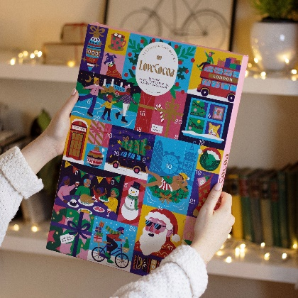
Nothing says Christmas more than a traditional chocolate advent calendar, and luxury, sustainable chocolate brand, Love Cocoa, has hit the festive sweet spot again. Designed to make December’s daily dose of chocolate as delicious as possible, this year’s line-up includes a trio of sophisticated calendars to choose from, with its first calendar for children too – yes, get ready to be spoilt for choice!
And you may have noticed, Love Cocoa has a new luxe look to shine a spotlight on its sustainable, ethical credentials. The brand’s commitment to responsibly producing delicious, high-quality chocolate remains, and the new designs are reflective of the luxury chocolate that lies within. The B Corp certified brand is all about driving positive change within the chocolate industry, led by founder and chocolatier, James Cadbury. Crafting with pride and care, Love Cocoa uses only the finest quality cacao that’s ethically sourced from growers who farm fairly and pay their workers properly.
As part of its ecological commitments, Love Cocoa is continuing its longstanding work with Eden Reforestation Projects via 1% for the Planet, with the aim of planting over 200,000 trees each and every year. To date, the brand has planted 1.6 million trees across North and East Africa in a bid to combat deforestation and climate change.
NEW! Love Cocoa Truffle Calendar - £25/364g -
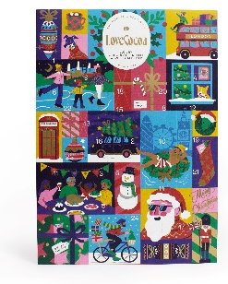
Available from Anthropologie, Fenwick, John Lewis, Next and https://lovecocoa.com/products/luxury-chocolate-truffle-advent-calendar
Countdown to Christmas one truffle at a time with this beautifully illustrated, gold-embossed, A3-size 100% plastic free calendar. Starring fabulously festive scenes, there are four decadent truffle varieties, all handmade using ethically sourced, palm oil free and single origin Colombian cocoa… Hazelnut Praline Heart, Giant Hazelnut Rocher, Salted Caramel Truffle and Spiced Gingerbread Truffle. And not forgetting a surprise Love Cocoa Mini Chocolate Bar to enjoy behind door number 24!
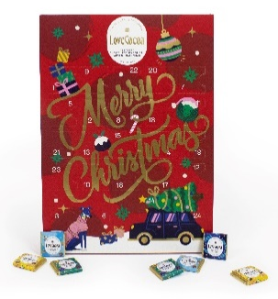
NEW! Love Cocoa Assorted Chocolate Calendar - £15/120g
Buy from Anthropologie, Fenwick, Next, Soho House and https://lovecocoa.com/products/love-cocoa-advent-calendar
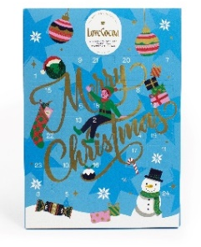
Love Cocoa’s bestselling flavours in delectable bitesize pieces for 24 days of tasty treats. A suitably grown-up affair featuring: Salted Caramel Milk Chocolate, Sea Salt Dark Chocolate, Colombian Milk Chocolate and Gingerbread Dark Chocolate. Merrily illustrated and 100% plastic free too.
NEW! Love Cocoa 41% Milk Chocolate Calendar - £15/120g
Buy from Anthropologie, Next and https://lovecocoa.com/products/love-cocoa-advent-calendar
Countdown to Christmas in the most delicious way with Love Cocoa’s new traditional milk chocolate calendar, targeted at the younger chocolate lovers amongst us. Starring 24 tasty squares of smooth, creamy Colombian milk chocolate, this calendar is merrily illustrated and 100% plastic free too.
Festive flavours crafted with care, this is Christmas chocolate made with love by the Modern Chocolatier.

-ends-

Contact Rachel Lawrence PR for further information / images:
rachellawrencepr@gmail.com
07932 384805

About Love Cocoa
In 2016, Cadbury descendant, James Cadbury, founded Love Cocoa upon the same ethical values that were at the heart of the original Cadbury company, and with sustainability at the core of its mission. Since then, the luxury brand has become known for its contemporary take on classic flavours that are aligned with modern, sustainable standards. Avoiding plastic and palm oil, planting trees to support reforestation projects and ethically sourcing their cocoa, the brand is all about driving positive change within the chocolate industry.
As well as tablet bars, Love Cocoa’s range now includes truffles, selection boxes, hot chocolate flakes, biscuits and seasonal gifting. The B Corp certified business is a proud member of 1% for the Planet, working in partnership with Eden Reforestation Projects to combat deforestation and climate change. To date, the brand has planted 1.6 million trees in North and East Africa. Love Cocoa is stocked in Anthropologie, Harrods, Fenwick, John Lewis, Liberty and Selfridges, plus independent outlets nationwide, and via lovecocoa.com.

