PRESS RELEASE

Dualit Expands EcoPress™ Range and
Reveals Vital Step in Aluminium Coffee Pod Recycling

- Nespresso® Vertuo coffee lovers can now recycle pods from home – the first to market
- ‘Stack & Squash’ revealed as a key step in ensuring aluminium coffee pods are efficiently recycled, following Dualit’s continued research with Alupro
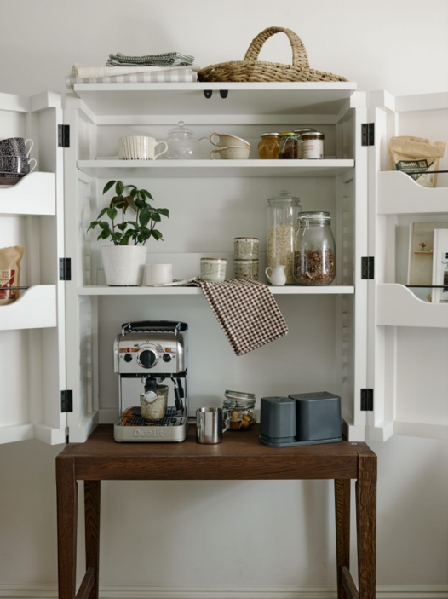

Since its launch in January 2020, Dualit’s original EcoPress™ has saved almost 27 million aluminium coffee capsules from UK landfill* – which is the equivalent weight of 26 African Bull Elephants. This affordable kitchen gadget has transformed the way aluminium coffee capsules are recycled and has created an accessible yet ingenious way to do so at home. Continuing the momentum for at-home coffee capsule recycling, Dualit is delighted to announce that the EcoPress™ range is expanding to include two NEW models: EcoPress™ Duo Max and EcoPress™ Vertuo.

Offering a mess free solution to coffee capsule recycling, the NEW additions to the EcoPress™ range work much the same as the original model. The gadget will invert the used coffee capsule so that the coffee is removed, users rinse off any remaining coffee residue and then the capsule can be added to the recycling bin ready for council collection. In addition, the used coffee grounds are collected safely in a built-in bucket ready to add to the compost heap or to food waste.

Key Differences
- Dualit EcoPress Duo Max allows users to recycle Nespresso® compatible aluminium coffee capsules 25% faster by pressing two capsules simultaneously
- Dualit EcoPress™ Vertuo allows users to EcoPress™ Nespresso® Vertuo aluminium coffee capsules – the first model to cater for this larger capsule size

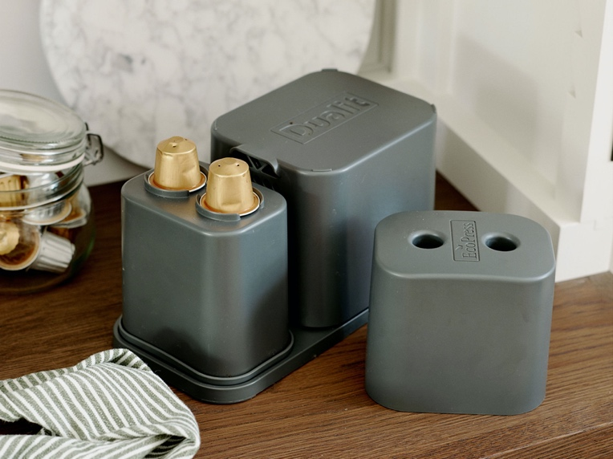

Dualit EcoPress Duo Max – Priced from £19.99
The new EcoPress™ Duo Max recycles Nespresso® compatible aluminium coffee capsules 25% faster than the original, as it enables users to press two capsules simultaneously. In addition, the Duo Max also features a storage container so up to 30 used capsules can be stored away from sight until you are ready to EcoPress™. Fully dishwasher safe, the bucket holds grounds of up to 30 capsules, and the lid doubles up as a rinsing tub. As part of the simple process, Dualit advises a ‘stack and squash’ method following rinsing, whereby 3+ capsules are ‘stacked’ together and ‘squashed’ length-ways before adding to the recycling bin. Following thorough research into the UK’s Material Recycling Facilities, it was found that many don’t have the machinery to collect fines (materials which can fall through – such as a single aluminium capsule). The ‘stack and squash’ method ensures a bigger surface area and will therefore be sent to can to can recycling.

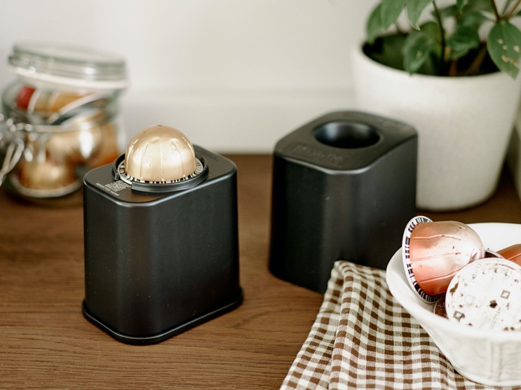
Dualit EcoPress™ Vertuo – Priced from £12.99
The new EcoPress™ Vertuo has been specifically designed to recycle all sizes of the Nespresso® Vertuo aluminium coffee capsules. The minimal design won’t take up valuable space on the worktop and looks sleek and stylish. The bucket holds grounds of up to 20 capsules and all parts are dishwasher safe.

Available from Dualit, www.dualit.com

ENDS

Notes to editors

*Based on cumulative data in relation to Statista’s report on average number of coffees consumed per day at home in the UK, and the number of EcoPress™ units sold since launch (Jan 2020 – Jan 2023)

For more information, high resolution images or samples for review, please contact:
Chloe MacDonagh at Sellers PR on 01962 977 950 or email chloe@sellerspr.com

