Luxury ‘Relax Hamper’ by artisan baker offers cake, tea and therapeutic treats

Treat a friend to ‘me time’ and support a charity too — £5 of every purchase goes to the Teenage Cancer Trust

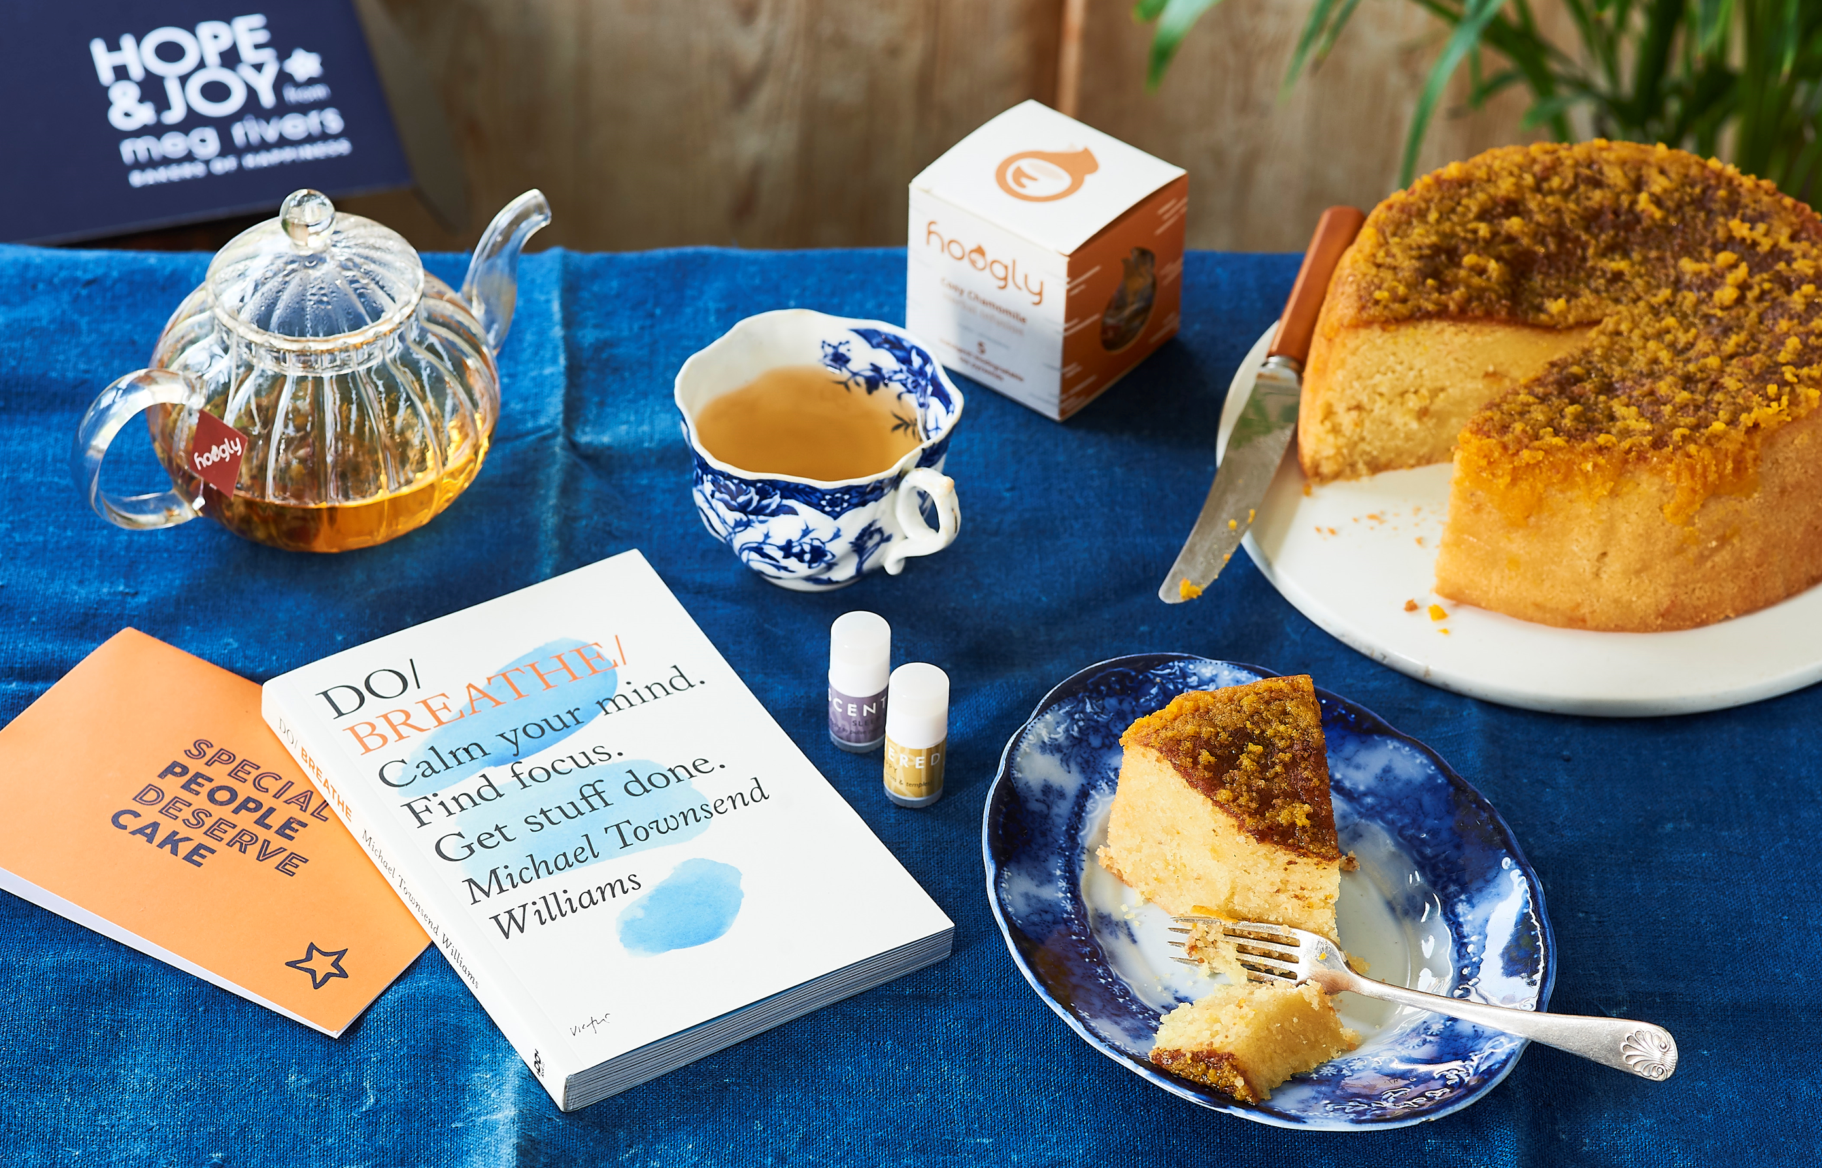
July 2020: Know a friend or family member who is overdoing it and needs some encouragement to relax? Perhaps they’re a household hero or work warrior, always looking out for others without prioritising their own needs. When a loved one is going through a tricky time, they’ll appreciate a generous dose of TLC — Tea and Lovely Cake! Whether it’s a special occasion or surprise treat to show how much you care, send this friend or loved one a Relax Hamper by HOPE & JOY from Meg Rivers Bakers of Happiness — it’s bound to brighten their day and encourage them to put their feet up.

The hamper, filled with a delicious Clementine & Almond cake, is one of the Baker’s most popular recipes; it goes delightfully with calming tea and therapy balms to relax even the most exhausted individual.

Lovingly created and curated by ‘Bakers of Happiness’ at a small family-run business in the heart of the Cotswolds, this beautifully gift-wrapped hamper contains:

- A full-size, moist and mouthwatering Clementine & Almond cake, lovingly laden with citrus syrup for the ultimate indulgence
- Five amazing tea pyramids of relaxing 'Cosy Chamomile' tea from the lovely folk at Hoogly
- A copy of 'Do Breathe' book by Michael Townsend Williams
- Two scented therapy balms, 'Be Happy' and 'Sleep Well' from the clever people at Scentered
- A special greetings card of your choice, with messages ranging from ‘Special people deserve special cake’ to ‘Thinking of you’

The Relax Hamper is available from the HOPE & JOY at Meg Rivers Bakers of Happiness website (www.megrivers.co.uk) for £40, £5 of which is donated to the Teenage Cancer Trust, bringing ‘HOPE’ to young people living with cancer. With just two talented bakers, the family running this lovely business have made it their mission to raise £1million for cancer charities across the UK with exclusive gift box ranges, like this Relax Hamper.

Jessica White, co-owner of HOPE & JOY at Meg Rivers Bakers of Happiness, commented:
“2020 has so far been quite stressful for all of us, for a number of reasons. What better way to send good wishes and love to friends and family than with our Relax Hamper. They’ll adore this incredibly comforting and tasty cake, learning all about self-care with the ‘Do Breathe’ book. This, together with the sweetly scented therapy balms, are a must for mindfulness — made to relax and calm the soul.
“As a mum of four and a small business owner, I know how hard it is to take time out to relax, and yet how important it is. We created this gift that could be shared with friends and family when they just need that encouragement to take some time off, personally selecting items that we think would benefit us when we need to relax; a full-size version of our most popular cake as well as some calming chamomile tea and scented therapy balms.”

To see and shop the full HOPE & JOY at Meg Rivers Bakers of Happiness collection, visit www.megrivers.co.uk. Here you’ll find special gifts to celebrate all occasions, from a new baby to birthdays and Christmas. Or perhaps you’d just like to say ‘thinking of you’ with a lovely gift — the ‘Chocolate Lovers’ Hamper is popular all year round. If you’d like to get creative at home, the website offers a fantastic range of recipes and an Artisan Home Baking Book.

You can also share ‘HOPE’ and ‘JOY’ on a monthly basis by signing up to the Cake Club subscription service to send your loved one a fresh cake, straight to their door, on a monthly basis. Or why not treat yourself? It’s the gift that keeps on giving!

Notes to Editors

PRESS CONTACT:
Amy Kimber or Beth Howard: hopeandjoy@wearebottle.com
Bottle PR

About Meg Rivers
A modern, forward thinking bakery and gift business based in the heart of the Cotswolds, producing cakes and treats based on recipes developed by founder Meg Rivers.
Established more than 30 years ago, Meg Rivers built an unparalleled reputation for quality and service. Since Meg's death from cancer in 2001, the business has been run by family friend Julian Day with help from his daughters. Their lives were also touched by cancer when Julian's wife Joy died leaving him to bring up their children alone. Julian and his four daughters now continue the Meg Rivers name, leading the business for a new generation, whilst continuing to bake delicious, wholesome cakes just as they would for their own families, in memory of Meg and Joy's love of home baking.

With this legacy, the Meg Rivers name and core values have been heavily shaped by charitable partnerships with some of Britain's most well-known charities and brands. Family, giving and sharing are intrinsic to the Meg Rivers story and what shapes this unique slice of the Cotswolds. After all, giving is a piece of cake.

Product is available through the website, a monthly cake club and a wholesale supply, as well as a corporate offering. Meg Rivers Bakers of Happiness also stocks product exclusively for limited periods at Liberty London and Selfridges, though not the HOPE & JOY collection specifically.

About HOPE & JOY
The HOPE & JOY collection has two main principals at its heart. To give JOY by delivering delicious cakes and carefully curated gifts for your enjoyment and HOPE by donating to a cancer charity with every gift purchase.
HOPE & JOY reflects co-owner Jessica’s’ family journey. Jessica’s mother, Joy, died from cancer when she and her three sisters still children. After her mum’s death, Jess’ father Julian gave up his career to care for them. After a while, he was asked by Meg Rivers to work part time at her bakery. Sadly, just a few years later Meg too died of cancer and Julian was asked by her family to take on the business. With this history, it perhaps is no surprise that charitable partnerships have been part of the Meg Rivers story ever since.

Allergen information
For allergens in the Relax Hamper, including cereals containing gluten, see ingredients in bold here. This collection is produced in an environment where nuts are used.

Connect with Meg Rivers Bakers of Happiness
Connect with the company online at or across social on Facebook, Instagram and Twitter. The hashtags are #givingisapieceofcake and #bakersofhappiness.

