The Ultimate Christmas Gifts for Kids and Families
Get Christmas wrapped up with the ultimate Christmas must-haves for kids and families this festive season, selected by John Adams, one of the leading UK toy and games companies. These top toys and games provide endless hours of fun for kids and adults of all ages, making them the perfect gift.
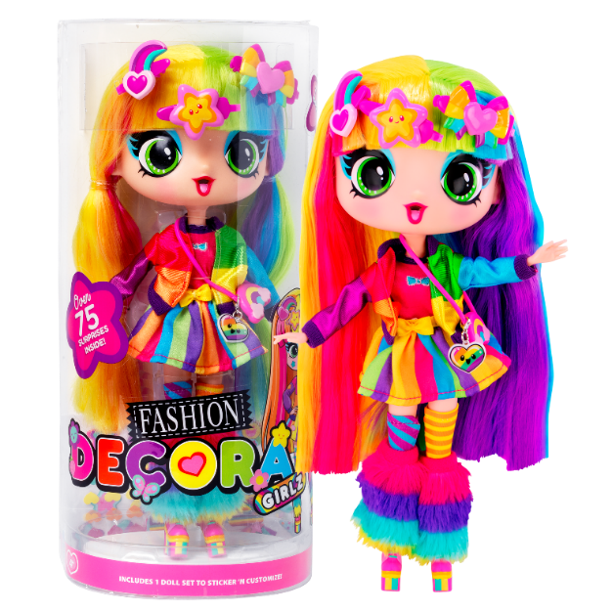

Decorate your Decora Girlz 11” Collectible Fashion Doll (£24.99) and yourself with lots of colour, sparkle and stickers galore. Each 11″ Decora Girlz doll has a unique character, super soft hair that’s easy to style, with a deluxe fabric outfit and plenty of accessories! Suitable for children 4 and over.

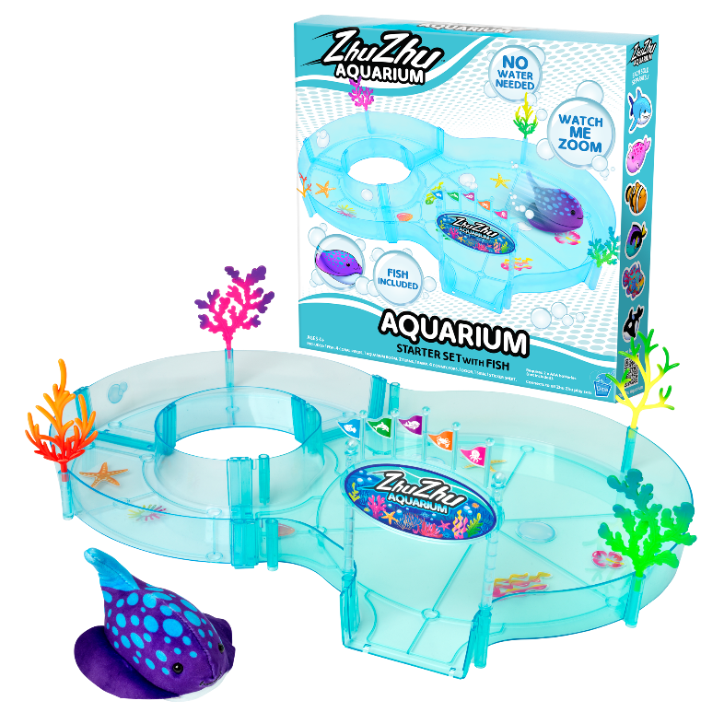
The Zhu Zhu Pets (£12.99 - £29.99) are back! A mess-free experience of imaginative fun with vibrantly coloured plush tropical fish and unique aquarium accessories. Dive into the Zhu Zhu Aquarium and experience the aquatic adventures of the new land swimming Zhu Zhu Pets! Suitable for children 4 and over.
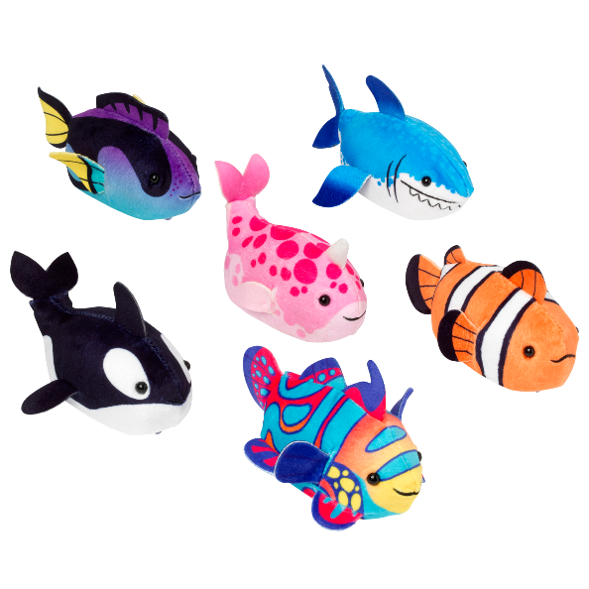

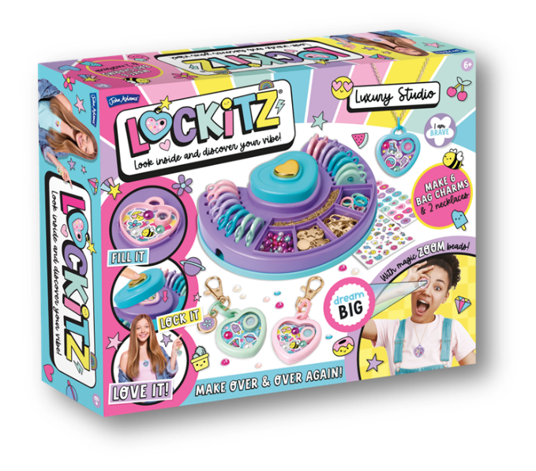
The Lockitz Luxury Studio Make (£24.99) lets creative kids make 8 amazing Lockitz to match their vibe! Make 6 bag charms and 2 necklaces. Fill it, lock it, love it! Look through the magic zoom bead to find a bright and colourful positive vibe waiting inside. Children can wear and share with their besties and family friends. Suitable for children 6 and over.
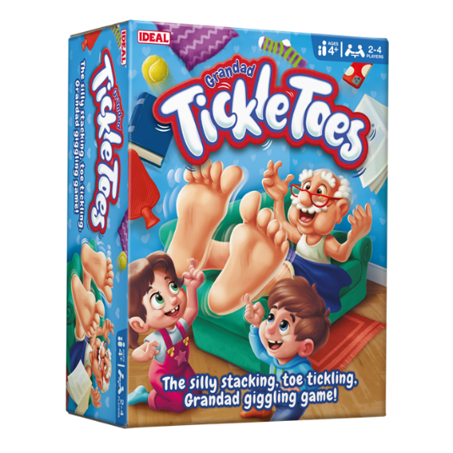

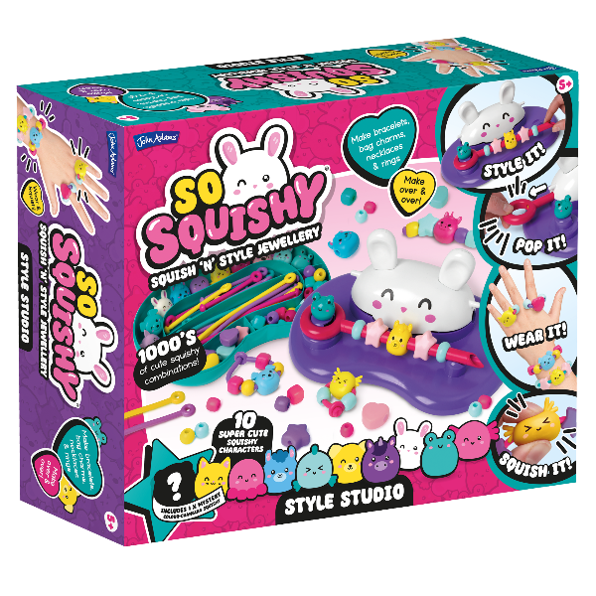
Grandad Tickle Toes (19.99) is a hilarious toe-tickling family game of risk and reward! Can you stack and tickle, without a topple?! The first player to stack all their items onto Grandad without startling him is the winner.

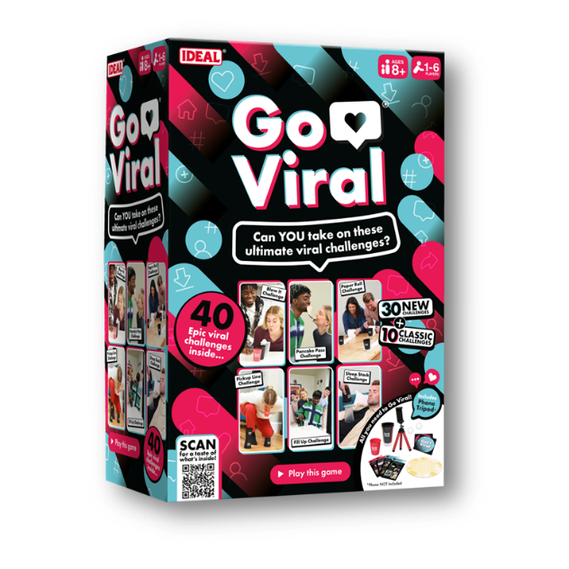
The So Squishy Style Studio (£22.99) make super squishy, fidget-friendly sensory jewellery! It’s so easy to create cute and colourful squishy character bracelets, bag charms, rings and more! Create endless combos to wear and squish.

Go Viral (£17.99) is the viral challenge party game, with 40 epic challenges to try! Bring your friends and family together for the ultimate party game to attempt the most viral challenges as seen on social media and level up your next game night gathering.

