Exploding Kittens Launches New Fast-Action, Two-Player Game, “A Game of Cat & Mouth”

Exploding Kittens, the hit tabletop game creator, has launched, A Game of Cat & Mouth, a fiercely competitive, magnet-powered, pinball’ish game. In the heat of intense ball flinging, players must hurl colourful balls through the cat’s mouth onto their opponents’ side. The game marks Exploding Kittens first non-traditional card game.

Since the box doubles as the board game, simply fold it open and get to playing. Players use the magnetic “Kitty Paw Flickers” to fling yellow balls as fast as they can through the “Cat Head” centrepiece. There are three ways to win a round: pop out the single black nose ball, knock out all three white “teeth,” or fling all eight yellow balls to the opponent’s side of the board. Best out of five rounds wins.

Unlike other Exploding Kittens games, A Game of Cat & Mouth relies heavily on distinctly accurate design and intricate details to determine playability. The Cat Head, which is the centrepiece of the game, had to be continually refined to find the balance between challenging and impossible. Additionally, instead of using springs that would wear out over time, the game features hidden magnets at the base of the Kitty Paw Flickers and in the board to ensure the longevity of the flinging mechanic without requiring batteries. By fitting all the components neatly into the folded-up game board box, A Game of Cat & Mouth is designed to be designed to be compact and easily portable.
7+, 2 Players, £24.99 Amazon £24.99

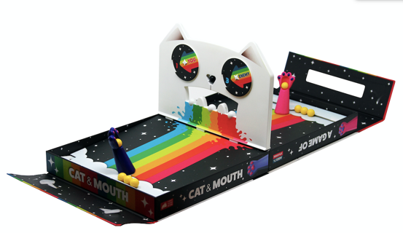

Media information
kelly@playtimepr.com
Graz@playtimepr.com

About Exploding Kittens
Exploding Kittens is a leading game and entertainment company with a mission to inspire people to connect, laugh, and play fun games in the physical world. After initially seeking to raise $10k through Kickstarter, the Exploding Kittens campaign raised $8.7M in 30 days from 219,000 backers. To date, Exploding Kittens is the #1 most-backed project in Kickstarter history and has sold over 9 million copies.

Started by former Xbox game designer Elan Lee and The Oatmeal’s founder Matt Inman, Exploding Kittens and its family of games recreates game night for a humorous and fun person-to-person experience. Today, there are six games available for purchase – Exploding Kittens, Bears vs Babies, You’ve Got Crabs, Throw Throw Burrito, On a Scale of One to T-Rex, Poetry for Neanderthals, as well as an Exploding Kittens mobile app that is one of the top 30 premium games on both iOS and Android.

In 2020, Exploding Kittens reached the milestone of selling over 11 million games in the company’s history. Since March, Exploding Kittens has seen record-breaking sales compared to 2019.

