PRESS RELEASE

Introducing Dualit's EcoPress
Aluminium Coffee Capsule Recycler
Recycle used aluminium coffee capsules with none of the mess

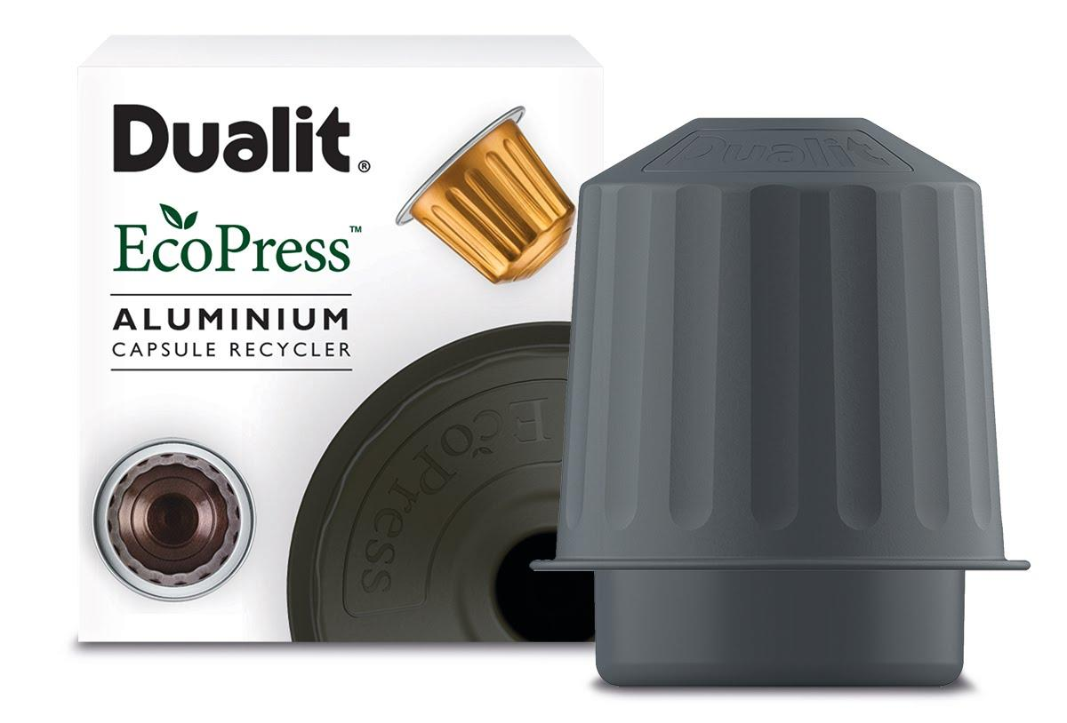
Dualit EcoPress Aluminium Capsule Recycler, £12.49

At a time when consumers are becoming more conscious about their consumption, waste and impact on the environment, iconic British manufacturer Dualit is delighted to introduce its new EcoPress Aluminium Capsule Recycler. Compatible for use with all Nespresso®* compatible brands*, the hand-held EcoPress offers a convenient and tidy solution to recycling used aluminium coffee capsules at home. A used aluminium coffee capsule is an ideal item to recycle; aluminium is an infinitely recyclable material and coffee grounds are compostable and biodegradable, so no waste is left behind.

Dualit was the first company to launch compostable coffee solutions – including compostable capsules** - to help tackle the millions of aluminium coffee capsules ending up in landfill every year.
350 million capsules are used annually and the majority end up in landfill***

The new EcoPress continues on this journey by supporting a greener lifestyle and eliminating the need for couriers, plastic bags and landfill. Simple to use, EcoPress prepares used aluminium coffee capsules ready for rinsing and recycling at home via kerbside recycling collections. Unique to Dualit, the ingenious EcoPress boasts a large pusher to ensure capsules are fully inverted, leaving minimal coffee residue behind to be composted or placed into an authorised food waste bin for collection by the council.****

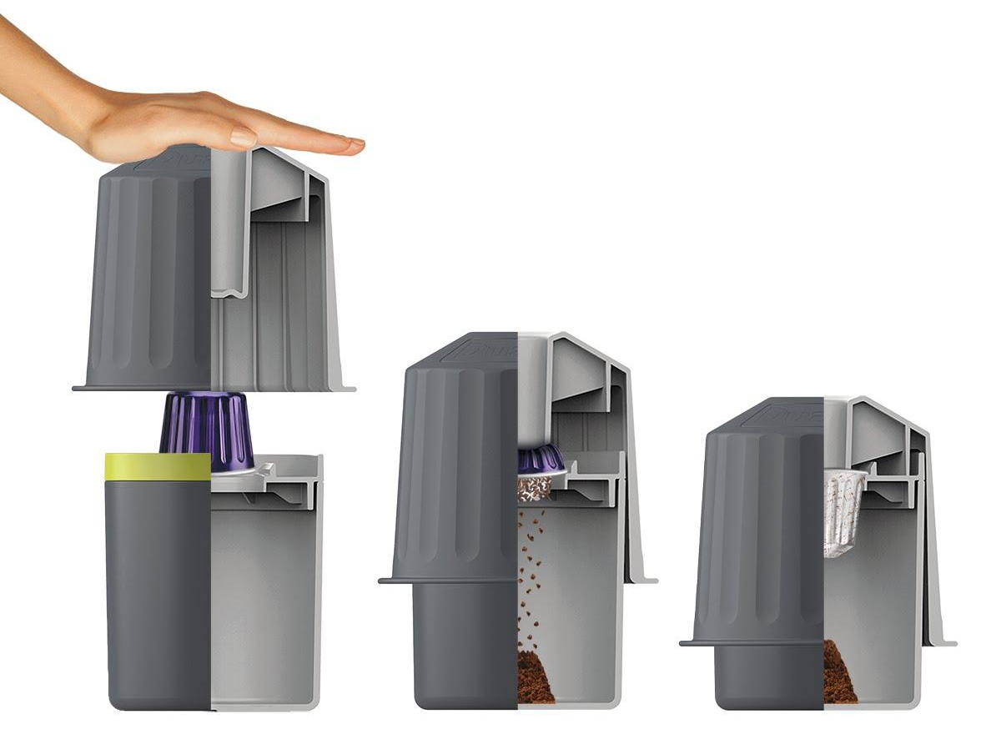

Renowned for its innovative engineering, product design and attention to detail, Dualit’s EcoPress is aesthetically pleasing and shaped to imitate the iconic coffee capsule shape. On-trend charcoal grey with light green detail, the EcoPress is compact and suits any kitchen style while offering a waste solution to ensure delicious coffee can be enjoyed without sustainability concerns. Dualit's EcoPress bucket conveniently holds the coffee grounds of up to 10 aluminium coffee capsules, while remaining easy to clean and dishwasher safe. With tough ABS construction, the EcoPress is truly built to last, making recycling aluminium coffee capsules easy for years to come.

Dualit EcoPress Aluminium Capsule Recycler, £12.49

Available from Lakeland and Dualit, www.dualit.com

ENDS

Notes to editors
*excluding capsules for professional, ‘built in’ and Vertuo models. Nespresso® trademark is owned by Société des Produits Nestlé S.A.

**Suitable for industrial composting through authorised food waste collection schemes.

***data taken from an article by The Independent, September 2019

****During the development for the EcoPress, Dualit liaised with Alupro, an organisation that works alongside the UK waste and resources industry to improve the collection of aluminium packaging for recycling. Alupro confirmed after receiving and testing an EcoPress, that the empty capsules would be able to be recycled at household recycling centres.
The machines that separate mixed recycling (trommel screens) also now pull out the 'fines' (small items) that in the past might have been missed and sent to landfill. Most materials recovery facilities then put the fines over an Eddy Current Separator, an advanced metal sorting system that uses magnets to pull out non-ferrous metals like aluminium, from other materials.
According to Alupro, if a capsule is still full of coffee then the Eddy wouldn't be strong enough to capture the capsule (which is the majority of capsules), so Dualit's capsules could be captured and recycled as long as they have been 'EcoPressed'.

For more information, high resolution images or samples for review, please contact:
Chloe MacDonagh at Sellers PR on 01962 977 950 or email chloe@sellerspr.com

