NEW BUMPER CAR FROM XOOTZ IS A REAL FAIRGROUND ATTRACTION…
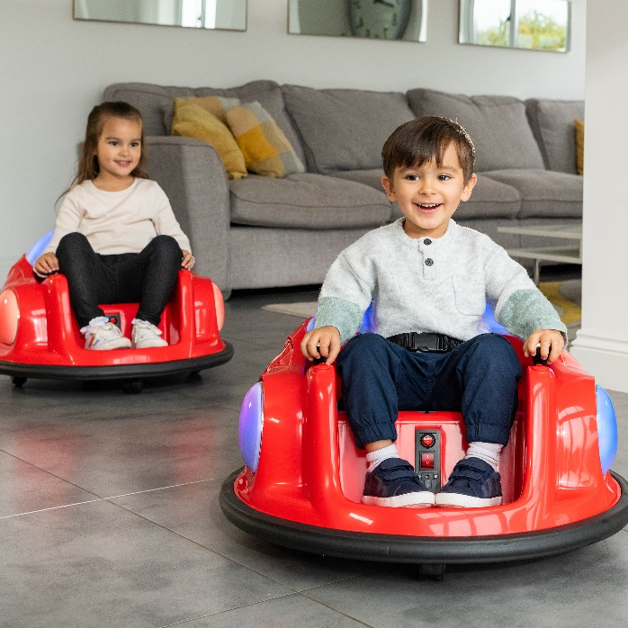
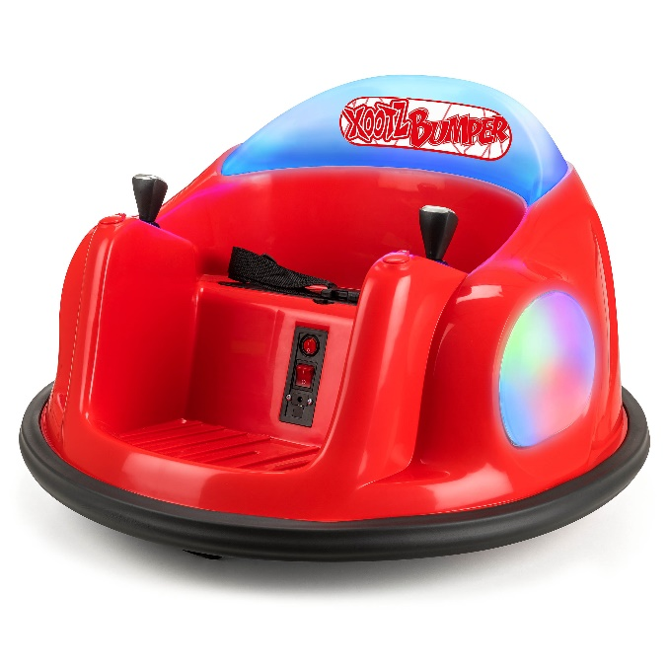
April 2022:
Scream if you want to go faster - the new Xootz Bumper Car brings all the fun of the fair directly to the home.

The ultimate ride-on for young children, little ones can drive, dodge, bump, and spin for fairground fun at home or in the garden. With two simple joysticks, little ones can reach speeds of up to 0.7mph and spin a full 360 degrees. There's no need to worry about safety as the Bumper Car has an adjustable seatbelt, anti-flat tires and a rubberised base that offers protection like a real bumper car. It has two LED side-lights and a light-up back panel.

Suitable for children over 18 months, the Bumper Car is a great introduction to the world of electric ride-ons and includes a remote control to give parents the ability to operate the vehicle.

The Bumper Car is the latest model to join the Xootz collection of electric ride-ons designed for younger children, and is available from stockists including Amazon, Argos, Very, Littlewoods, and Halfords.

For further information, imagery, and sample requests, please contact Playtime PR:
Louise Hathaway: louise@playtimepr.com / 07970 770572
Sophia Hutchinson: sophia@playtimepr.com / (0)7713 969952

- ENDS -
About Xootz:
Xootz. Fun Without Limits.
Xootz bridges the gap between wheeled toys and action sports and our mission is to inspire and encourage kids to get outdoors and have fun without boundaries and to do it in style!
Since 2014, Xootz has developed a multi-award-winning range of scooters, go-karts, skateboards, electric drift trikes, skates, and ride-ons including premium officially licensed vehicles from BMW to McLaren. This offers hours of thrills for kids with no boundaries.
Xootz products are available from a range of well-known stockists, including Amazon, Argos, Very, Littlewoods, Skates.co.uk, Halfords, and Skate Hut.
Follow Xootz on social media:
Instagram: @xootzofficial
Facebook: @xootzofficial

