Hello Kitty Cappuccino
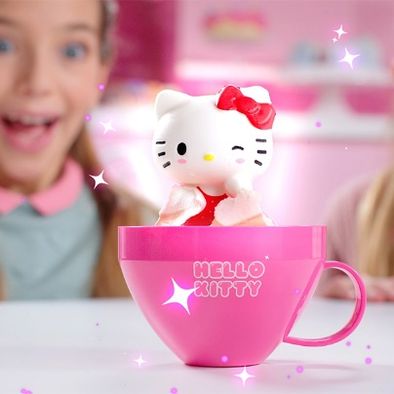

KAP Toys launched the Hello Kitty Cappuccino’s in January 2023 and has experienced great success in the market. Hello Kitty enjoys a global fanbase with a demographic spanning both children and adults. The brand is fully supported in all forms of media; on TV for 3.5 hours every day and benefits from its Roblox game, the most played branded game on the platform that boasts 12m monthly users and has racked up impressive average play times of 18 minutes!
Retailers know that Japanese anime is a growth trend and that Hello Kitty is a superstar in the world of kawaii.
Hello Kitty was born in the suburbs of London. She lives with her parents and her twin sister Mimmy who is her best friend. Her hobbies include baking cookies and making new friends. As she always says, “you can never have too many friends!“
The individual cappuccino cups simply need a splash of water to ignite the magic and reveal the Hello Kitty squishy within. With eight different characters to collect, the simple reveal adds a magical element to the kawaii-style collectible. Kids are delighted as they watch the squishable, scented Hello Kitty character pop up from the colourful coffee cup.

For more info, please see our KAP Toys website:
Hello Kitty - KAP Toys

