**THE NON-ALC STOUT THAT’S OFFICIALLY BETTER THAN GUINNESS 0.0**

*Mash Gang’s indulgent pastry stout, Lesser Evil scores a double gold at the International Non-Alcoholic Competition and pips Guinness 0.0 to the title of Beer of the Year.*

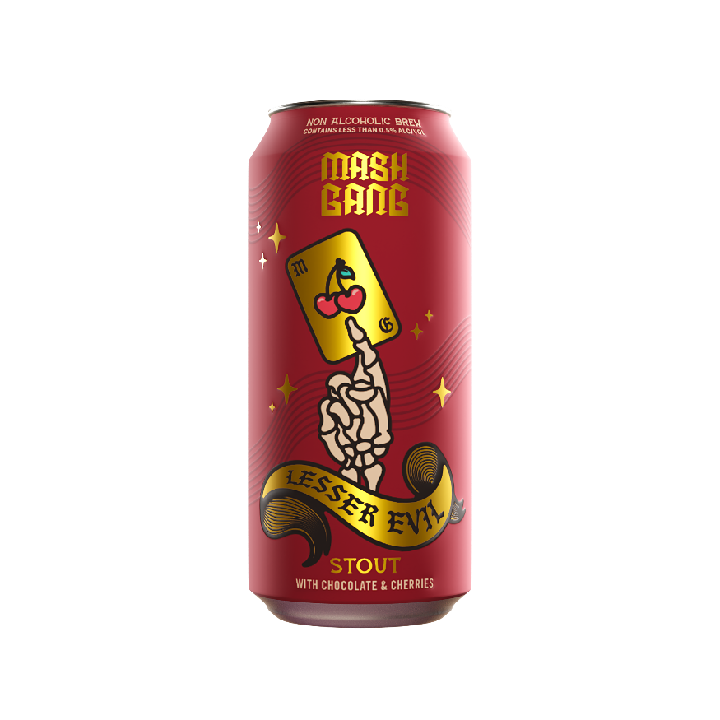

Mash Gang’s signature pastry stout, Lesser Evil, has scored double gold at the International Non-Alcoholic Competition and was crowned beer of the year ahead of Guinness 0.0.

Lesser Evil is a masterful blend of rich chocolate, velvety oats, and a generous dose of sweet and sour cherry juice, offering a luxurious, cake-like drinking experience.

Stout consumption has been growing rapidly worldwide, with a global volume increase of 11% from 2021 to 2022, according to IWSR. The UK saw an even higher rise at 23%, driven in part by increased interest in alcohol-free varieties[1]. *Lesser Evil* taps into this trend, providing the richness and decadence stout lovers crave whilst remaining non-alcoholic and vegan-friendly.

*Lesser Evil* is available in eye-catching 440ml cans, distributed through select retail outlets and Mash Gang’s online store. Its striking packaging and indulgent flavour profile make it a standout addition to shelves and taprooms.

Jo Taylor, Global Marketing Director for Mash Gang, commented:

**ENDS**

**Notes to Editors**

Mash Gang’s other beers in the core range also scored highlight with Chug (add in flavour profile) taking home a gold award and Journey Juice (add in flavour profile) and Glug (add in flavour profile) both taking home bronze at the competition.

For further information and media enquiries, please contact the Mash Gang PR team at [mashgang@hatch.group](mailto:mashgang@hatch.group) / 0113 361 3600.

**About Mash Gang**

Mash Gang began as a homebrewing experiment during the pandemic and has grown into one of the most respected non-alcoholic breweries in the world. With a focus on bold flavors, premium ingredients, and a supportive community, Mash Gang has redefined the craft beer experience. Backed by DioniLife, Mash Gang is a key player in revolutionizing the adult beverage industry.

Mash Gang recently launched in the U.S., starting in Colorado and quickly securing placement in leading outlets. In less than three months, Mash Gang has become the #1 selling beer in leading Denver stores —not just within the non-alcoholic category, but across the entire beer category. Mash Gang’s flagship SKU, Chug, is outperforming industry heavyweights like Athletic Brewing, Budweiser, and Guinness. Stores stocking it have seen the whole category grow.

1. *https://www.theguardian.com/society/2024/apr/04/higher-stout-consumption-driven-by-female-drinkers-and-low-alcohol-options*