Easter Bunnies or Bells?
Chocolate Easter Treats with Bonne Maman

Did you know that whilst we are all looking out for the Easter Bunny here in the UK,
in France it is the Church Bells – Les Cloches – that bring chocolate treats and gifts to
excited, ‘well behaved’ children?
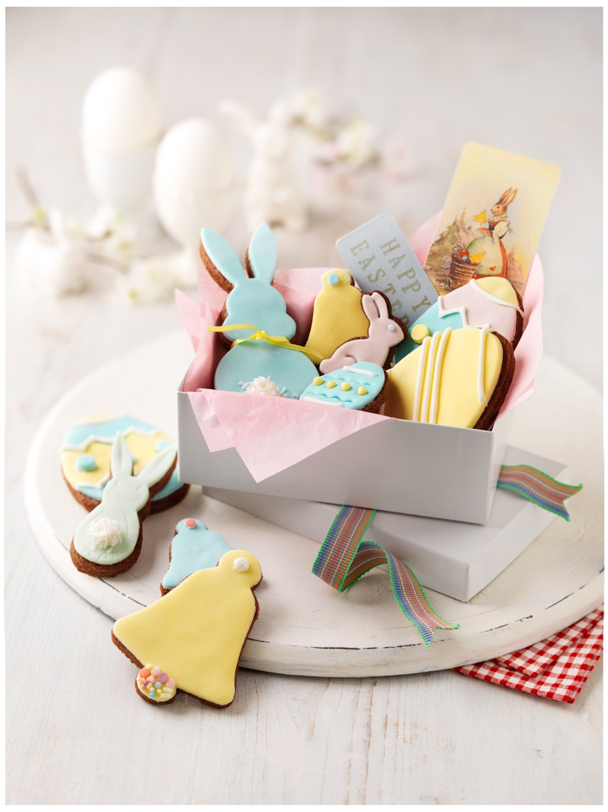
Whatever your preferred tradition, new Bonne Maman Hazelnut Chocolate Spread is a great addition to Easter baking and feasting. Made with all natural ingredients, 20% hazelnuts and containing no palm oil, Hazelnut Chocolate Spread lends itself deliciously to simple, fun family recipes like these Chocolate Easter Biscuits.

A very easy Hazelnut Chocolate Cookie Dough is rolled and cut into the cutest Easter shapes, then decorated with pastel coloured fondant icing, sprinkles and an occasional mini marshmallow for bunny tails! Prettily arranged in a gift box with ribbon and a little tag, they make a gorgeous, personal present.

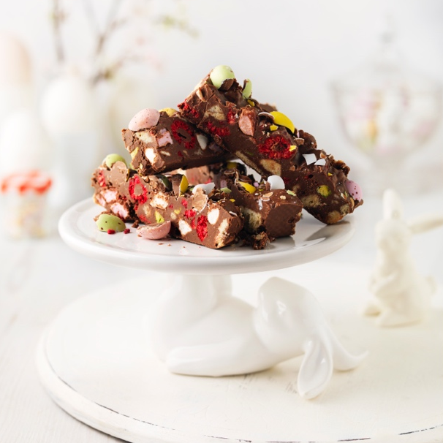
Chocky Rocky Road
A wonderful welcome treat to serve – or gift - at Easter, this Chocky Rocky Road combines Bonne Maman Hazelnut Chocolate Spread, with zingy dried raspberry pieces, chunks of shortbread biscuits, mini marshmallows and crushed mini eggs. Satisfying and simple to make, as well as being completely delicious, it can be made in advance and kept in the ‘fridge for up to two weeks.

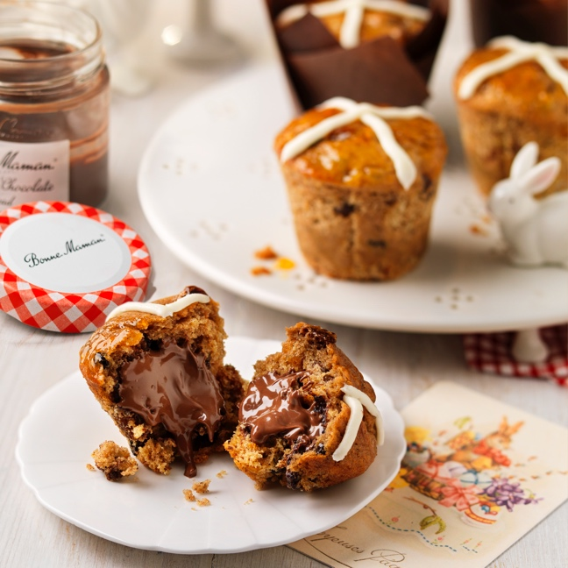
Hot Cross Chocolate Muffins
What says Easter more than a hot cross bun?
A delicious alternative to a classic - these Hot Cross Chocolate Muffins combine all the wonderful flavours of a traditional Easter hot cross bun, but with the added surprise of a delicious, gooey hazelnut and chocolate centre. For the utmost Easter indulgence, eat these warm to discover a melting chocolate middle.

Chocolate Thick-Shake
The ultimate indulgent and creamy chocolate thick-shake to enjoy this Easter… and even better, made in minutes! To enjoy a pure glass of chocolate heaven, combine Bonne Maman Hazelnut Chocolate Spread with ice-cream and milk, then top with whipped cream and chocolate curls. To complete the Easter theme, add in some mousse-filled chocolate bunnies placed on wooden skewers. Délicieux!

Costing £2.80rrp for 250g jar, new Bonne Maman Hazelnut Chocolate Spread is available from all major retailers.
-Ends-

High resolution and other images, recipes and samples available – contact Pippa Evans on e:pippa@wixhill.co.uk or Holly Darke on e:holly@wixhill.co.uk or call WixHill on 01483 203992.
For further information, tips and recipes see www.bonnemaman.co.uk, like on Facebook @BonneMamanUK and follow on Instagram @bonnemaman_uk
- Stockists may vary
- Image copyright, Bonne Maman UK
About Bonne Maman: Bonne Maman is one of Britain’s best-loved conserves, famous for its signature gingham lids, use of simple, traditional methods and high quality, all natural ingredients. The full Bonne Maman UK range includes:
- Conserves - Rhubarb & Strawberry, Mirabelle Plum, Strawberry, Strawberry & Wild Strawberry, Wild Blueberry, Black Cherry, Fig, Apricot, Berries & Cherries, Raspberry, Peach, Damson Plum and Blackcurrant
- Intense Conserve – Strawberry, Apricot and Raspberry
- Curds – new Lemon
- Marmalades - Bitter Orange
- Caramels – Salted Caramel
- Hazelnut Chocolate Spread
- Compotes – Apricot, Cherry, Rhubarb and Peach
- Chilled Desserts – Strawberry Mousse, Chocolate Mousse, Rhubarb Mousse, Blackcurrant Mousse and new Clementine Mousse; Salted Caramel Crème, Coffee Crème, Dark Chocolate Crème with a Touch of Sea Salt and Milk Chocolate Crème; Crème Caramel, Crème Brûlee, Baba au Rhum and Riz au Lait plus Tarte au Citron and Red Fruit Tarte
- Yoghurts – Layered Yoghurts: Raspberry, Rhubarb and Apricot plus Large pot Fruit Yoghurts; Morello Cherry, Rhubarb & Strawberry, Violet Fig plus Raspberry & Blackberry.

February 2022

