A Game of Cat and Mouth
Get your quarantine buddy off the couch and dive into the rainbow splattered,
intensely competitive, ball-flingin’ world of Cat & Mouth! A fiercely competitive, wickledly fun hands-on pinball’ish game from the creators of Exploding Kittens. It’s like playing pinball with slingshots - there's Kitty Paw Flickers, ball flinging and Rainbow Ralphing cat.
7+, 2 Players, £24.99 Amazon £24.99

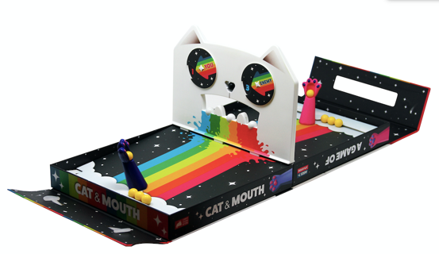

Poetry for Neanderthals
Poetry for Neanderthals is a competitive word-guessing game where you can only give clues by speaking in single syllables. So, instead of saying "broccoli," you'd say something like "green thing you eat for live long and have good health." If you mess up and use a big word, such as "vegetable," you get bopped on the head with a NO! Stick. It's a game that forces you to explain complicated ideas using simple vocabulary.
7+, 2 players +, Amazon £19.99

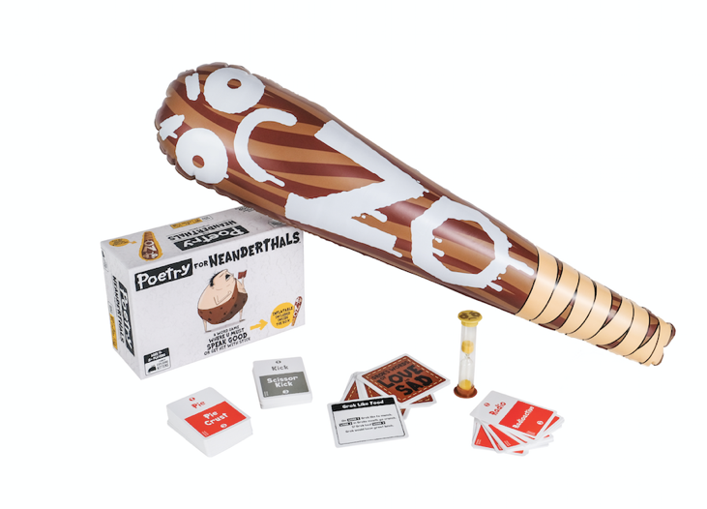

Throw Throw Burrito
Throw Throw Burrito is a family-friendly party game unlike any you've played before. It's a combination of a card game and dodgeball where players go head to head collecting cards, earning points, and throwing squishy toy burritos at one another.
7+, 2-6 players, Amazon £24.99

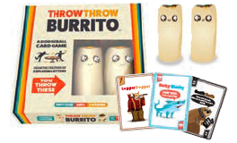

Tacocat Spelled Backwards
A lil' board game with a cat who is also a taco.
With Tacocat on the line, anything can happen in this palindrome-powered tug-of-war! Win duels
by playing cards of matching or higher value to defend your hand or sacrifice your lowest card.
When you’re on your final card, whoever has the lowest value card wins the round bringing
Tacocat closer to their side.
Tacocat Spelled Backwards is a fun balance of strategy, luck, and instinct! With its portable
open-and-play design, it’s a perfect two-player anytime, anywhere game; the box is the board!
7+, 2 Players, Amazon RRP £14.99

Exploding Kittens
Exploding Kittens is a highly strategic kitty-powered version of Russian Roulette. Players try to avoid drawing Exploding Kittens (which boot them from the game) using catnip sandwiches, deploying special ops bunnies, and seeking out the wisdom of an all-seeing goat wizard.
Ages 7+, 2-5 players, £19.99, Amazon

Barking Kittens Epansion Pack
This is the THIRD expansion of exploding kittens. This is not a standalone game—it requires a copy of Exploding Kittens to play.
Ages 7+, £14.99, Amazon

