Celebrating 250 Years with the introduction of the NEW Contemporary fragrance Collection
www.yardleylondon.co.uk RSP: £9.99/50ml & £14.99/125ml. Available at Boots Stores and www.boots.com

Yardley London is a brand that has stood the test of time, with its British heritage and expertise in creating fragrances, with quality ingredients, for generations of women for 250 years. Renowned for their ground-breaking advertising since the 1920s, with Twiggy and Jean Shrimpton the face of the 1960’s campaigns and Linda Evangelista in the 1990’s, as well as being the holder of 6 Royal Warrants since the 1920’s, it’s a fragrance brand with an impressive portfolio and one that has been built on substance, success and longevity that will continue for many years to come.

Celebrating 250 years in fine fragrance, Yardley London is proud to remain relevant to today’s female consumer. Continuing to be inspired by the power of flowers, Yardley London introduces four new Contemporary Floral Fragrances into its growing portfolio. Developed with esteemed perfumers, and incorporating current trends in women's fragrances, these four beautiful scents will have broad appeal with olfactory notes to suit every taste.

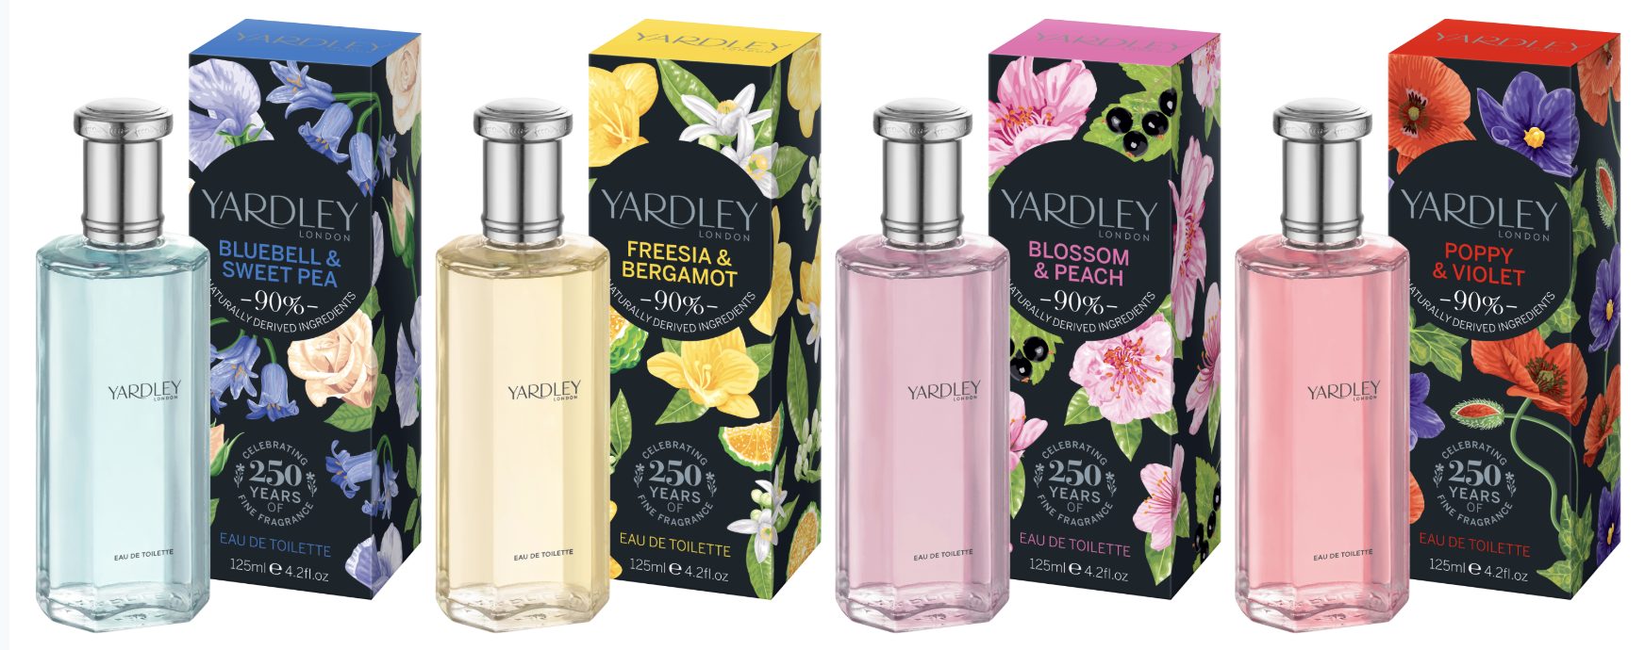
Presented in the stunning, iconic Yardley London bottle with a sophisticated, stylish floral inspired pack design, these new introductions reinforce Yardley London’s position as a forward facing fragrance house. Also available as Moisturising Fragrance Mists RSP £6.00/200ml and Body Sprays RSP £2.49/75ml.

Bluebell & Sweetpea
A light, feminine and fresh, fruity floral fragrance opening with uplifting citrus, bergamot, lemon and cassis chords in the top note, followed by a flirty heart of bluebell, jasmine, rose, lily of the valley and peony accented with a touch of sweet pea and enhanced with smooth, woody notes, vanilla and musk in the base.
Fressia & Bergamot
A refreshing, light citrus floral fragrance with energising top notes of bergamot, lemon, mandarin, and cypress leading to a vibrant and aromatic floral heart that combines freesia, lily of the valley, ginger and pepper, enhanced with a warm, sensual base of sandalwood, musk and amber.
Blossom & Peach
A fruity, spicy floral with citrus and cassis blended with feminine cherry blossom and pink pepper top notes, combining a pretty floral heart of rose, peach, lilac and geranium finishing with woody base notes enhanced with patchouli and musk.
Poppy & Violet
Herbaceous wild ivy opens this fragrance composition together with sparkling bergamot and spicy red pepper transitioning to a floral heart of English poppy with accents of rose and violet, blending with a base of cashmere, musk and warm cedarwood.
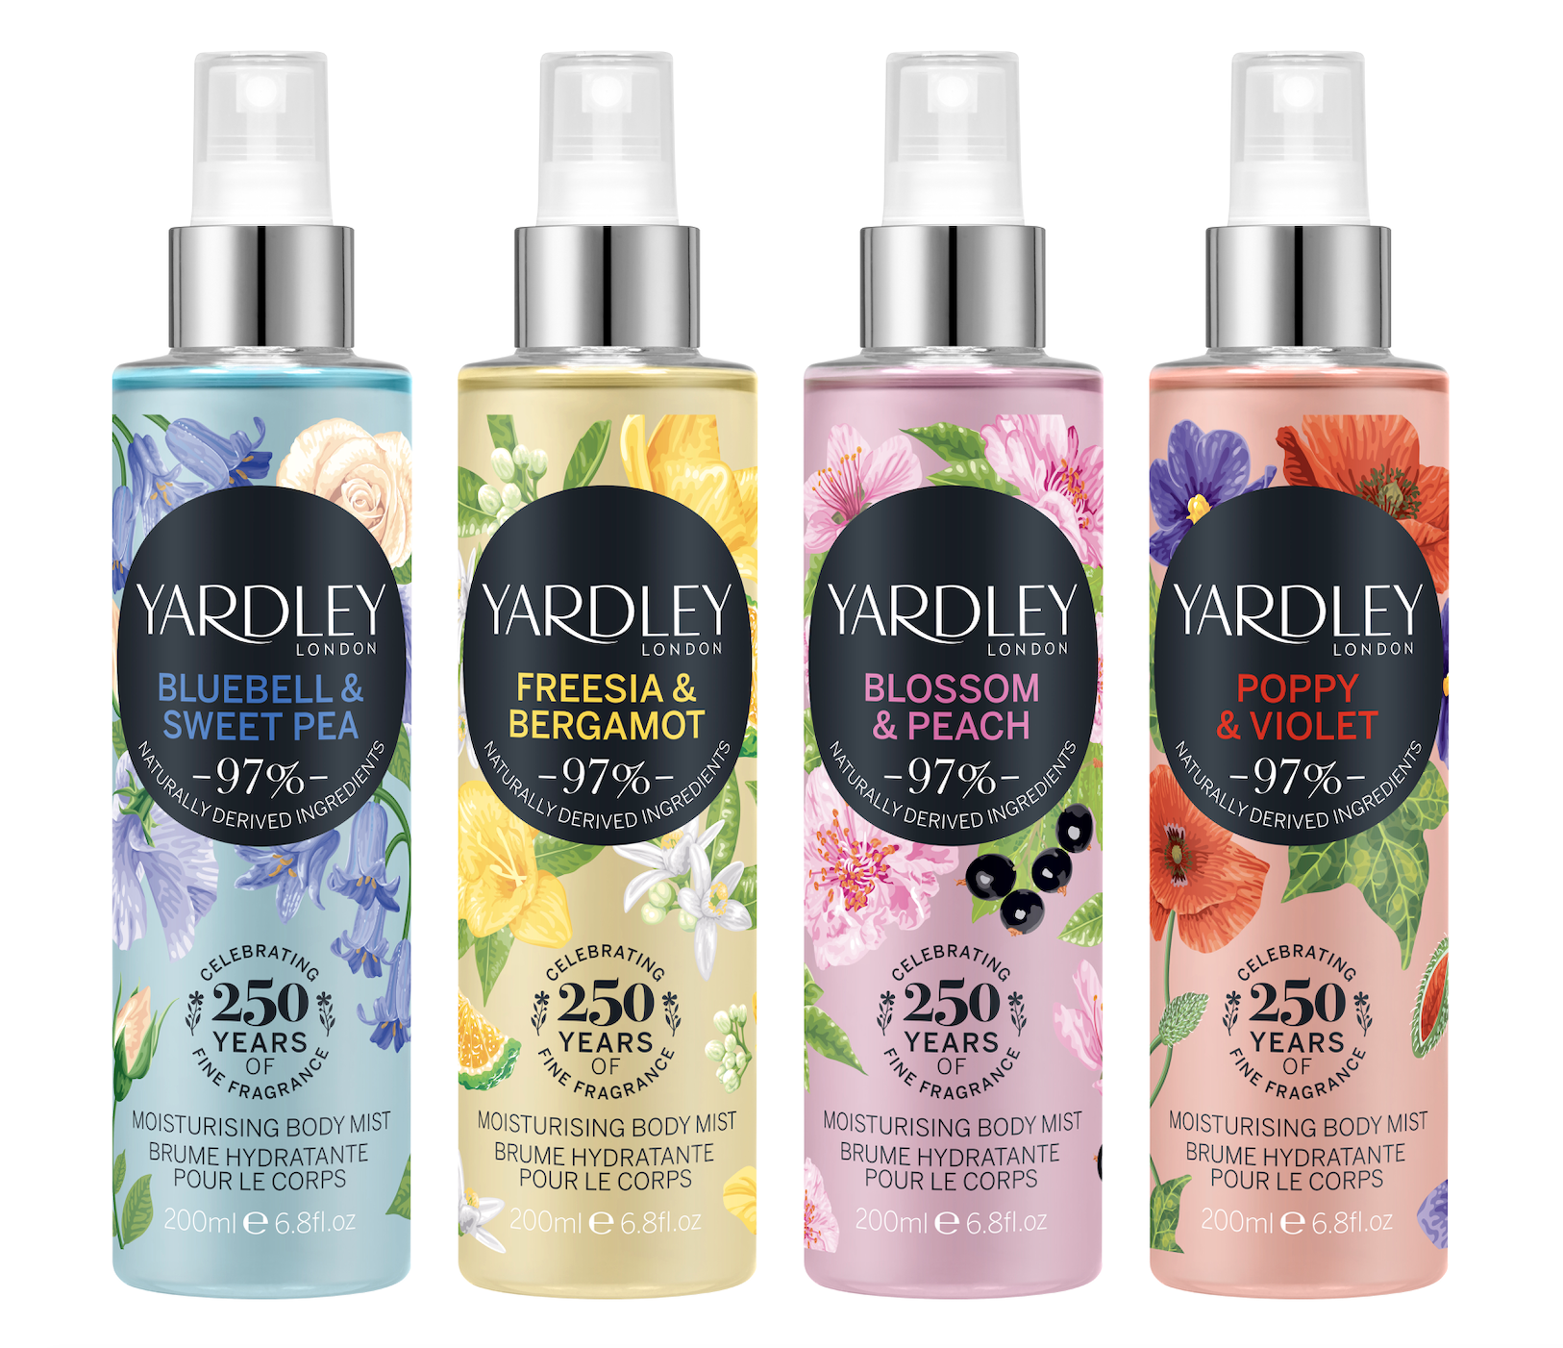
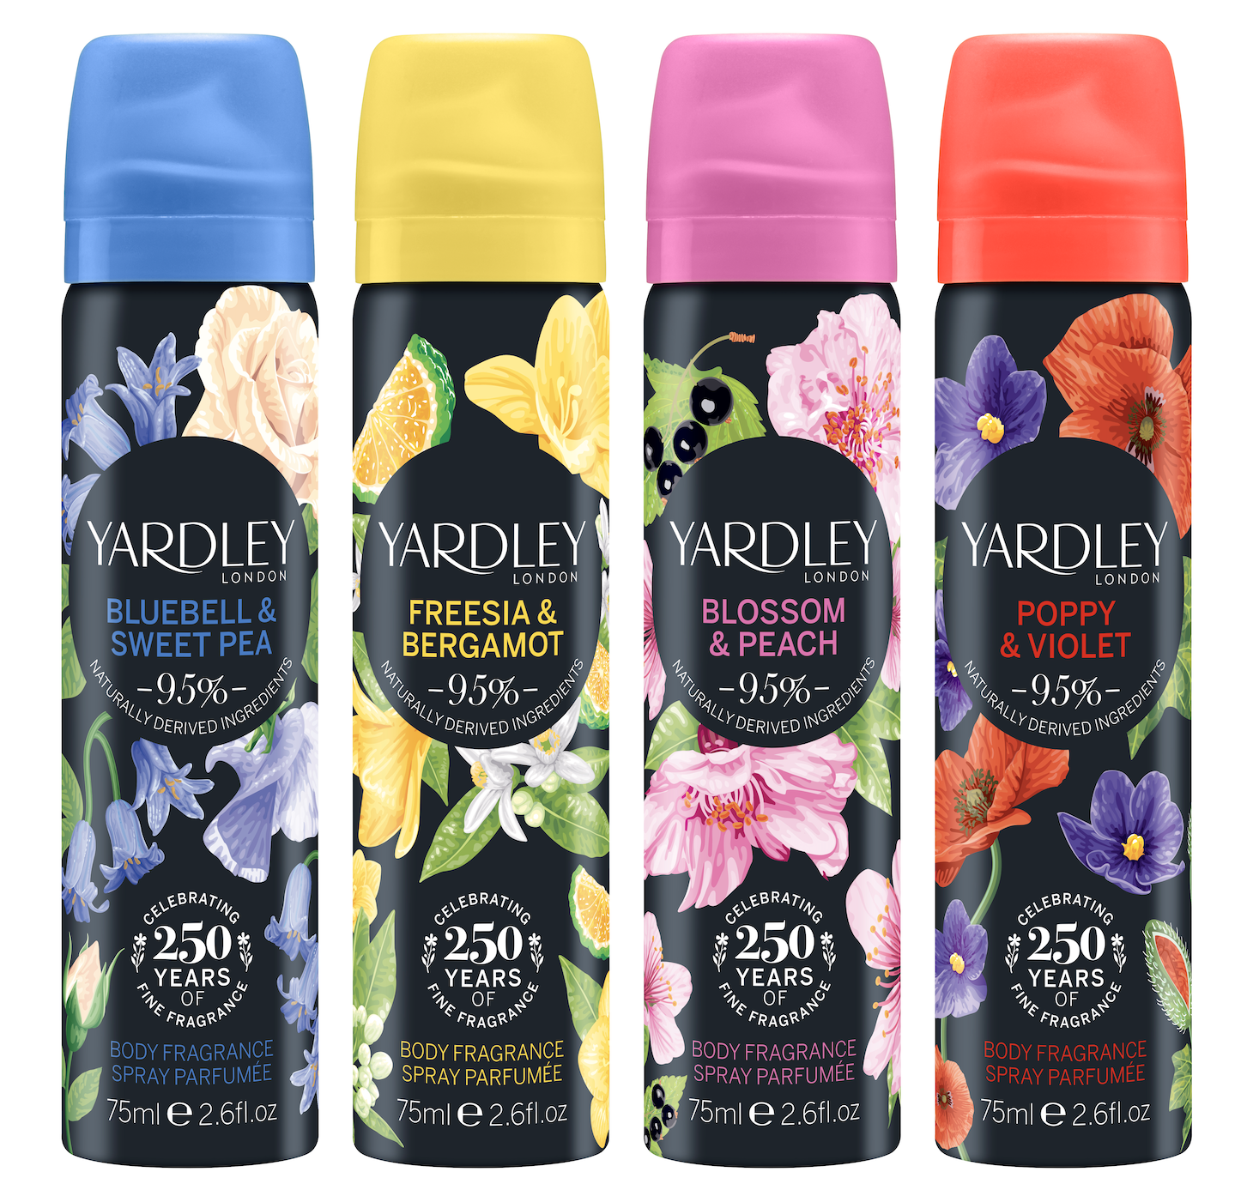

All Contemporary Fragrances are suitable for vegans and contain up to 97% naturally derived ingredients. EDTs and Mists have a vegetable alcohol base.
For more information, high res imagery and queries please contact Catalyst PR on pr@catpr.com, @CatalystPR_

