DRINK ‘TURTLEY’ WASTE FREE THIS SUMMER
Hawksbill Caribbean Spiced Rum launches Mango and Pineapple flavours made from waste fruit in a new eco-friendly bottle
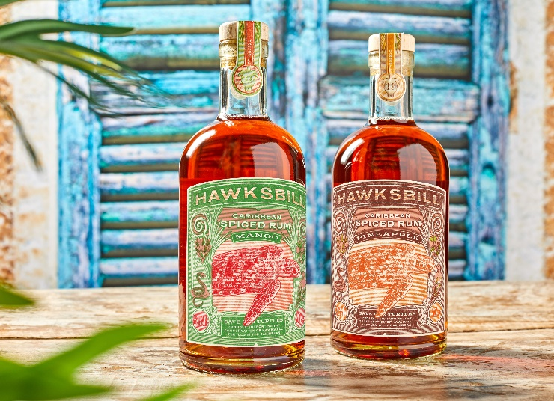
The turtle-saving Hawksbill Caribbean Spiced Rum is continuing its conservation and sustainability mission with the addition of two new delicious, fruity rums to its range – Mango and Pineapple.
The brand is taking its pledge to the environment a step further with these two tasty flavours. Not only do they bring together the very best Caribbean rums from Trinidad and Guyana, blended with a distinctive combination of spices, but they also utilise fruits that would have otherwise gone to waste – all in a lighter, more eco-friendly bottle.
Food waste is a huge issue across the globe and UK households throw away 6.5 million tonnes of it every year, 4.5 million of which is completely edible¹. With food waste proven to feed climate change and therefore fuel the negative impact on our planet and its wildlife, Hawksbill Rum wanted to utilise fruit that would have otherwise been disposed of.
The two new flavours not only include the original flavour packaging elements, such as the cork made from waste material and a sugarcane fibre label printed with plant-based inks, but also come in a lighter weight bottle (740g to 600g), saving over 100kg per pallet. This helps to decrease CO₂ emissions due to its reduction in weight when transporting to retailers and drinkers, so you can drink and enjoy with a clear conscience!
In addition, the new flavours continue to support the endangered turtles after which the brand is named by donating 10% of the profits from every bottle sold to the Barbados Sea Turtle Project, a conservation project set up to help protect endangered and critically endangered sea turtles and their habitats.
If you want to help support their ‘turtley’ awesome efforts, you can purchase the new flavours as well as the original Hawksbill Spiced Caribbean Rum for RRP £23 (70cl bottle) directly from their website as well as via Amazon.
ENDS
1 https://www.lovefoodhatewaste.com/
Notes to Editors

For all media enquiries please contact the team at ICB@hatchpr.co.uk or 0113 361 3600.

Hi-res imagery can be found here: https://we.tl/t-vgjlmun8rH.

About Hawksbill Caribbean Spiced Rum

Launched in October 2020, Hawksbill Caribbean Spiced Rum provides more than a taste of the Caribbean, with each bottle helping to save endangered Hawksbill turtles.

Hawksbill has partnered with the Barbados Sea Turtle Project, based at the University of the West Indies, whose mission is to recover marine turtle populations. 10% of the profits from Hawksbill sales will go directly towards turtle conservation projects in the Caribbean.

The liquid itself brings together the very best Caribbean rums from Trinidad and Guyana, along with its own distinctive blend of spices. Sweet Vanilla floats across the palate before a wave of toasted nutmeg, cinnamon, and raisin breaks, allowing a hint of cardamom and sea salt to nestle on the taste buds.

A limited run of the Mango and Pineapple flavours was released for Zero Waste Week last September and after its popularity, Hawksbill has relaunched both flavours into its core range, this time implementing the lighter, more eco-friendly bottle, too.
About Barbados Sea Turtle Project:
- The BSTP has been involved in conservation of the endangered marine turtle species for over 25 years
- Aim is to help restore marine turtle populations, protect its environment and future. Through research, education, public outreach as well as monitoring nestings and hatchlings.
- Research based conservation in action
- They have 1 full time member of staff – Carla and Volunteers from local community and overseas volunteers
- Throughout the nesting period they go out at night and patrol the beaches to make sure female turtles finding a suitable nesting place are safe as well as her eggs.
- They track post nesting turtles to foraging grounds and follow their journeys
- They operate a 24hour helpline and work with resorts to educate its visitors on the turtles and how to approach one
- Support comes from a number of different funds including US turtle charities keen to especially support them through struggles of Covid
- Check out their Facebook and Instagram pages as you’ll see some of the amazing work they do!

