STIHL LAUNCHES FIRST GRASS TRIMMER IN AS SYSTEM

Introducing the first grass trimmer in STIHL’s AS System of interchangeable battery-powered tools, the FSA 30. Boasting a compact and lightweight design, the FSA 30 grass trimmer is perfect for trimming lawn edges in small gardens.

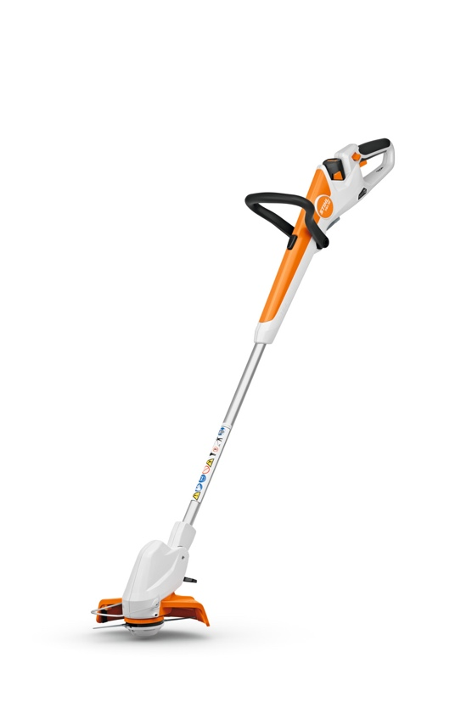
Offering optimum balance and control, the FSA 30’s extremely lightweight and easy to manoeuvre design features an adjustable loop handle and an extendable shaft, allowing the machine to be customised to users of different heights. The angle of the trimming head can also be optimised, ensuring a neat and even cut.

Not only does the shaft of the FSA 30 extend by up to 17cm, but it can also be rotated by 90° too. In this mode the FSA 30 can be used for trimming lawn edges for a crisp finish to the lawn. A spacer bar prevents the PolyCut blades from touching obstacles such as plant pots or young plants, and a hanging mount on the handle allows for easy storage on the shed or garage wall.

The FSA 30 uses PolyCut blades that are not only easier to replace and longer lasting compared to standard mowing line, but much more efficient too. Thanks to the PolyCut blades and efficient motor, the FSA 30 has a working time of up to 19 minutes - plenty of time to get the lawn looking great on a single charge.

The STIHL AS System comprises of a range of compact, easy-to-handle garden tools with interchangeable batteries, including cordless shrub shears, a garden pruner, hedge trimmers and a mini vacuum which is ideal for tidying up dry debris in your garden shed or car boot.

The RRP for the FSA 30 is £99 for the tool only, RRP £139 for the set, which includes an AS 2 battery and AL 1 charger, and RRP £159 for the set with an additional AS 2 battery.

The new FSA 30 will be available to buy from STIHL Approved Dealers nationwide from spring 2024. For more information on STIHL's AS System of interchangeable battery-powered tools, please visit www.stihl.co.uk.

-ENDS-

About STIHL

It all started with a chainsaw, and to this day, it's still the product for which the STIHL brand is best known worldwide.

Ever since Andreas Stihl invented the first portable chainsaw, the STIHL name has stood for revolutionary technology, driven by significant investments in research and development and a single-minded passion for making people's lives easier when working in nature. It's because of this that STIHL has been the world's best-selling petrol chainsaw brand since 1971.

But the STIHL name is now synonymous with many other industries too, as well as with home gardeners looking for premium quality tools. The extensive STIHL range includes hedge and grass trimmers, multi-tools, pressure washers, construction tools, lawn mowers, lawn tractors, robotic mowers and of course, chainsaws.

A family-owned business based in Germany; STIHL employs more than 20,000 people worldwide and sells products in more than 160 countries globally.

STIHL GB is a wholly-owned subsidiary of the global STIHL Group. In Great Britain, STIHL products are available from more than 700 specialist Approved Dealers who offer expert advice and after sales support. Selected tools are also available from quality garden centres and from STIHL's own online store https://shop.stihl.co.uk/

Whatever STIHL tool you choose and however it's powered - battery, petrol or electric - each features countless innovations, exceptional performance and lasting quality.

Issued on behalf of STIHL GB by HROC Ltd. For further information please contact:

HROC Limited
Tel: 0121 454 9707
E: prstihl@hroc.co.uk

