
RUSSELL HOBBS RELEASES STEAM GENIE 2-IN-1 TO TACKLE STUBBORN CREASES ALL OVER THE HOME
The Steam Genie 2-in-1 tackles stubborn creases quickly and effortlessly using One Temperature technology and killing up to 99.9% bacteria in less than 60 seconds*!
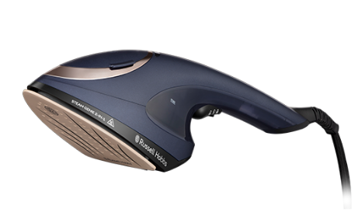

Continuously creating thoughtful innovations, Russell Hobbs has understood the needs of households since 1952 and is one of the most trusted brands in the UK.
The latest addition to their garment steamer collection is the Steam Genie 2-in-1. Its innovative 2-in-1 design allows users to steam and iron clothes, curtains, and fabrics effortlessly without the need for hours spent at the ironing board.
Standing out from the crowd, this garment steamer does it all, with a steaming and ironing function and is available now in all major retailers. With the innovative One Temperature technology, you can save time deliberating what temperature to use, as the ceramic soleplate heats up in just 60 seconds and evenly distributes heat, smoothly eliminating creases from your clothes and home. It’s incredibly simple to use.
The steamer has a 20g steam output with a steam trigger lock releasing a powerful hit of steam which opens the fibres to help better penetrate the fabric to tackle even the toughest creases. The steam also kills 99.9% bacteria in 60 seconds* so you can enjoy fresh, softer and cleaner fabrics around your home.
The Steam Genie 2-in-1includes a 1700w performance, 150ml water capacity and a heat-resistant bag accessory which can be used as a storage bag or a mat to rest your steamer on, perfect for on-the-go cleaning and ironing. The 3m power cord and cord storage also gives more freedom to give your home a steam, whilst tidying away into a neat package when it’s not in use.
Thanks to the Steam Genie 2-in-1’s upholstery, delicate and fabric attachments, you no longer have to worry about damaging your fabrics and can deodorise and freshen up even the larger materials around your home like bedding, soft toys, sofas and even mattresses.
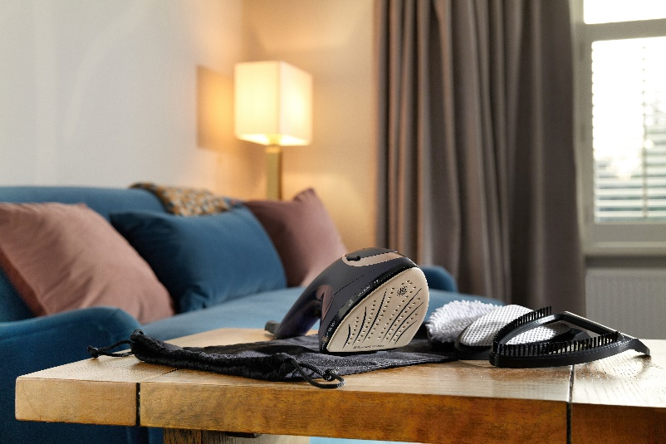
Cira Jones, UK brand manager at Russell Hobbs, said: “We’re thrilled to have launched our Steam Genie 2-in-1. After some great success with our other garment steamer products, we’re confident this will be a huge hit with customers who want to effortlessly remove creases and freshen up fabrics around their home.
“We want to provide our customers with variety and quality performance throughout our range so they can choose the right product to suit their lifestyle as we understand the individual needs of consumers and what matters to them most. We get that life can be busy and stressful at times and we want to create products that are simple to use and make life easier and we feel we have done just that with the Steam Genie 2-in-1.
The Steam Genie 2-in-1 is available to buy from www.russellhobbs.com, where you can also find more product information.
-END-

For more information, please contact russellhobbs@hatchpr.co.uk

Notes to editors

About Russell Hobbs:
Every ingenious Russell Hobbs creation is here to help you do you. That’s because we’re inspired by the things that matter to you.
Just-in-time brews. Tackling creases on your own terms. Giving new recipes a go. We get what’s important, especially when life’s hectic and, let’s face it, far from perfect. That’s why our ideas are beautifully British and ready for living.

Disclaimer:
*2 types of bacteria on 3 surfaces. Laboratory tested. See website for more details.

Product Features:

- 2 in 1 Design: Steaming Feature / Ironing Feature
- One Temperature Technology
- Kills up to 99.9% Bacteria in 60 Seconds*
- Quick 60 Second Heat-Up Time
- Heat Resistant Bag Accessory
- 1700W
- Ceramic Soleplate
- 150ml Water Tank Capacity
- 20g Steam Output with Steam Trigger Lock
- Over 7 Minutes Steaming Time
- 3m Power Cord with Cord Storage
- Power and Temperature Indicator Light
- Accessories: Delicate, Upholstery, Fabric Brush and Travel/Storage Bag
- Auto Shut-Off

