GAIA Skincare Christmas Gift Selection 2026

Handmade, Natural & Vegan Skincare Gifts for Christmas

Award-winning natural skincare and spa brand GAIA Skincare presents its 2026 Christmas collection of handmade, organic and vegan skincare and home gifts. Combining pure essential oils, plant actives and spa-inspired rituals, the collection features beautifully curated gift sets and standalone treats designed to bring moments of relaxation, wellbeing and natural beauty to the festive season.

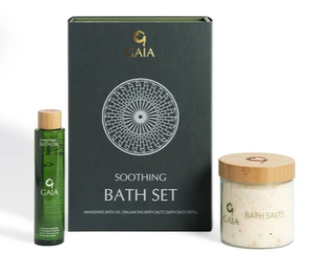
Soothing Bath Gift Set | £45 - The perfect gift for a relaxing soak.
Mineral-rich bath salts and uplifting bath oil combine to create a spa-inspired bathing ritual that relaxes the body and restores the mind.
Includes: Balancing Bath Salts and Awakening Bath Oil.

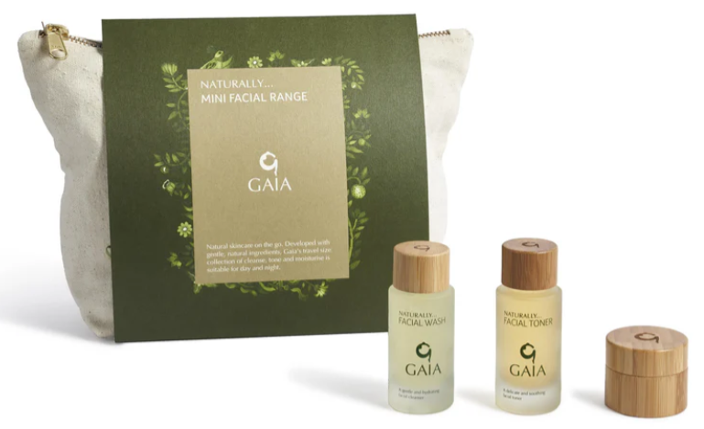

Mini Facial Range | £32.50 - A festive skincare reset in a beautifully presented collection.
A selection of facial essentials to cleanse, balance and hydrate, helping skin look and feel its best throughout the festive season.
Includes: Facial Toner, Facial Wash and Facial Moisturiser.

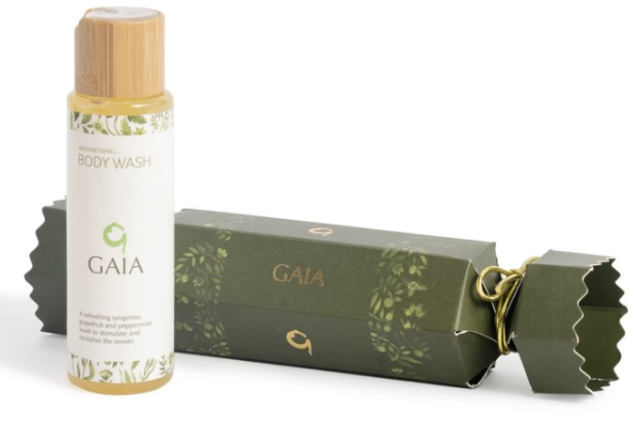

Body Wash Cracker | £12 - A little burst of wellbeing, wrapped for Christmas.
Featuring GAIA’s uplifting Awakening Body Wash, infused with grapefruit, tangerine and soothing botanicals to gently cleanse and refresh from head to toe.

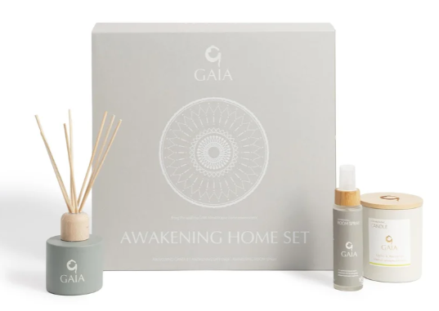
Home Gift Set | £65 - Bring the GAIA spa experience into the home.
Featuring the uplifting Awakening Blend, this beautifully presented collection fills any space with comforting, energising aromas.
Includes: Awakening Room Spray, Awakening Candle and Awakening Diffuser.

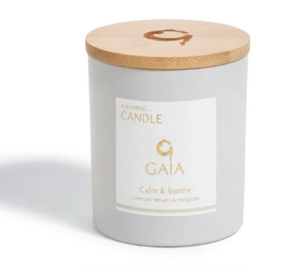

GAIA Full-Sized Candle | £17.25 - Festive ambience, beautifully wrapped.
A natural candle designed to fill the home with uplifting aromas and bring a touch of everyday wellbeing to any room. Available in Awakening, Balancing or Calming blends.

Available at: www.gaiaskincare.com
For further information and images, contact: Liz Parry - pr@gaiaskincare.co.uk

ENDS

ABOUT GAIA
Blending the finest ingredients, plant actives and essential oils, GAIA products are full of intention and integrity. Created to nourish and nurture, GAIA is led by the brand philosophy, Your Wellness, Naturally. Each ingredient has been chosen for its beneficial properties for the body and mind, how it will make you feel and what the ingredient will do. Made with natural and organic ingredients, no GAIA products have been tested on animals. The GAIA Skincare range features three collections made with GAIA’s Awakening, Balancing and Calming blends. GAIA products do not contain parabens, sulphates, synthetic colours or fragrances.

