Press Release

GAIA Skincare’s Advent Calendar Is Back – A 24-Day Countdown to Festive Wellbeing
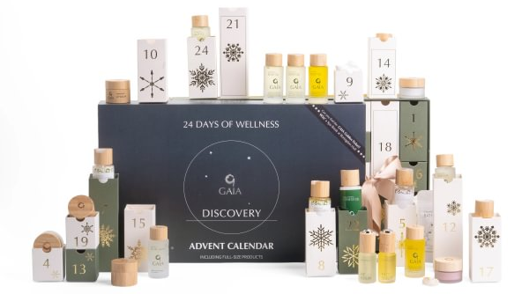
Hi-res images

Devon, Christmas 2026 – Award-winning natural skincare and spa brand GAIA Skincare is delighted to announce the return of its much-loved Wellness Advent Calendar for Christmas 2026. Back by popular demand, this limited-edition collection offers 24 premium skincare and wellbeing treats, including full sized products worth over £300, giving customers the chance to experience GAIA's luxurious natural skincare for just £160.

Made with natural and organic ingredients, GAIA's award-winning products are cruelty free and formulated without parabens, sulphates, synthetic colours or fragrances, bringing together botanical extracts and expertly blended essential oils to nourish both body and mind.

Designed to bring moments of calm and self-care throughout the festive season, the calendar features an expertly curated mix of face, body, bath and hair care, including full-size favourites such as the Face Serum, Eye Serum, Awakening Body Lotion, Awakening Shampoo, Awakening Conditioner and Fitness Gel, alongside bestselling oils, balms, facial essentials, bath salts and an uplifting Citrine crystal.

One lucky customer will also discover a Golden Ticket hidden inside their calendar, winning an indulgent overnight stay for two at the five-star Boringdon Hall Hotel, complete with treatments at the flagship Gaia Spa.

Key highlights

- 24 premium products spanning face, body, bath and hair care, including full-size skincare favourites and bestselling wellbeing essentials.
- Worth over £300, RRP £160, offering exceptional value and the perfect introduction to GAIA's award-winning natural skincare range.
- Includes customer favourites such as Face Serum, Eye Serum, Awakening Body Lotion, Awakening Shampoo & Conditioner, Fitness Gel, Sleep Balm, Crystal Nourishing Cream and the signature Awakening, Balancing and Calming bath and body oils.
- Golden Ticket prize hidden in one calendar, offering an overnight spa stay for two at the five-star Boringdon Hall Hotel.

Whether gifted to a loved one or enjoyed as a seasonal treat, the GAIA Wellness Advent Calendar is an indulgent way to discover the brand's award-winning collection while enjoying 24 days of luxurious self-care.

Price: £160 (worth £300)
Available at: www.gaiaskincare.com/products/advent-calendar
For further information and images, contact: Liz Parry - pr@gaiaskincare.co.uk

ENDS

NOTES TO EDITOR

ABOUT THE PRODUCTS
Blending the finest ingredients, plant actives and essential oils, GAIA products are full of intention and integrity. Created to nourish and nurture, GAIA is led by the brand philosophy, Your Wellness, Naturally. Each ingredient has been chosen for its beneficial properties for the body and mind, how it will make you feel and what the ingredient will do. Made with natural and organic ingredients, no GAIA products have been tested on animals. The GAIA Skincare range features three collections made with GAIA’s Awakening, Balancing and Calming blends. GAIA products do not contain parabens, sulphates, synthetic colours or fragrances.

