YuMe Toys launches the ‘Netflix Gift Box’:
The Ultimate Family Essential

- ‘Netflix Gift Box’ filled with 24 exclusive items from 7 fan favourite titles
- Available on Amazon and all leading retailers from 01 October 2024

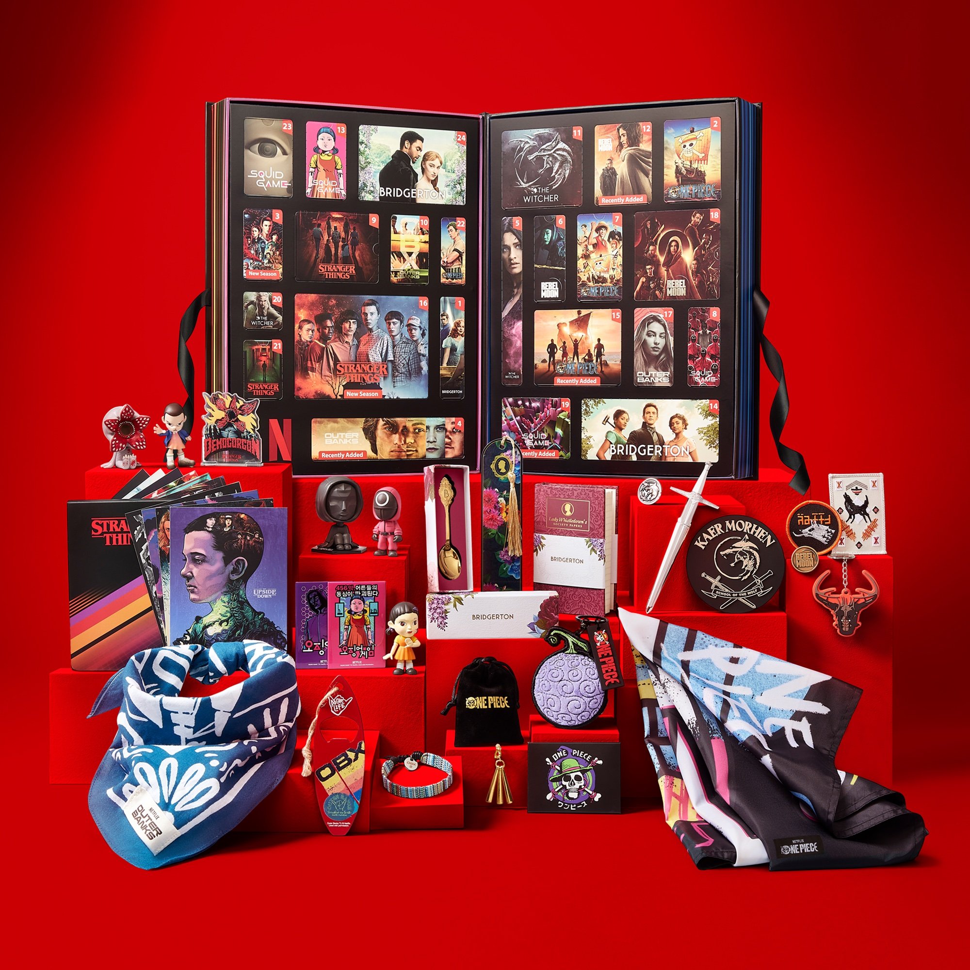

London, XX September 2024: YuMe Toys, in partnership with Netflix, is turning up the heat with something truly special for the Autumn/Winter 2024 season - the ‘Netflix Gift Box’. Far from a box of collectibles, it includes a range of exclusive items that pay tribute to some of the entertainment company’s most beloved shows and films.

Retailing at £99.99 and launching on 1st October via Amazon and all leading retailers, the ‘Netflix Gift Box’ is set to be the must-have item for the holiday season. Whether it’s family game nights, cozy evenings in, or simply a way to indulge your Netflix fandom; this gift box offers enjoyment for all.

Inside, there are 24 numbered compartments, each a gateway to the world of one of seven beloved Netflix titles. Carefully curated, these compartments hold exclusive, premium products that reflect the essence of each show or film. Whether fans of the regency-era romance of Bridgerton, the nail-biting tension of Squid Game, the monster-slaying adventures of The Witcher, the nostalgic horror of Stranger Things, the epic sci-fi journey of Rebel Moon, the adventurous spirit of Outer Banks, and the anime-inspired thrill of One Piece - there’s something for everyone.

“The ‘Netflix Gift Box’ is not just a product; it’s an experience, a celebration, and a testament to the power of storytelling and innovation,” says Ryan Kravontka, Head of Global Marketing at YuMe Toys. “We are incredibly proud of developing this with Netflix - a product that will delight and be shared by fans of all ages.”

-ENDS-

Media Information:

Media contact: Kirsty Barr, Grapevine PR, Tel: 07375 110558

For images: https://www.pressfix.co/yumetoys-com

Video link: https://youtu.be/a69qXvpZddg

