STIHL ADDS TWO NEW LIGHTWEIGHT HEDGE TRIMMERS TO AS SYSTEM

The latest additions to STIHL’s AS System range of battery-powered tools, the HSA 30 and HSA 40 hedge trimmers, are compact and simple to use, making light work of fresh growth on small hedges.

Both hedge trimmers feature high quality diamond ground and hardened blades, resulting in a clean cut and long-lasting sharpness. The HSA 30 and HSA 40 are extremely lightweight and well-balanced too, making them easy-to-use and manoeuvre – in fact, the HSA 30 is the lightest hedge trimmer in STIHL’s extensive range, making it suitable for all home gardeners.

The HSA 30 and HSA 40 are almost silent in operation so there’s no need to worry about disturbing the neighbours, and with a long working time of 50 minutes and 40 minutes respectively, it’s easy to finish the job on one charge. The new hedge trimmers come with a lifetimes supply of gearbox grease for easy maintenance, meaning all the user must look after is the condition of the blades.
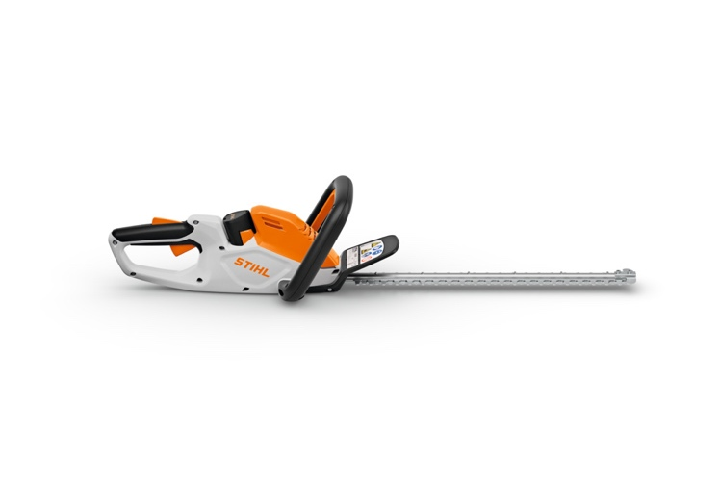
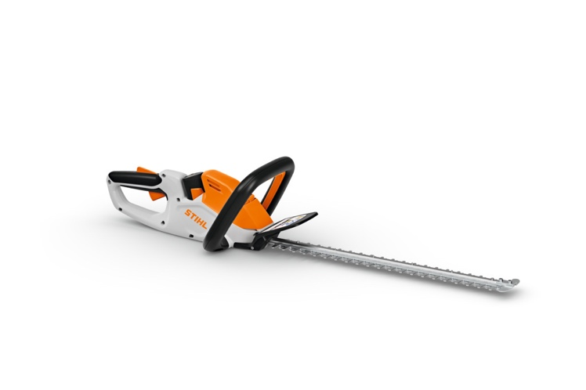
Figure 1 HSA 30
Figure 2 HSA 40

The HSA 40 boasts 25% better cutting performance than the HSA 30, making it suitable for more demanding tasks. The HSA 40 also features a 5cm longer cutting bar, 2mm larger tooth spacing and an extra AS 2 battery included in the set for even longer working times.

The STIHL AS System comprises of a range of compact, easy-to-handle battery garden tools with interchangeable batteries, including cordless shrub shears, a cordless garden pruner, grass trimmer and mini vacuum which is ideal for tidying up dry debris in your garden shed or car boot.

The RRP for the HSA 30 is £99 for the tool only, with a RRP of £139 for the HSA 30 set, which includes an AS 2 battery and an AL 1 charger.

The RRP for the HSA 40 is £129 for the tool only, with a RRP of £179 for the set, which includes two AS 2 batteries and an AL 1 charger.

The new HSA 30 and HSA 40 hedge trimmers are available to buy now from STIHL Approved Dealers nationwide. For more information on STIHL's AS System of interchangeable battery-powered tools, please visit www.stihl.co.uk.

-ENDS-

About STIHL

It all started with a chainsaw, and to this day, it's still the product for which the STIHL brand is best known worldwide.

Ever since Andreas Stihl invented the first portable chainsaw, the STIHL name has stood for revolutionary technology, driven by significant investments in research and development and a single-minded passion for making people's lives easier when working in nature. It's because of this that STIHL has been the world's best-selling petrol chainsaw brand since 1971.

But the STIHL name is now synonymous with many other industries too, as well as with home gardeners looking for premium quality tools. The extensive STIHL range includes hedge and grass trimmers, multi-tools, pressure washers, construction tools, lawn mowers, lawn tractors, robotic mowers and of course, chainsaws.

A family-owned business based in Germany; STIHL employs more than 20,000 people worldwide and sells products in more than 160 countries globally.

STIHL GB is a wholly-owned subsidiary of the global STIHL Group. In Great Britain, STIHL products are available from more than 700 specialist Approved Dealers who offer expert advice and after sales support. Selected tools are also available from quality garden centres and from STIHL's own online store https://shop.stihl.co.uk/

Whatever STIHL tool you choose and however it's powered - battery, petrol or electric - each features countless innovations, exceptional performance and lasting quality.

Issued on behalf of STIHL GB by HROC Ltd. For further information please contact:

HROC Limited
Tel: 0121 454 9707
E: prstihl@hroc.co.uk

