Uplifting Products Announces Charity Partnership with Sea Sanctuary
taking mental healthcare out of the office and onto the water
April 2020 - Uplifting Products Ltd proudly partners with Penryn based charity, Sea Sanctuary to support those in need of mental health support. A percentage of every Uplift 2.0 sold on the company’s website will go towards funding those who need financial help accessing the charity’s services.

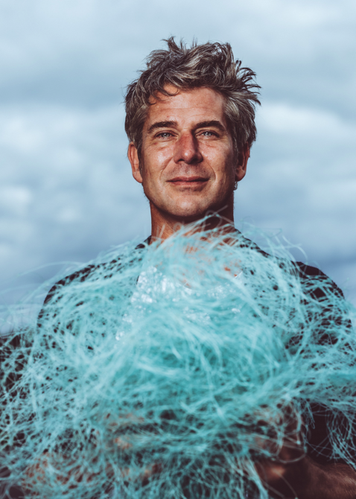
Good for our minds, good for our planet
Uplift 2.0 is the latest creation from British inventor, TV personality and co-founder of Uplifting Products Ltd, Tom Lawton.
Uplift 2.0 is a mesmerising, spiralling sculpture which sits on your window-sill and gentle revolves. Powered by the sun, it generates a visually soothing motion designed to help you relax and unwind. The progressive new design is inspired by the sea’s translucent colour and hypnotic motion of the waves. 100% recycled fishing nets from local Cornish Hake Fisheries form the spiral’s structure and make the aquamarine colour.
Tom Lawton comments, ‘Inspired by the ocean, Uplift 2.0 inspires you to unwind, relax, and find a meditative moment of calm in everyday life. There’s a symbiosis between Uplift 2.0 and the charity, it’s a natural fit’.

Sea Sanctuary is a unique mental health and wellbeing charity rooted in the concept of ‘blue health’. Its programmes rely on the environment and use techniques thought to be the first of their kind in the world. They use a combination of sail training, marine activities and evidence-based therapies to help children and adults who are struggling with issues such as stress, anxiety, depression, and a whole range of mental and emotional health problems.
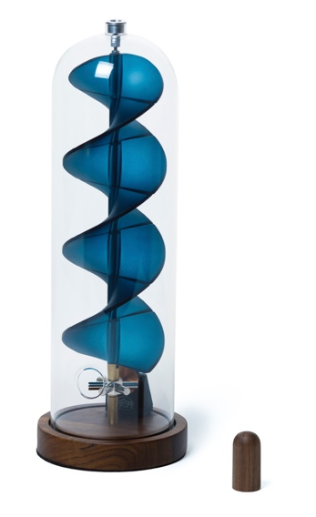
Joe Sabien comments “As founder of Sea Sanctuary, I am always keen to explore the possibility of synergy in relation to other organisations. Given the platform for our mental health interventions is exclusively sea-based, it stands to reason that any such synergy would have a ‘blue’ element to it. In this case, it is, quite literally blue and in the form of a helpful and therapeutic classic design piece. Based on my knowledge of this little gem of wellbeing, it will help us slide, effortlessly, into a place of relaxation and remind us to be in the ‘here and now’. As someone who has a long-standing and deep passion for the sea, if I could open my house up and invite it in, I surely would. To my mind, this is the next best thing. It seems, ostensibly, to capture the very essence of the sea; gentle, calming, blue and dreamy. Thank you, Uplifting Products, for your kind financial support which will help us to continue helping some of the most vulnerable people in society; those afflicted with mental ill health.”

Tom Lawton continues, “Joe and the team at Sea Sanctuary provide invaluable support to vulnerable people via their unique concept of ‘blue health’. What they do is truly remarkable and we’re very proud to be supporting them.”

For every Uplift 2.0 sold on beuplifted.co.uk, £10 will be donated to the charity and go into the ‘Be Uplifted Bursary’ to aid those seeking finical support in order to access the charity’s services.

Uplift 2.0 is designed, manufactured and assembled by hand in England. Available now from https://beuplifted.co.uk with delivery from 1st September RRP: £185.
-ENDS-
Boiler Plate
Welcome to Uplifting Products. We’re new on the scene, inventing uplifting products designed to make you smile. With an award-winning British Inventor at the helm, we lift spirits and provide moments of calm in an otherwise chaotic world. Tom Lawton, co-founder of Uplifting Products is the epitome of the great British inventor and is possibly Britain's loveliest one too. Concerned about the environmental crisis and passionate about doing something positive about it, Tom looks for long-lasting solutions to some of life’s problems.

Uplift Celebrity Testimonials
"Wowzer, Tom Has done it again. Uplift 2.0 captures the essence of the regenerative future; she runs on sunlight, turns waste material into timeless art, and calms the spirit as she spins. Just beautiful!" - Kate Raworth, Renegade Economist

"I love it. Such a beautiful thing" - Matt Haig, Author

"I love this. A happy, dreamy, solar sculpture" - Derren Brown, Mentalist

"Uplift is so hypnotic. I could watch it forever" - Jamie Oliver, Chef

"The infinite movement of the Fibonacci spiral in the beautiful and calming sculpture Uplift always connects me to my true potential and source. I'm so grateful for my Uplift and I enjoy it everyday!" - Gordana Biernat @mypowertalk

Press Office
LFPR
Lydia Ford | Lydia@lydiafordpr.com | 07801802014. More information and interviews are available on request. High resolution images, logo and videos can be found http://bit.ly/UPLIFT2PRESSFOLDER
Social Media
Follow Tom’s journey for uplifting products on social media:
Instagram: https://www.instagram.com/tomlawton/
Twitter: https://twitter.com/tomlawton
Notes to Editors
Sea Sanctuary - Waterside Court, Falmouth Road, Penryn, Cornwall TR10 8AW
Sea Sanctuary takes therapy out of the office and onto the water – it’s a recipe that has helped hundreds of people improve their mental and emotional wellbeing since the charity was launched in 2006.
https://seasanctuary.org.uk

Recycled Fishing Nets - Fishy Filaments, Newlyn, Cornwall
Working with Fishy Filaments, an award-winning waste processing start-up based in in Newlyn, Cornwall, Uplift 2.0 successfully uses recycled fishing net to make the sculpture’s spiral structure. On average, every single waste fishing net allows Lawton to make roughly 70 Uplift 2.0's. With 1,000 pre-orders already taken, Lawton is using 100kg of recycled material in his initial batch, the equivalent of fifteen fishing nets. This is a significant amount of waste fishing net being recycled off the Cornish coast and prevented from going to landfill, or worse still, left in the ocean.
Tom Lawton - British Inventor
Tom Lawton is an award-winning British Designer based in Wiltshire. Tom was the winner of the Green Dot Award (2009) and Sustainable Design Award (2010). Tom was the star of C4 series 'Tom's Fantastic Floating Home' in 2013. His previous inventions include Million Mile Light, BubbleScope, Firewinder, WakeYoo and Honkies. Tom Lawton founded Uplifting products in 2019 as part of his mission to lift the spirits of a stressed out world.
For Tom’s full bio, visit: www.tomlawton.com

Uplift 2.0 Technical Specifications
- Product Diameter: 11cm | Product Height: 30cm | Overall weight: 900g
- Power: 100% Solar Powered Engine
- Included in the box: Base, Spiral, Dome and Magnetic Wand
- Recyclable Materials: Walnut (base), Mild Steel (mechanism), Waste Fishing Net Nylon (spiral), Borosilicate Glass (dome)
- Each unit is shipped in recycled gift packaging

Uplift 2.0 Kickstarter campaign
Uplift 2.0 raised £25,000 within 48 hours as part of a Kickstarter campaign which went live on 26th November 2019. The campaign ran until 31st December 2020 and has now raised £76,739.00.
https://www.kickstarter.com/projects/millionmilelight/uplift-20-unwinding-spiral-sculpture-to-soothe-the-soul

