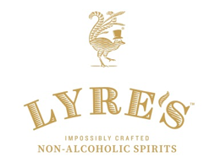
LYRE’S BECOMES MOST AWARDED PORTFOLIO OF SPIRITS GLOBALLY IN THE NON-ALCOHOLIC SPIRITS CATEGORY AND SEES RECORD GROWTH

- Lyre’s non-alcoholic spirit brand sees record growth across e-commerce
- Lyre’s pivots to direct-to-consumer sales in response to COVID-19

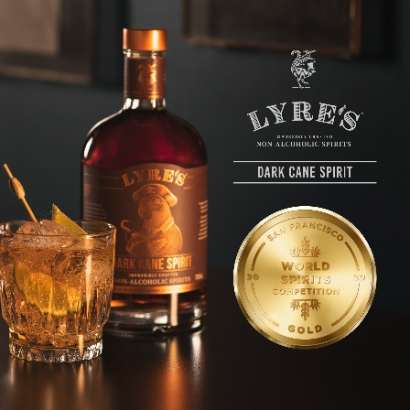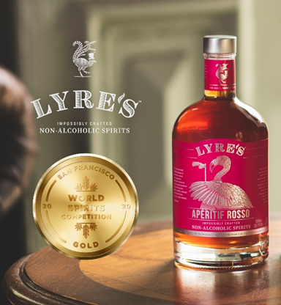

27th April 2020: Premium non-alcoholic spirit brand Lyre’s sees record e-commerce growth as it pivots to direct-to-consumer sales in response to COVID-19 and wins big at the San Francisco World Spirits Competition becoming the most awarded portfolio of spirits globally in the non-alcoholic spirits category.

Launched in 2019, Lyre’s has seen a 400% increase in global sales compared to this time last month and doubled its UK conversion rates last weekend, while in the US the brand saw its largest revenue sales days to date. It also launched last week on both Amazon and Google Shopping in the UK.

Lyre’s is at the forefront of the mindful drinking movement, encouraging people to drink more carefully especially during this period of isolation by either cutting back or substituting for a non-alcoholic alternative, and generally inspiring them to create beautifully crafted non-alcoholic drinks. Recent research from global data analytics company Nielsen suggests that the sale of alcohol has increased by 291% during the pandemic, while last week academics warned that increased consumption could lead to a second national health crisis.

These strong growth figures come after Lyre’s became the most awarded non-alcoholic spirit brand in the world, winning 10 medals at this month’s prestigious San Francisco World Spirits Competition 2020 (SFWSC), reflecting the brand’s excellence in the creation of impossibly crafted non-alcoholic spirits.
Judged by a panel of 52 leading industry experts, Gold medals were awarded to Lyre’s Aperitif Rosso and Dark Cane Spirit, while Aperitif Dry, Amaretti, Coffee Originale, and Spiced Cane Spirit received silver medals. In addition, Lyre’s Orange Sec, Dry London Spirit, White Cane Spirit, and American Malt were recognized with bronze medals. The 2020 SFWSC competition was the biggest in its history, featuring almost 3,000 entries in various categories.

Anthony Dias Blue, the competition’s founder and executive director comments: “The San Francisco World Spirits Competition has seen an increase the past few years with non-alcoholic entries and this is the first year that they have placed exceptionally well with Lyre’s Non-Alcoholic Spirits. The judges tasted Lyre’s against alcoholic counterparts in the aperitif, coffee liqueur, fruit liqueur, nut liqueur, other whiskey, and sugar cane spirits categories. It was exciting to discover non-alcoholic products that could sit on the back bar like an alcoholic spirit and the medals reflect how impressed we were with the quality across the range.”

The awards are the result of Lyre’s creator and founder Mark Livings’ desire to create a non-alcoholic range of products that pay homage to the flavours and aromas of the world’s favourite spirits. The brand is named in honour of the lyrebird, an Australian breed known for its ability to mimic the birdsong of any other creature it hears. The Lyre’s range draws from a library of over 12,500 extracts, all-natural essences and distillates to replicate classic spirits, all derived from a proprietary mix of international fruits, spices, and botanicals. The portfolio now surpasses all others brands in the category, having claimed the most awards for flavour and taste.

Mark Livings, creator and founder of Lyre’s, comments: “As the world grapples with the challenges of the coronavirus pandemic, we have been quick to refocus the business and are now seeing record growth across e-commerce both in the UK and globally.

“It is also brilliant to see Lyre’s honoured with such a prestigious set of awards and I am even more pleased to see non-alcoholic spirits participating in and winning awards at competitions like the San Francisco World Spirits Competition.

“As the movement toward lower ABV and zero-proof drinks continues to rise, Lyre’s offers consumers an option to enjoy their drink, their way. We believe our collective medals from highly controlled blind tasting competitions makes Lyre’s the most awarded non-alcoholic spirit brand globally and undeniably reinforces the credibility of this new category and our range and flavour leadership.”

The Lyre’s collection is available for purchase on www.lyres.co.uk. Each variant retails at £23.50 for a 700ml bottle with multiple gift set options. For at-home cocktail inspiration, follow @LyresSpiritCo and search #StaySpirited on Instagram.

ENDS

Notes to editors

For further information please contact:
Joe Lamb, joe.lamb@visiblepr.co.uk / 07748368384

Lara Leventhal, lara.leventhal@visiblepr.co.uk / 07920 177703

Assets:
- High-res imagery of Lyre’s award-winning products is available to download here
- High-res lifestyle cocktail imagery is available to download here

About Lyre’s Non-Alcoholic Spirits:
Launched in Australia in July 2019, Lyre’s Non-Alcoholic Spirits is an exquisite range of 13 alcohol-free classic spirits, created using a unique understanding of food science and flavor architecture. The brand was created and founded by EY Entrepreneur of the Year Finalist, Mark Livings with the mission to provide an alternative to those who don’t wish to imbibe alcohol without sacrificing the flavors of their favorite spirits. Lyre’s is currently available in Australia, New Zealand, the United States, the United Kingdom, Hong Kong, Singapore and through Europe. For more information, visit lyres.co.uk and follow the brand on Instagram at @LyresSpiritCo.

