NEW JIGSAW PUZZLES FOR REBEL GIRLS

Gibsons partners with the Rebel Girls team behind the internationally best-selling book series, Good Night Stories for Rebel Girls, to launch two inspiring Jigsaw Puzzles for Rebel Girls that celebrate heroic women throughout history.

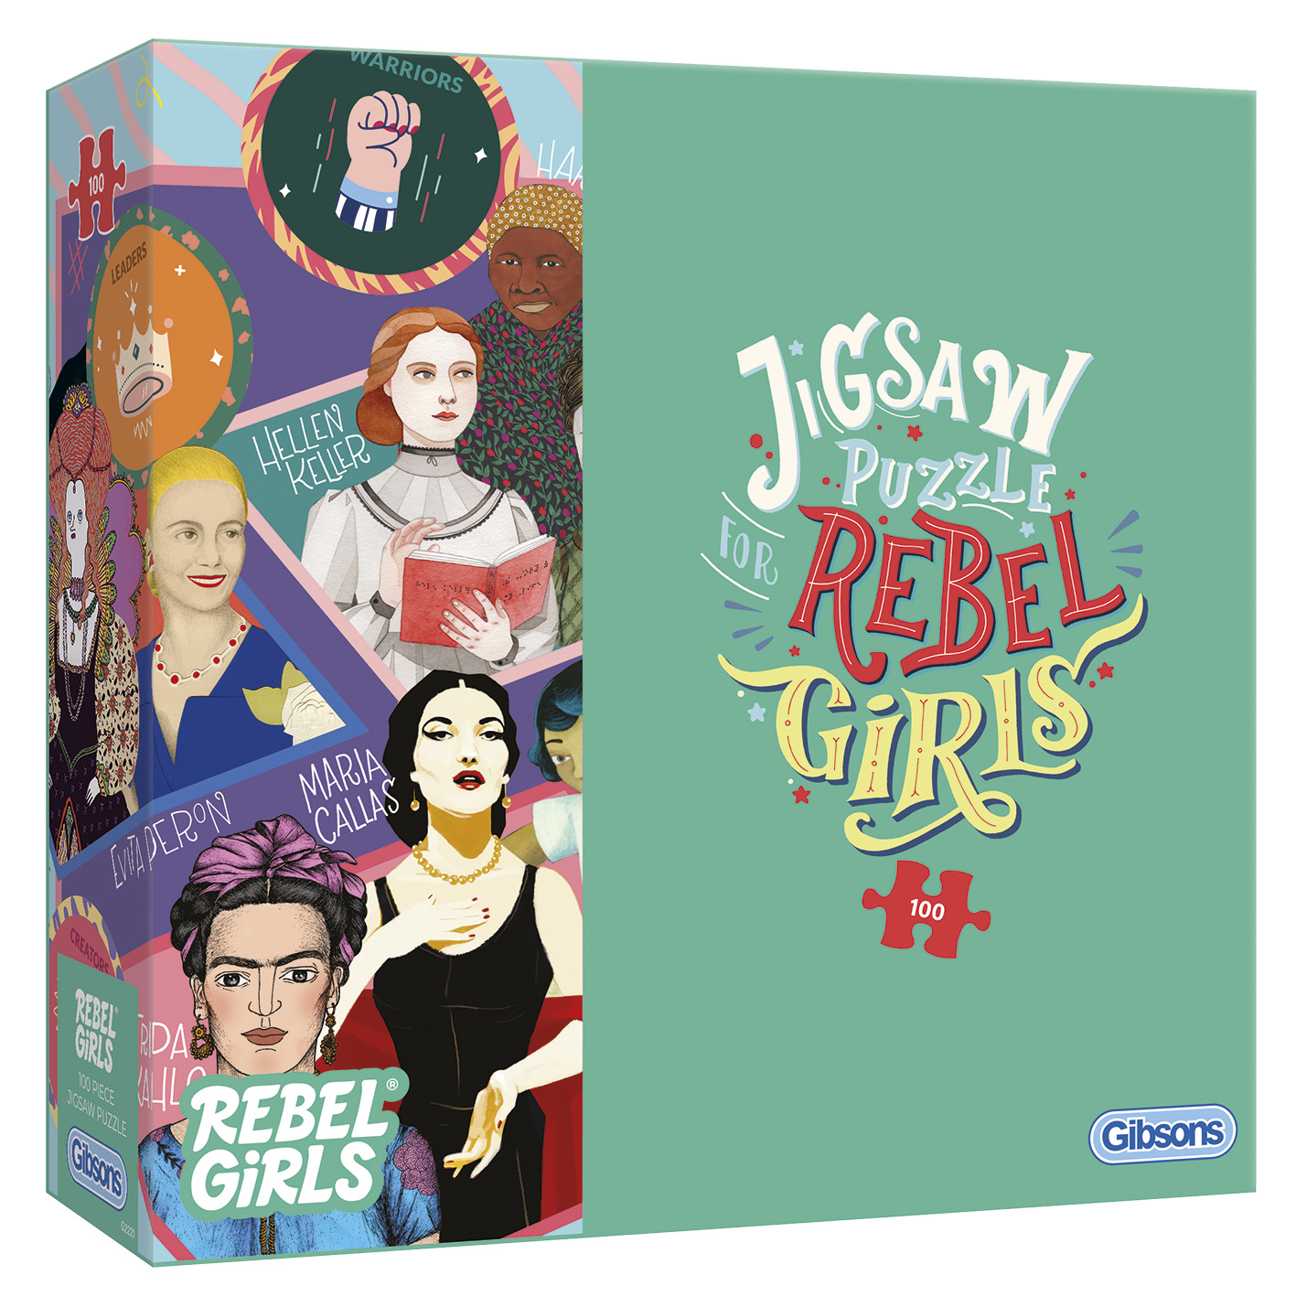
Designed to let children explore, learn and play, the new puzzle collection features queens, activists, scientists, artists, sporting champions, iconic world leaders and little-known pioneers.

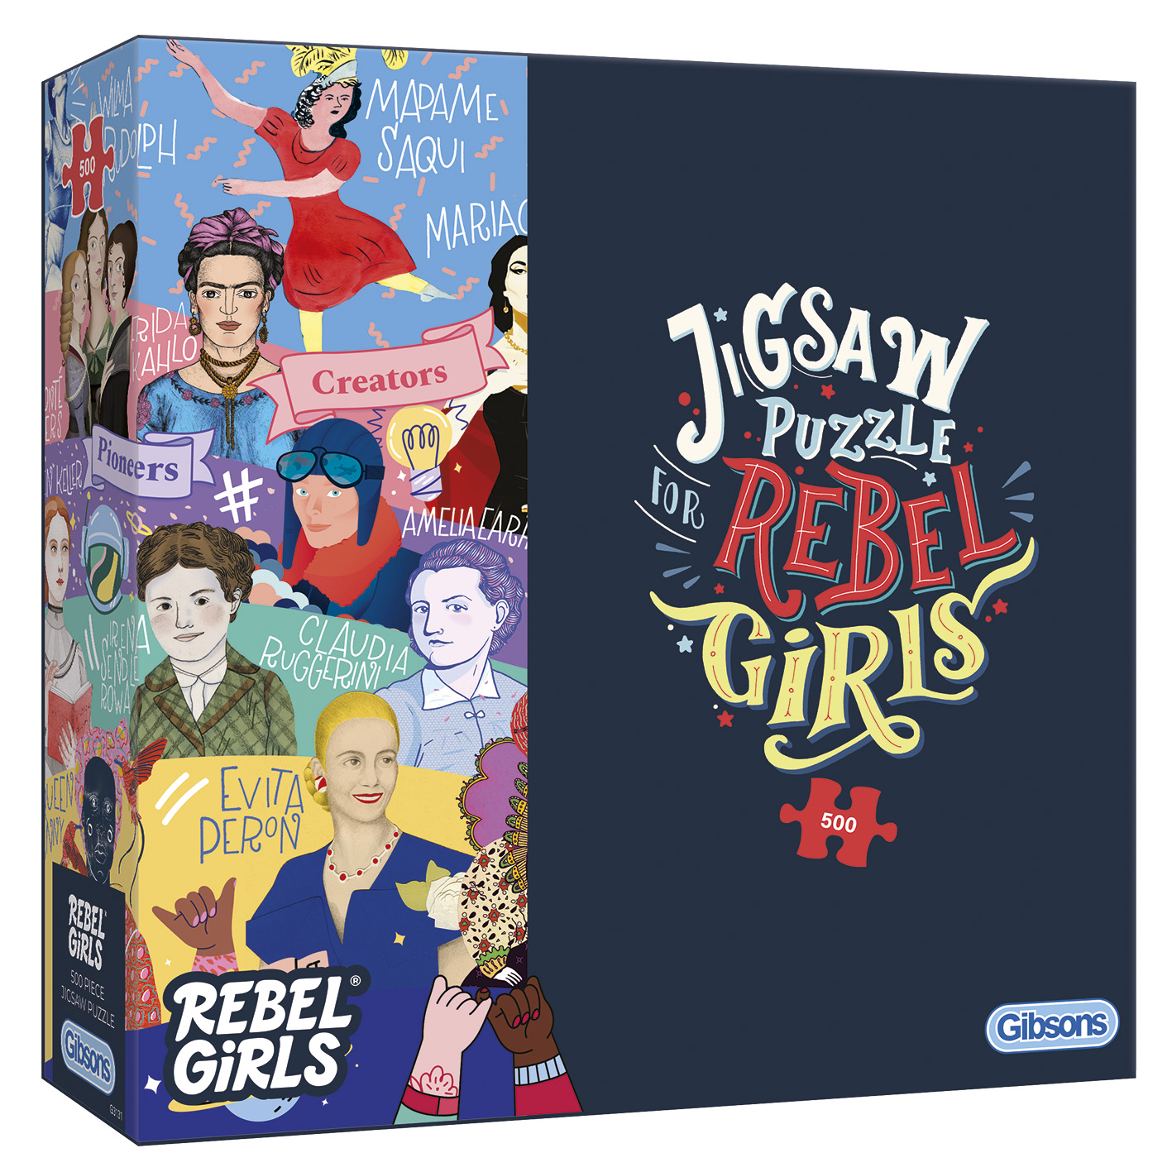
The 100 piece Jigsaw Puzzle for Rebel Girls is ideal for children from 5yrs+. It features heroines Elizabeth 1, Empress Jingu, Irena Sendlerowa and Ada Lovelace.

The Jigsaw Puzzle for Rebel Girls 500 piece is perfect for older children, teens and young adults. It features inspirational and empowering role models such as, Maria Callas, Valerie Thomas, the Brontë sisters, Wilma Rudolph, and Hatshepsut.

Just like the novels, the new puzzles focus on bold designs of amazing women - bright, vibrant, colourful and imaginative illustrations, by female artists from every corner of the globe.

Price: £10.50
Availability: www.gibsonsgames.co.uk
Ends

Note to Editors
Rebel Girls is the preeminent educational entertainment company that empowers girls to pursue their dreams without limits. Rebel Girls products inspire girls to dream bigger and realise their fullest potential, by introducing them to extraordinary women throughout history. Stories are brought to life through book publishing, podcasts, toys, and digital media. The Rebel Girls community spans over 85 countries, with 5.5M books sold in 49 languages, and 6M podcast downloads.
Gibsons: An independent, British, family-owned jigsaw puzzle and board game company, known for its innovative puzzle designs and best-selling games. Gibsons’ jigsaws use 100% recycled puzzle board, FSC paper and work with the best artists from around the world. Everyone loves a Gibsons Jigsaw, even Her Majesty Queen Elizabeth II has been spotted with one.

For further information please contact Playtime PR:
Chrissie Williams – chrissie@playtimepr.com – 07715 816363

