AUDIO PLATFORM FOR KIDS, YOTO, LAUNCHES MINDFULNESS CONTENT FOR EARLY LEARNERS

- Nearly 40% of kids under 11 have required professional mental support
- Research shows mindfulness training can improve the quality of sleep for individuals with sleeping difficulties¹
- Yoto to assist in meditation and mindfulness teaching for early learners at home
- Mindfulness plays an important role in ability to concentrate, manage stress and be present in early learners

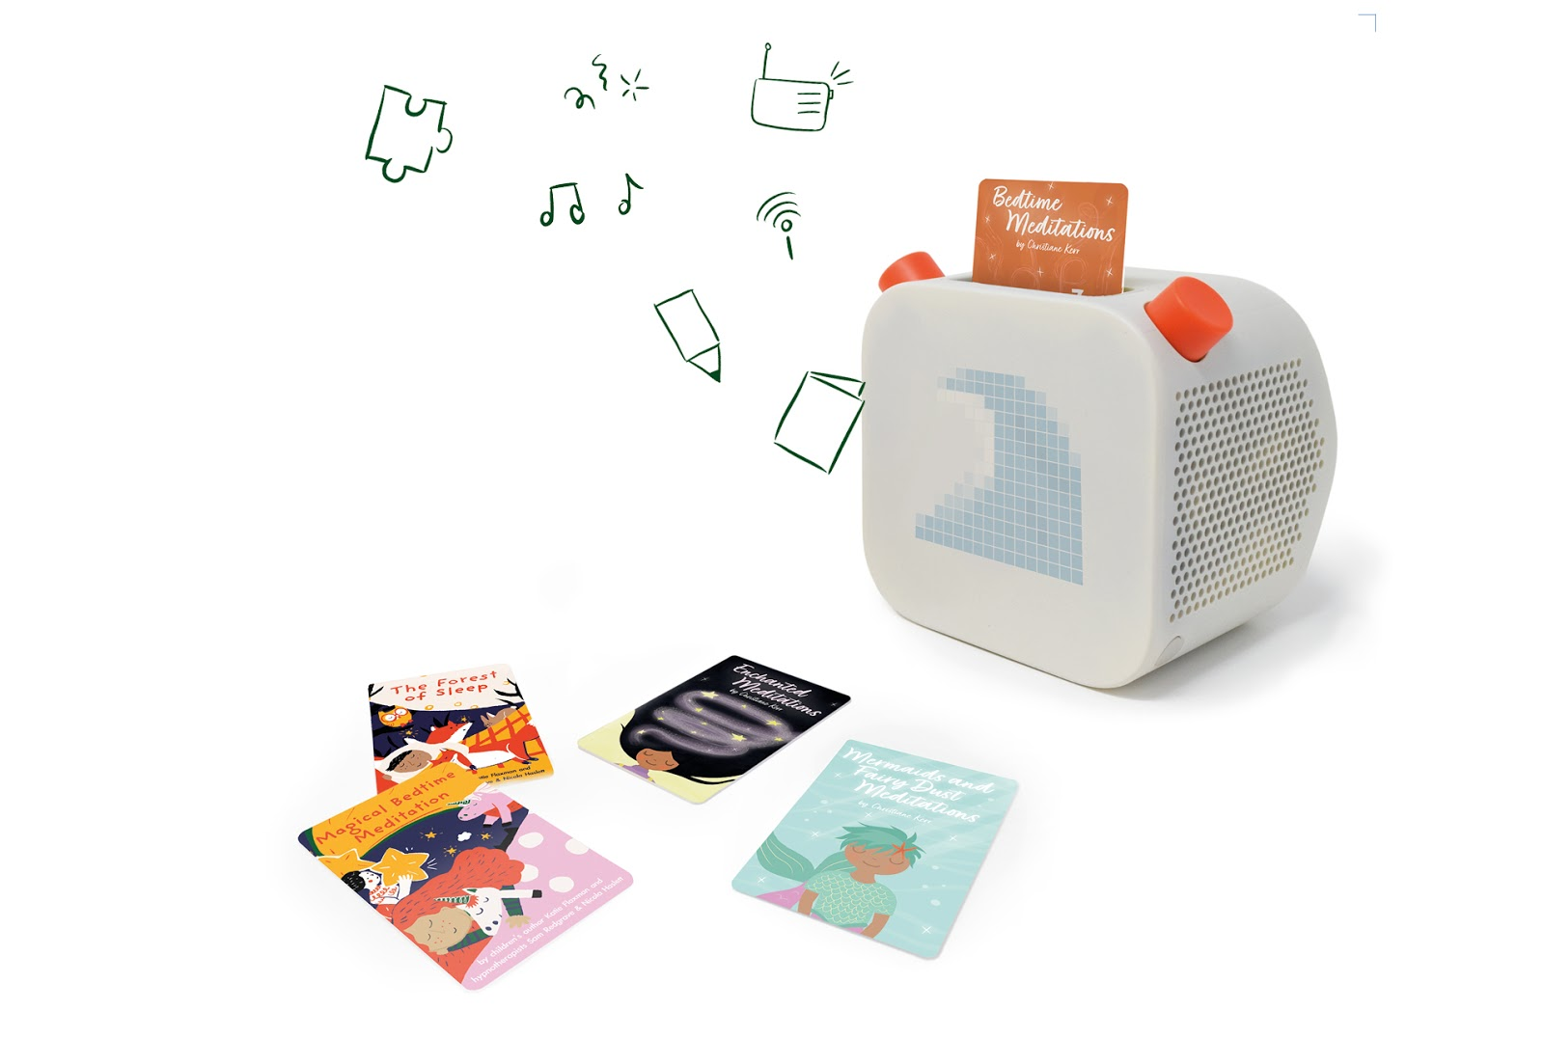

Since we went into lockdown, more children are reported to have developed mental health conditions, including post-traumatic stress. Being cooped up at home, not being able to go to school or regularly see their friends, anxiety about family members’ health and for some, a lack of regular hot meals and internet access have all contributed to a 37% spike² in the number of children under the age of 11 requiring professional mental health support.

In recognition of this, Yoto the audio platform for kids, behind the critically acclaimed and award-winning Yoto Player has announced its new Mindfulness content, designed to introduce early learners to the topic of wellbeing. Yoto has partnered with children’s charity Barnardo’s and will be donating £1 from every Mindfulness card sold from the UK website for the rest of the year.

Yoto has also teamed up with some of the world’s leading teachers and authors including Christiane Kerr, Katie Flaxman and Nicola Haslett to deliver a stream of mindfulness content aimed exclusively at children aged 0-8 years old. Taking the form of guiding meditations, the stories take listeners on a journey that unlock the building blocks of mindfulness, helping children relax and enhance feelings of happiness and contentment. Each reader skilfully guides children to the creative part of their mind through a number of carefully scripted story meditations, with an underlay of subtle sound effects and gentle music which combined with calming narration make them irresistible and deeply relaxing.

While most mindfulness content is aimed at adults who are facing the day- to- day stressors of modern life - work, money, mortgage and so on - it is a practice that can have vast benefits when learned in the pre-adolescent stage of life. Mental health and stress management, heightened concentration and cognition, emotional learning and behavior are all areas where regular mindfulness practice can be used to help and improve a child's ability to navigate daily life.

Ben Drury, CEO and co-founder of Yoto, comments, “mindfulness is a rich and rewarding practice that can be developed at a very young age, and can ultimately provide young learners with the tools they need to tackle complicated situations and stressors. In a time where we are all navigating a ‘new normal’, these tools are an asset and we as parents can make a lasting change in our children’s perception of these challenges by introducing an awareness of mental wellbeing now. We’re proud to offer parents a relaxing but engaging first step to introducing mindfulness to our children’s daily routines.”

Each guided meditation can be purchased in the form of a physical card that users simply insert into their Yoto Player to instantly activate it, with an accompanying pixelated display designed to heighten the relaxation experience. Alternative the content is available to play directly from your smart device upon purchase.

The Mindfulness cards will be available from 10th August 2020 for £4.99 from www.yotoplay.com.

Yoto Player is available to buy from www.yotoplay.com with an RRP starting from £79.99. For more information please visit www.yotoplay.com.

The smartphone Yoto parents app is available to download for free on iOS and Android, where you can find a free mindfulness sample.

-ENDS-

Notes to editors
¹Gong, H., Ni, C. X., Liu, Y. Z., Zhang, Y., Su, W. J., Lian, Y. J., ... & Jiang, C. L. (2016). Mindfulness meditation for insomnia: A meta-analysis of randomized controlled trials. Journal of Psychosomatic Research, 89, 1-6
²https://www.itv.com/news/2020-07-15/generation-covid-how-coronavirus-lockdown-has-impacted-uk-childrens-mental-health

Media contact
For more information please contact the team at W Communications at yoto@wcommunications.co.uk.

About Yoto
In 2015 inspired by Montessori principles, as well as the cassette players of their youth, Ben Drury and Filip Denker thought up the idea of a connected, screen-free audio device that children could be fully in control of using physical smartcards.

With no experience in hardware, electronics or industrial design, but liking the idea of a challenge, they got to work prototyping a basic device and started testing with their own families and friends.

An award-winning industrial designer joined the team in 2016 and helped develop their hacked-together prototype into a product for market release. With a more stable concept in hand, they launched a Kickstarter campaign for the Yoto Player in November 2017 and achieved full backing in a few days.

With help from their Sheffield based manufacturing partner, 2018 was spent producing and fulfilling the first-generation Yoto Player which sold out in August 2019. Raising investment off the success of this model, the new Yoto Player has been created with globally renowned design partner Pentagram. Yoto Player is the brand’s first product release of 2020, building on its already successful audio ecosystem.

